How healthy is our stream for freshwater organisms and how do our actions on land potentially impact the stream and the organisms that live in it?

Water Quality Unit for Middle School (5-8 weeks)
Author: Ann M. Novak PhD, Greenhills School, Ann Arbor MI (anovak@greenhillsschool.org)
This work is licensed under Creative Commons Attribution-NonCommercial ShareAlike 4.0 International License. Please credit author Ann M. Novak, PhD anovak@greenhillsschool.org Greenhills School, Ann Arbor MI

Table of Contents

Water Quality Unit for Middle School (5-8 weeks)
Overview
NGSS Learning Performances (LP’s)
LESSON #1: Why do we want to study water quality? What questions can we ask about water quality?
LESSON #2: How do experts determine water quality? What can WE do to determine water quality?
LESSON #3: pH - Is the stream acidic, basic, or neutral?
Day 1: Explore pH, design an experiment to test pH of substances
Day 2: Test pH of everyday substances
Day 3: Introduce scientific explanations
Day 4: Collecting pH of your water body
LESSON #4: Temperature - Is our stream too warm for freshwater organisms?
Day 1: Thermal pollution and thermal pollution standards
Day 2: Investigating temperature differences in your water body
Day 3: Sharing and discussing temperature difference results
LESSON #5: How healthy is our stream based on pH and temperature evidence?
Day 1: Models and modeling with SageModeler
Day 2: Continue building models and share/critique
LESSON #6: How many dissolved solids are in our stream
Day 1: Understanding Conductivity
Day 2: Conductivity of everyday substances
Day 3: Investigating conductivity of your water body
LESSON #7: How healthy is our stream based on pH, temperature, and dissolved solids?
LESSON #8: How much oxygen is in our stream? Is there enough oxygen to support life?
Day 1: Understanding Dissolved Oxygen
Day 2: Taking measurements with dissolved oxygen kits
Day 3: Investigating the dissolved oxygen of your water body
LESSON #9: How many floating particles are in the stream? Is this a problem for freshwater organisms?
Day 1: Understanding Turbidity
Day 2: Investigating the turbidity of your water body
LESSON #10: How healthy is our stream and how do our actions on land impact it? Final Model
LESSON #11: How healthy is our stream and how do our actions on land impact it? Final Explanation
Day 1: Introducing students to explaining the stream phenomenon
Day 2: Sharing and Critiquing of Explanations
Day 3: Water quality symposium
LESSON #12: Assessment Challenge
Day 1: Overview of assessment task and review of scientific explanation
Day 2: Assessment - constructing explanations using the Blue River scenario

Overview

This middle school unit explores the driving question, "How healthy is our stream for freshwater organisms and how do our actions on land potentially impact the stream and the organisms that live in it?” The project-based learning unit utilizes three-dimensional (3-D) learning envisioned by the Framework for K-12 Science Education (2012) and further articulated through the Next Generation Science Standards (NGSS Lead States, 2013). It builds towards several performance expectations, integrates DCI’s from life and earth science, several crosscutting concepts, and many scientific and engineering practices. Students actively engage in investigation to figure out the health of a stream or another freshwater body as they develop usable knowledge of the phenomenon. Throughout the unit, students are engaged in practices such as asking questions, designing and carrying out investigations, analyzing and interpreting data, and developing dynamic computer-based models and constructing scientific explanations. The unit also focuses on students developing usable knowledge of several crosscutting concepts -- cause and effect relationships, patterns, stability and change, and systems. A summary of the unit’s 3-D Learning Ideas from the Framework/NGSS and the performance expectations that the unit builds towards are below in Table 1 and Table 2.

Students collect and analyze pH, temperature, conductivity, dissolved oxygen, and turbidity data at a local creek, stream, river or pond. In this authentic context, students use their real-time data as evidence to create a model and/or to construct a scientific explanation of the water system. Engaging in these practices assists students to systematically analyze data, look for cause and effect relationships and find patterns to determine the quality of the stream for supporting life. Developing models and constructing explanations of complex phenomena, like the water quality of streams, can support students in developing useable knowledge of science ideas.

Adapting and personalizing your water unit
This unit is flexible! You have options to adapt this unit in three areas: 1.) personalizing the unit to your local community and your access to a body of freshwater, 2.) access to technology tools and/or water quality test equipment, and 3.) the amount of time you have available.

First, personalize and situate the unit to your community. Students are always more motivated to learn when what they are learning is meaningful and important to them. Setting a context with a waterway and water issues in your community will engage your learners. There may be water issues right in your local community, a nearby community, or in your state. You may live in a water-rich area or a water-scarce area. You may have a stream or a pond within walking distance of your school. Your water source may be a bus ride away. You may not have ready access and need to bring in containers of water from your local source to investigate inside your classroom. Customizing the unit will help engage students throughout the unit! As well, it will assist in making science learning accessible to all learners.

The second area of adaptation is related to technology tools. This curriculum engages students in using five water quality measures to investigate a freshwater stream. You may have scientific probes. You may have water quality kits. You may only have thermometers and pH paper. You may have these tools for all of your students or a limited amount. This unit can be adapted and suggestions are provided throughout the unit for classrooms with varying data collection tools.
Water quality testing options: Scientific probes and/or water quality kits can be used. Two companies, Pasco Scientific, (https://www.pasco.com) and Vernier (www.vernier.com/), sell probes. Probes are now wireless and data can be sent to cell phones, tablets, or computers. For Lesson 3, pH paper may be used in place of probes or kits and may be obtained from various companies that supply science equipment and chemicals. A variety of water quality testing kits may be obtained from companies such as Hach (https://www.hach.com) or LaMotte (http://www.lamotte.com/en/education/water-monitoring/5870-01.html).

The third area of flexibility is time. In this unit, students collect five pieces of evidence, over time, in order to figure out the water quality of their water system. Fresh water systems are complex with many components. Students use evidence from the various water quality measures, over time, to build and revise a dynamic computer-based model, construct a scientific explanation of the water system, or both. If you have time constraints or equipment constraints you can do three or four of the water quality measures. You may also expand this unit to include additional water quality measures that are not in this unit. You may decide to have your students develop models, have your students construct scientific explanations, or to do both.

Regardless of your situation you can utilize this unit, adjust it to fit your needs, and engage your students in investigating and explaining freshwater phenomena using 3-D teaching and learning. Figure 1 presents a flowchart that shows several possible pathways. One option is to set the context of the study - Lessons 1 and 2 - and then do all the lessons related to the five water quality measures - Lessons 3, 4, 6, 8, and 9, as seen in the center of the flowchart. Once these lessons are complete you may choose to have students construct models (Lesson 10) or develop scientific explanations (Lesson 11) or students may do both - Lesson 10 followed by Lesson 11. Another option is for students to construct an initial model after lessons 3 and 4 (pH and temperature), add to their models in Lesson 7, (after Lesson 6 on conductivity), and then finish their models after Lessons 8 and 9 (dissolved oxygen and turbidity). You can see this pathway by following the arrows in Figure 1. Still, another option is to have students develop an initial explanation after Lessons 3 and 4 (see dotted lines), revise it and add conductivity after Lesson 6, and then do a final revision after Lessons 8 and 9. As students revise their explanations that also include new evidence from additional water quality measures they may need to adjust their claims of the overall health of the stream. Explanations are introduced at the end of Lesson 3.

Prior Knowledge
Coming to this unit with an understanding of the water cycle and of watersheds is a plus, since understanding how people’s actions on land potentially impact water quality builds on these ideas. If your students are unfamiliar with watersheds Lessons 3 includes a basic discussion of watersheds. An optional watershed activity is included that can easily be incorporated into the lesson that will assist your students to develop understanding of these ideas. This watershed activity integrates well with a discussion of the water cycle.
Prior experiences with scientific and engineering practices and with crosscutting concepts are beneficial but are not a requirement for the unit. The many practices and crosscutting concepts (see Table 2) that are an integral part of this unit are carefully articulated throughout the unit and include teacher supports and ideas for supporting students.
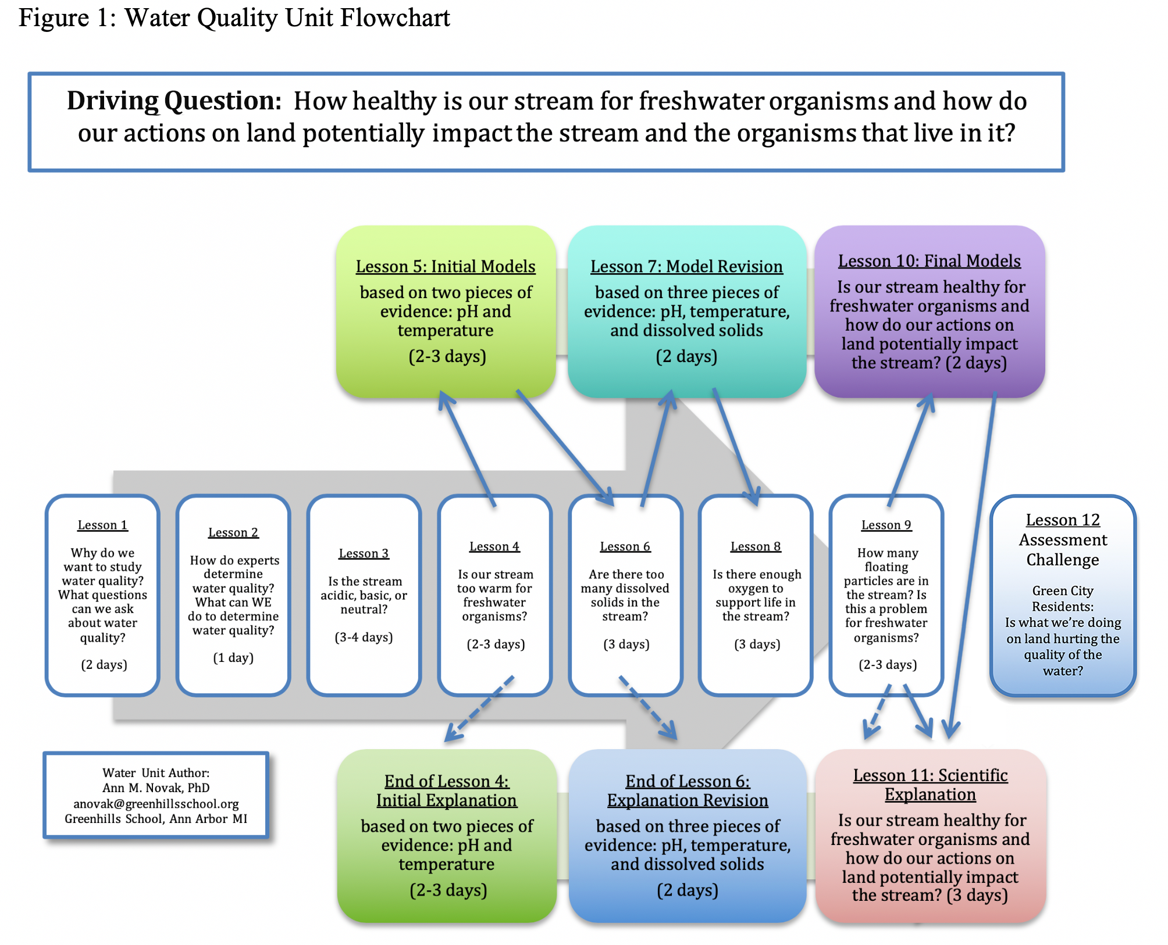

Table 1: Performance Expectations Water Unit builds towards (Framework/NGSS)
MS-LS2: Ecosystems: Interactions, Energy, and Dynamics | MS-ESS3: Earth and Human Activity | MS-ETS1: Engineering Design*
Students who demonstrate understanding can: | Students who demonstrate understanding can: | Students who demonstrate understanding can:
MS-LS2-4. Construct an argument supported by empirical evidence that changes to physical or biological components of an ecosystem affect populations.  MS-LS1. Analyze and interpret data to provide evidence for the effects of resource availability on organisms and populations of organisms in an ecosystem. | MS-ESS3-3. Apply scientific principles to design a method for monitoring and minimizing a human impact on the environment. | MS-ETS1-1. Define the criteria and constraints of a design problem with sufficient precision to ensure a successful solution, taking into account relevant scientific principles and potential impacts on people and the nature environment that may limit possible solutions.  *A design opportunity is an optional activity in Lesson 9

Table 2: Water Unit’s 3-Dimensional Learning Ideas from the Framework/NGSS
Science and  Engineering Practices | Disciplinary Core Ideas | Crosscutting Concepts
Practice 1:  Asking Questions and Defining Problems.  Practice 2: Developing and using models  Practice 3:  Planning and carrying out investigations  Practice 4:  Analyzing and interpreting data  Practice 5:  Using Mathematics and Computational Thinking  Practice 6: Constructing explanations and Designing Solutions  Practice 7:  Engaging in argument from evidence  Practice 8: Obtaining, evaluating, and communicating information  Connections to Nature of Science:  Scientific Knowledge is open to Revision in Light of New Evidence | MS-LS2 Ecosystems: Interactions, Energy, and Dynamics  LS2.A: Interdependent Relationships in Ecosystems  · Organisms, and populations of organisms, are dependent on their environmental interactions both with other living things and with non-living factors (MS-LS2-1)  · Growth of organisms and population increases are limited by access to resources. (MS-LS2-1)  LS2.C: Ecosystem Dynamics, Functioning, and Resilience  · Ecosystems are dynamic in nature; their characteristics can vary over time. Disruptions to any physical or biological component of an ecosystem can lead to shifts in all its populations. (MS-LS2-4)  · Biodiversity describes the variety of species found in Earth’s terrestrial and oceanic ecosystems. The completeness or integrity of an ecosystem’s biodiversity is often used as a measure of its health. (MS-LS2-5)  MS-ESS3 Earth and Human Activity  ESS3.A: Natural Resources  · Humans depend on Earth’s land, ocean, atmosphere, and biosphere for many different resources. Minerals, fresh water, and biosphere resources are limited, and many are not renewable or replaceable over human lifetimes. These resources are distributed unevenly around the planet as a result of past geological processes. (MS-ESS3-1)  ESS3.C: Human Impacts on Earth Systems  · Human activities have significantly altered the biosphere, sometimes damaging or destroying natural habitats and causing the extinction of other species. But changes to Earth’s environments can have different impacts (negative and positive) for different living things. (MS-ESS3-3)  MS-ETS1: Engineering Design*  ETS1.A: Defining and Delimiting Engineering Problems  The more precisely a design tasks’ criteria and constraints can be defined the more likely it is that the designed solution will be successful. Specification of constraints includes considerations of scientific principles and other relevant knowledge likely to limit possible solutions. (MS-ETS-1)  *A design opportunity is an optional activity in Lesson 9 | 1. Patterns. Observed patterns of forms and events guide organization and classification, and they prompt questions about relationships and the factors that influence them.  2. Cause and Effect: Mechanism and explanation. Events have causes, sometimes simple, sometimes multi-faceted. A major activity of science is investigating and explaining causal relationships and the mechanisms by which they are mediated. Such mechanisms can then be tested across given contexts and used to predict and explain events in new contexts.  4. Systems and system models: system under study-specifying its boundaries and Defining the making explicit a model of that system-provide tools for understanding and testing ideas that are applicable throughout science and engineering.  7. Stability and change. For natural and built systems alike, conditions of stability and determinants of rates of change or evolution of a system are critical elements of study.

Connections to Common Core State Standards (NGAC and CCSSO 2010)

Students are introduced to scientific explanations at the end of Lesson 3. There are optional opportunities for students to construct explanations at the end of Lessons 4 and 6, and/or in Lesson 11. Constructing explanations is an important ELA standard:

ELA
CCSS.ELA-LITERACY.WHST.6-8.1
Write arguments focused on discipline-specific content.
CCSS.ELA-LITERACY.WHST.6-8.1.A
Introduce claim(s) about a topic or issue, acknowledge and distinguish the claim(s) from alternate or opposing claims, and organize the reasons and evidence logically.
CCSS.ELA-LITERACY.WHST.6-8.1.B
Support claim(s) with logical reasoning and relevant, accurate data and evidence that demonstrate an understanding of the topic or text, using credible sources.
CCSS.ELA-LITERACY.WHST.6-8.1.C
Use words, phrases, and clauses to create cohesion and clarify the relationships among claim(s), counterclaims, reasons, and evidence.
CCSS.ELA-LITERACY.WHST.6-8.1.E
Provide a concluding statement or section that follows from and supports the argument presented.
- Students should be able to “adjust their use of spoken, written, and visual language (e.g., conventions, style, vocabulary) to communicate effectively with a variety of audiences and for different purposes.” (IRA and NCTE Standards for the English Language Arts, 1996)

Connection to ELA and Social Studies

Standard 10: Range, Quality, & Complexity » Range of Text Types for 6-12
A Long Walk to Water, by Linda Sue Park

This New York Times best seller is a book that may be integrated into ELA or Social Study classes as an introduction to water issues.

Lessons 6, 8, and 9 engage students in three different water quality tests that involve proportional relationships. Students use evidence from these tests to figure out what potential products people use on land, how much they use, and how these products may enter waterways with potentially serious consequences for aquatic organisms

Mathematics: Analyze proportional relationships and use them to solve real-world and mathematical problems.
CCMM.MATH.CONTENT.7/RP.A.2
Recognize and represent proportional relationships between quantities.

Using 3-Dimensional Assessments to probe students understanding
Formative and summative 3-dimensional assessments that assess various aspects of the performance expectations are provided throughout the unit. All assessments call upon students to make use of their understandings using practices, crosscutting concepts, and DCI’s.

NGSS Learning Performances (LP’s)
Water Quality Unit’s integration of practices, disciplinary core ideas (DCI’s), and crosscutting concepts (CCC).
Practice DCI CCC…

Lesson #1: Why do we want to study water quality? What questions can we ask about water quality?
LP1: Students generate questions to explore how human activities related to products people use on the land, may negatively impact populations of organisms in fresh waterways. CCC = cause and effect

Lesson #2: How do experts determine water quality? What can WE do to determine water quality?
LP2: Students gather, read, and communicate information from multiple sources to explore how experts determine water quality where human activities may alter the biosphere, impacting fresh waterways and their populations of organisms. CCC = cause and effect

Lesson #3: Is the stream acidic, basic, or neutral? What does pH measure and what is the best pH for freshwater organisms? What happens to organisms if the pH is too acidic or basic? Are products that people use on land acidic, basic, or neutral?
LP3: Students plan and carry out an investigation to test pH of everyday substances that people use outside that can get into waterways in large quantities and that may negatively impact populations of organisms in fresh waterways. CCC = cause and effect
LP4: Students construct a scientific explanation to explain how an everyday product’s pH could affect freshwater organisms. CCC = cause and effect
LP5: Students collect and analyze pH data to explore how human activities on land may negatively impact populations of organisms. CCC = cause and effect, change and stability, patterns, systems

Lesson #4: Is our stream too warm for freshwater organisms?
LP6: Students collect and analyze data to explore the relationship between people’s actions on land, the temperature of the stream, and the quality of the water for various populations of organisms. CCC = cause and effect, change and stability, patterns, systems

Lesson #5: How healthy is our stream based on pH and temperature evidence?
LP7: Students develop models to explore how pH and temperature changes resulting from human activity affect water quality and the organisms that live in the stream. CCC = cause and effect, change and stability, patterns, systems

Lesson #6: How many dissolved solids are in our stream?
LP8: Students plan and carry out an investigation to test the level of dissolved solids of everyday substances that people use on land that can get into waterways in large quantities. CCC = cause and effect
LP9: Students collect and analyze data to explore the relationship between the level of dissolved solids of the stream and the quality of the water for various populations of organisms. CCC = cause and effect, change and stability, patterns, systems
LP10: Students construct an argument to infer which specific substances account for the levels of dissolved solids in the water and how human activity impacts those levels. CCC = cause and effect, change and stability, patterns, systems
LP11: Students construct an argument that levels and sources of dissolved solids may or may not lead to a disruption of the life cycle. CCC = cause and effect, change and stability, patterns, systems

Lesson #7: How healthy is our stream based on three pieces of evidence: pH, temperature, and dissolved solids?
LP12: Students develop and revise models to explore patterns of shifts in populations of water organisms that are negatively impacted as the result of human activities that result in disruptions to physical or biological components of an ecosystem. CCC = cause and effect, change and stability, patterns. systems

Lesson #8: How much oxygen is in our stream? Is there enough oxygen to support life?
LP13: Students collect and analyze data to explore the relationship (cause and effect) between the amount of dissolved oxygen in the stream and the quality of the water for various populations of organisms.
LP14: Students construct an argument that levels of dissolved oxygen may or may not be a result of a disruption of the life cycle. CCC = cause and effect, change and stability, patterns, systems

Lesson #9: How many floating particles are in the stream? Is this a problem for freshwater organisms?
LP15: Students collect and analyze data to explore the relationship (cause and effect) between the turbidity levels of the stream and the quality of the water for various populations of organisms.
LP16: Students construct an argument to infer which specific substances might account for the turbidity levels of in the water and how human activity impacts those levels.
LP17: Students design and build a device to capture pollutants that allow them to collect, analyze and interpret turbidity data from a waterway. relationship (cause and effect)

Lesson #10: How healthy is our stream is our stream for freshwater organisms and how do our actions on land potentially impact the stream and the organisms that live in it? (Final Models) (2-3 days)
LP18: Students construct a model of how various water quality measures resulting from human activities in agriculture, industry and everyday life can have major impacts on rivers lakes, and streams to illustrate cause and effect relationships, that small changes in one part of the system (the stream phenomenon under study) might cause large changes in another part of the system, and that stability might be disturbed either by sudden events or gradual changes that accumulate over time.

Lesson #11: How healthy is our stream is our stream for freshwater organisms and how do our actions on land potentially impact the stream and the organisms that live in it? (Final Explanations) (3 days)
LP19: Students construct a scientific explanation of how various water quality measures resulting from human activities in agriculture, industry and everyday life can have major impacts on rivers lakes, and streams to illustrate cause and effect relationships, that small changes in one part of the system (the stream phenomenon under study) might cause large changes in another part of the system, and that stability might be disturbed either by sudden events or gradual changes that accumulate over time.

Lesson #12: Assessment Challenge: Green City Residents: “Is what we are doing on the land hurting the quality of the water in Blue River?”
LP19: Students construct a scientific explanation of how various water quality measures resulting from human activities in agriculture, industry and everyday life can have major impacts on rivers lakes, and streams to illustrate cause and effect relationships, that small changes in one part of the system (the stream phenomenon under study) might cause large changes in another part of the system, and that stability might be disturbed either by sudden events or gradual changes that accumulate over time.

LESSON #1: Why do we want to study water quality? What questions can we ask about water quality?
Overview: This one to two-day lesson introduces students to the driving question, “How healthy is our stream for freshwater organisms and how do our actions on land potentially impact the stream and the organisms that live in it?” Students generate questions they have about water quality. The teacher guides the students to not only think about the water and organisms in the water, but also about people and how people might impact the water quality. The lesson includes anchoring activities that could include a video or two and a stream walk. Students brainstorm to begin to figure out, “Why should we investigate water quality? How do people affect the water quality of streams, rivers, and lakes?” In this first lesson a context is set for exploring the driving question (DQ). In order to answer the driving question, students will need to engage in several practices and use crosscutting concepts. The DQ is rich with scientific ideas. The lesson, as well as the entire unit is flexible. It depends on teacher resources. Is there a stream/river nearby? Are there water issues in the teacher’s particular area?
NGSS Performance Expectations for the Unit:
MS-LS2-4. Construct an argument supported by empirical evidence that changes to physical or biological components of an ecosystem affect populations.
MS-LS1. Analyze and interpret data to provide evidence for the effects of resource availability on organisms and populations of organisms in an ecosystem.
MS-ESS3-3. Apply scientific principles to design a method for monitoring and minimizing a human impact on the environment.
Lesson Learning Performance:
LP1: Students generate questions to explore how human activities related to products people use on the land, may negatively impact populations of organisms in fresh waterways. (CCC = cause and effect)
Safety Guidelines: None
Preparation: Some internet sites are provided that introduce water quality issues. However, conducting a search to find issues in your community or a nearby community will help to contextualize the unit even more and make it more interesting and meaningful to your students.
Time: One or two class periods
Materials:
- Videos, websites related to water quality, preferably related to local issues.
- Post-it notes

INSTRUCTIONAL SEQUENCE
1. Introduction: Begin to set a context for studying water quality. (~1-2 min)
Purpose: Set a context for small group brainstorming.
Begin by asking students questions about their water use. Questions could include:

“How many of you took a shower last night or this morning before you came to school?
Did all of you brush your teeth this morning?
You’re all wearing clean clothes; how did they get clean?
You ate breakfast with clean dishes. How did they get clean?
Did any of you drink water this morning or have drinks that contain water?
What do you know about water and all living organisms, including us?
Water - it’s a pretty important part of our lives. We can’t live without it. Plants and
animals can’t live without it either!”

2. Small group brainstorm: WHY should we investigate water quality of freshwater bodies of water such as rivers, lakes, and streams? Do you think people are related to water quality? If no, explain. If yes, how? (~5 min)
Purpose: Illicit student prior knowledge of water quality of freshwater lakes, rivers, streams
This activity allows students to brainstorm and share ideas. It provides you with insights into students’ prior knowledge. Since everyone has some knowledge of water it empowers all students to share and begins to develop a collaborative learning environment.
Making science learning accessible to all learners: Whether one lives in an urban, suburban, or rural environment, or a water rich or water scarce area, all students have everyday experiences with water in their homes and communities. As well, all students live in a watershed that directs the flow of rainwater or snowmelt that can carry potential pollutants - products people use outside on the land - into nearby lakes, rivers, and streams. Each of your students, therefore, will bring valuable personal experiences to a unit on water. This makes a water quality unit naturally engaging to all learners.
Ask groups of 3-4 students to work together to generate specific ideas related to the two questions. They may split a paper in half with one question on each half (see below). Encourage students to try to come up with at least three ideas for each question. Assist students that are struggling. For example, “What are some things that people might do that impact water?”
WHY should we investigate water quality of freshwater bodies of water such as rivers,
lakes, and streams?

Do you think people are related to water quality?

3. Classroom Sharing: Groups sharing ideas. (~10 minutes)
Purpose: Share everyone’s ideas, learn from others, identify common ideas. This will lead to unit’s driving question. This sharing will continue to provide you with insight into students’ prior knowledge.
Going from group to group, have a student share one idea that the group generated. You may want to record these ideas on the board. You can split the board into two sections: one related to WHY we should investigate water quality and the other, how are PEOPLE related to water quality. There will most likely be overlap of ideas and themes will emerge. You may ask, “How many groups had the same idea?” to get a sense of where students are at. This will be particularly useful if a group shares an idea that you know will be addressed during the unit.

4. Introductory video related to freshwater creek, stream, river, or lake quality (3-10 minutes)
Purpose: Set a context for studying water quality of freshwater lakes, rivers, streams. Show one or two short videos to set an interesting context. There are a few suggestions below. However, a quick search and you may find interesting videos based on water issues right in your own community. Avoid videos that “tell” students all of the answers. Rather, look for ones that pique interest.
Making science learning accessible to all learners: The teacher can make the unit accessible and motivating to all students by personalizing and situating a water unit to their community. Teachers can set a context with a local waterway or local issues in the community or have students research to find out if there are local water issues. There may be water issues right in the local community, a nearby community, or somewhere in the state. The context should promote engagement and participation of all learners.

A powerpoint presentation is included with some ideas of contextualizing a unit. This context is in a small city in Michigan. You will personalize the unit based on your context.

- EPA Water Quality Video - YouTube ▶ 2:15
https://www.youtube.com/watch?v=o8uVOxsl90w
- Urban Waters Voices
https://www.epa.gov/urbanwaters/urban-waters-voices
Thirteen, 3-minute videos from different parts of the country related to local water quality. Look for one near your community. Here is the introduction from the website:
“Urban Waters Voices is a series of video interviews featuring locally led efforts to restore urban waters in communities across the United States. These videos feature local efforts and strategies to improve urban water quality while advancing local community priorities.”
- UNESCO Protecting Water Quality for People and the Environment - YouTube ▶ 8:29
https://www.youtube.com/watch?v=i5jGxO28Kw8
- 15 recent water quality issues, threats in Michigan
http://www.mlive.com/news/index.ssf/2015/09/michigan_water_issues.html

Background
All organisms need water. The earth’s surface is 70-75% water, yet less than 1% (closer to 0.1%) is freshwater that is usable by people. And this water needs to be shared with other organisms that need freshwater. This idea may come up in one of the video’s or during discussion during this introductory lesson. If it doesn’t come up, you may want to integrate this into the way you contextualize the lesson. Earth’s nicknames are “Blue Planet” and “Water Planet” because we have so much water. But pollution threatens the availability of that water.

5. Small Group: Specific Questions related to water quality and people: (~5 min)
Purpose: Students generate questions based on the initial brainstorming activities and the video(s) related to water quality of freshwater bodies of water and people. Hopefully, many of their questions will be addressed during the unit. This facilitates students to take ownership in their learning as these are student-generated questions. This activity also sets the context for the next lesson. Also, when students have choice, they are more motivated to learn.
Students should work in groups, using post-it notes to write down a couple of well-thought-out questions - one or two - related to ideas that were generated in the class discussion, video(s), or any new ideas. These questions should be of interest and meaningful to them and that they deem important to investigate. You can decide whether or not students put their names on the questions.
Collect the questions, but do not read them yet. Read through the questions later and group them. Once you introduce the driving question you can create a driving question board (DQB). A DQB is a bulletin board or an area on a wall where the driving question is posted. It is a visual tool to focus learners’ attention, post questions that they generate, record what they have learned, and used as a reference to make connections to the driving question throughout the entire unit. If you have multiple classes you may have different parts of the room where you display their questions. Another option is to combine the various questions. Chances are good that some, and hopefully many, of the questions generated will be addressed in the unit. When this occurs, you may pull the post-it note and read it aloud to either introduce what’s coming up or as you are engaged in addressing the question.

6. Stream walk or other contextualizing activity (~10-20 min)
Purpose: To show students the phenomenon under investigation and to motivate students. To introduce the driving question, “How healthy is our stream for freshwater organisms and how do our actions on land potentially impact the stream and the organisms that live in it?”
There are different options depending your access to a freshwater body of water:
- If you have a creek or stream within quick walking distance of your classroom, walk students out to show them the waterway. Introduce the driving question, “Is our stream healthy for freshwater organisms and how do our actions on land potentially impact the stream?”
- If you do not have a creek or stream within quick walking distance, but you have a waterway that you will be able to regularly access, pull up a picture, video, etc. of that waterway. Then introduce the driving question.
- If you do not have a waterway that you will be able to access as a class, but have a waterway from which you will be obtaining water samples and bringing them to class, pull up a picture, video, etc. of that waterway. Then introduce the driving question.
Once students see the water phenomenon that they will be investigating, they may have new questions that can be added to the DQB.

Concluding the lesson

Regardless of what body of water you will be investigating, you will now tie together everything that was done in this introductory lesson. Refer to the brainstorming ideas and to the initial videos that introduced the lesson (if time, you may show others). Let students know that you will read through the questions they generated during class and that hopefully many of them will be answered as we, as a class, investigate the stream (or creek, etc.) We will use the driving question as the guide for the entire unit and explore sub-questions - hopefully many that will spring from students’ questions - that will be part of the driving question.
Homework or reading: None, unless you wish for students to research water issues.

LESSON #2: How do experts determine water quality? What can WE do to determine water quality?
Overview: In the prior lesson, students were introduced to the driving question, “How healthy is our stream for freshwater organisms and how do our actions on land potentially impact the stream and the organisms that live in it?” They were also introduced to the specific phenomenon that they would be investigating (a local creek, etc).
In this one-day lesson, students conduct a short internet search to investigate what experts do to investigate water quality (this could be done as homework the night before). After sharing what experts do the teacher informs students of water quality measures that the class will be doing. Students discover that we will be doing many of the same water quality tests that expert scientists do! Students are asked to think about how many pieces of evidence are needed to figure out and explain the waterway phenomenon (whether is be a creek, stream, river, pond, or lake) under investigation.
NGSS Performance Expectation for Unit: PE: MS-LS2-4, PE: MS-LS2-1, PE: MS-ESS3-3
Lesson Learning Performance:
LP2: Students gather, read, and communicate information from multiple sources to explore how experts determine water quality where human activities may alter the biosphere, impacting fresh waterways and their populations of organisms. (CCC- cause and effect)
Safety Guidelines: None
Time: One day
Materials: Internet availability

INSTRUCTIONAL SEQUENCE
1. Internet search - How do experts determine water quality? (~15 min)
Purpose: To allow students to see that we will be conducting many of the same water quality tests that experts conduct. This will further motivate students because they will both be excited to do what experts do and it will enhance the value and importance of water quality monitoring.
Begin by reviewing yesterday’s class: You can begin class by asking students to summarize what was done in class yesterday - we generated ideas related to water quality of freshwater streams, etc. and people’s relationship with water quality. You may ask students for their ideas of how we will know if our stream is healthy? Build from student suggestions by introducing the following: If we are going to study water quality of our local stream, etc. ask students if it makes sense to see what experts do to determine water quality. If we know what experts do, then we can see if WE can do any of the same things to investigate our stream.
Students should spend 10 minutes searching the internet. They should access several different sites that they think should be reliable such as government sites. They may also look at sites that are from state or local water quality monitoring projects. Stress to students to investigate water quality for freshwater organisms. This search is not related to drinking water. Students should simply LIST 6-8 different ways experts test streams, rivers, etc. Students do not need to read about the tests, but simply find a couple of sites that discuss monitoring water quality of streams and write down various water quality tests, in list format. The purpose is simply to introduce students to some measures, not for students to develop any understanding of these measures. Here are search phrases that students can use:
Search phrases: 1. Water quality tests for streams, 2. river and stream water quality monitoring.
Background
This unit has students investigating pH, temperature, conductivity, oxygen, and turbidity. They will also conduct a visual survey: qualitative observations in the water, next to the water, and near the stream - the area of the mini-watershed surrounding the stream. Below are some tests/words students will find during their search and which ones are related. Following this are some other measures that are not part of this unit.

pH: acids, bases, neutral
Temperature: thermal pollution
Conductivity: salinity, phosphorus /phosphates, nitrogen/nitrates, nutrients
Oxygen: dissolved oxygen, B.O.D (biological oxygen demand), flow rate
Turbidity: secchi disks, dirt, floating particles, suspended particles, erosion

Other measures not included in this unit : metals, ammonia, hardness, toxic substances, e-coli/bacteria, benthic macroinvertebrates,

2. Class sharing of water quality measures (~10 min)
Purpose: Students share information they found during their internet search.
Bring the class back together and ask students to share what they found. Record their responses on the board. You will see that some responses are simply synonyms. For example, turbidity, floating particles, and clarity are all synonyms. Others will be related, for example, nitrogen, phosphorus, and road salt are all dissolved solids measured by conductivity, or nitrate and phosphate kits. Regardless of what is shared (even synonyms), record it on the board and ask students to record anything that is shared that is not on their list. In the end, everyone will have the same list.

3. Identifying what can be investigated during the unit. (~5 min)
Purpose: Inform students what the class can investigate. Excite and motivate students as they see that they will be conducting many of the same water quality tests as the experts.
One by one go down the list and circle items from the list that will be investigated during the unit. For example, circle pH, saying, “We will be able to test this” and/or “We have equipment to investigate this.” For items that cannot be tested, simply cross them off saying something like this: “We don’t have equipment to test this.” You may circle words and let students know that some are related. In the end, there should be many items that are circled. You can step back and ask students to look at the overall board. Everyone should be able to conclude that we will be able to investigate some, if not many, of the tests that experts conduct.
This is also an opportunity to make connections with questions that students generated in the previous lesson. Some of the questions may also be related to the water quality measures that are on the driving question board (some that may be addressed and others that may not). This will allow you to let students know if the class will be investigating these questions, or if the questions are valuable, but not feasible to address in the unit.

4. How much evidence do we need to collect? Basketball analogy (~5 min)
Purpose: Provide students with a real-life, non-science, example to help them understand why we need to have several pieces of evidence in order to best answer the driving question.
Say to students, “Let’s pretend for a moment that you have been asked to evaluate a basketball player who is a senior in high school to see if she is good enough to play college basketball. You go to the gym and see her standing at the free-throw line and, swish, she makes the free-throw. Do you conclude that she is college material?” Students should respond that one free-throw is not enough information to conclude that the player is strong enough to play college ball. Ask students if they observed her making 19/20 frees throws if this would be enough information. They should have a similar response. Ask students what other information they might want to obtain that would allow them to make an informed decision to fully respond to the question, “Is this girl good enough to play college basketball?”. Students may suggest that they need to see if she can pass, dribble, play defense, and if she has a good shot from many areas. They may want to know if she’s a team player, if she can play under pressure, and if she has a good work ethic. Based on these responses, you can help students conclude that if they want to fully understand this senior’s college basketball potential, they need to obtain several pieces of evidence from which they can make a conclusion. In other words, they need to support their conclusion with evidence.
Let students know that this is the same case with science. To be able to answer the driving question, “Is our stream healthy for freshwater organisms and how do our actions on land potentially impact the stream and the organisms that live it?” we will need to collect several pieces of evidence. The stream is a complex system (systems and systems modeling in an important crosscutting concept). We will be conducting several tests (also called measures) over the course of the next couple of weeks. As we collect data, we will build and test models* or we will write a scientific explanation to explain our understanding of the water we are studying. We will expand our models as we obtain more evidence to see if our models accurately portray the water quality of the phenomenon.
You will determine, in advance, if your students will construct models, develop explanations, or both. As well, you will determine if student models or explanations develop across time or if they are a culminating activity at the end of the unit. See the flowchart in the Unit Overview for options.

This is an opportunity to introduce quantitative and qualitative data. Quantitative data is data obtained, usually using an instrument, to measure something, and obtain a number. Qualitative data is data obtained using our senses (except taste) where we write a rich description using words.

5. Introducing the first water quality measure - pH (5-10 min)
Purpose: Assess students’ prior knowledge of pH. Introduce the homework reading.
Remind students that one of the water quality measures they found when exploring what experts do to determine water quality is pH. Inform students that the first water quality measure that we will use to investigate the stream (or whatever water phenomenon that you are investigating) will be pH. Ask students, when they hear the term “pH” what do they think of? You may have students first share with a partner (one minute) and then share as a class. Let students simply share their ideas until all ideas are shared. Some students may share that they test for pH in their fish tanks. Other students have seen testing at a swimming pool that could be pH. Some students may say pH is related to acids and to stomach indigestion. Whatever students say, let them know that pH is an important water quality measure for freshwater.
Show students a pH probe (or pH paper, or whatever you are using to measure pH). Let students know that this is an instrument that we will use to test pH. A pH probe will provide us with a number - the pH of the stream. Ask students if that is enough information. Help students realize that before we can test for pH in the stream, we need to have an understanding of what pH measures and why pH is important for freshwater organisms. The probe (or pH paper) only provides us with a number. Stress that we are the ones who need to figure out what the number means for organisms, and try to figure out why the stream has that pH level.

Concluding the lesson (~5 min)
Quickly summarize today’s lesson. We investigated what the experts do to determine water quality. We found out that we will be able to conduct many of the same tests that experts do. We decided it’s important to conduct several different types of tests in order to get a more complete picture of the stream, which is a complex system. Our first water quality test will be pH. We have some ideas about pH, but need to learn more, particularly why is it important for freshwater organisms and what causes pH levels in various waterways to change.
This sets the context for the homework.

Homework: pH Student Reader
Making learning accessible for all students: Depending on the reading level of your students, you can also do the reading as a close read in class.

For homework, students will complete a short reading that includes a few questions. Let students know that this reading introduces them to the importance of pH for freshwater organisms. They should carefully study the chart that is part of the reading. A couple of the questions require students to use the chart. The reading will lead to a three or four-day lesson on pH. The reading should take the average student around 10-15 minutes to complete. Some students, however, may need more time. Tomorrow’s lesson will begin with a discussion of this reading. The pH student reader with and without answers is available as separate documents.

Student Reader, pH
Student Reader, pH - Key

LESSON #3: pH - Is the stream acidic, basic, or neutral?
Lesson Questions: Is the stream acidic, basic, or neutral? What does pH measure and what is the best pH for freshwater organisms? What happens to organisms if the pH is too acidic or basic? Are products that people use on land acidic, basic, or neutral?
Overview: In the last lesson, students explored how experts determine water quality as well as determined that the class could conduct many of the same water quality tests as experts. In this lesson, students explore the first water quality measure – pH. They are introduced to what pH measures and a pH chart that includes the pH ranges needed for various freshwater organisms to survive. With teacher support, students plan and carry out an investigation, collecting and analyzing data as they test the pH of various everyday substances that people use on land in large quantities. Discussion of how these products can get into the water and change the water’s pH (causes), the possible impact on the stream’s pH (consequences/effects), the effects on fish population and other organisms’ population are included. To assess student understanding, students are introduced to scientific explanations and construct a simple explanation about organisms’ ability to live in a waterway based on pH levels using one product from the pH lab.
Once students test these everyday substances they then test the pH of their stream. They now will have insight into whether or not the stream is healthy for freshwater organisms based on pH and possible causes of what may have caused the pH to be acidic or basic, should their results fall out of the neutral zone for pH.
NGSS Performance Expectations for Unit: PE: MS-LS2-4, PE: MS-LS2-1, PE: MS-ESS3-3
Lesson Learning Performances:
LP3: Students plan and carry out an investigation to test pH of everyday substances that people use outside that can get into waterways in large quantities and that may negatively impact populations of organisms in fresh waterways. (CCC = cause and effect)

LP4: Students construct a scientific explanation to explain how an everyday product’s pH would affect freshwater organisms. (CCC = cause and effect)

LP5: Students collect and analyze pH data to explore how human activities on land may negatively impact populations of organisms. (CCC = cause and effect, change and stability, patterns, systems))

Safety Guidelines: Students will be testing everyday substances, some of which will be acidic or basic. They should wear goggles. Students should be careful to avoid falling into the water when testing the pH of their waterway.
Preparation:
Time: 3 days (4 days if constructing the explanation)
Materials:
For the teacher | groups | individuals
pH PowerPoint  student reader - pH - key | pH probe, paper, or kit  Products in tennis cans  Bottles of distilled water for cleaning the probes | pH PowerPoint  student reader - pH  lab setup - pH of substances  Data sheet, pH of substances  Data sheet, pH of freshwater body  Data sheet, results of all water quality tests  Goggles

INSTRUCTIONAL SEQUENCE

Day 1: Explore pH, design an experiment to test pH of substances
Background
Here are elements of the DCI that are introduced in this lesson. Other water quality tests also address some of these DCI’s.

- People unknowingly use products outside that can impact the pH of streams, making them unconducive for populations of freshwater organisms.
- Human activities alter the biosphere and may negatively impact populations of organisms.
- Organisms, and populations of organisms, are dependent on their environmental interactions both with other living things and with nonliving factors

Everyone lives in a watershed, the land area that directs the flow of water to creeks, streams, river, etc. When people use products on land, to wash their cars, fertilize their lawns, clean their windows, decks, or trash cans, these products get picked up by rainwater or snowmelt and travel downhill to a storm drain or simply run downhill and then to the nearest creek, stream or river. These products are untreated and pollute the water because they can change the water’s pH. Sprinkler systems, or cleaning driveways with tap water from the hose produces runoff that may change the pH of streams; the pH of treated drinking water is not an appropriate pH for aquatic organisms. All of these human activities on the land may not only impact pH, but many other water quality measures. The result can be devastating for freshwater organisms. Additionally, emissions from factories and cars can contribute to the development of acid rain that can also can the pH of waterways.
Overall then a major cause related to humans impacting the pH of streams is products people use outside that can get into the water. There is overall one effect or consequence of water that is too acidic or basic: aquatic organisms die.

Optional: You may describe nonpoint and point source pollution. Nonpoint source pollution is a result of run-off where the source is not easily identified. Acid rain is also non-point in that the emissions from factories that contributed to the acid rain could be hundreds of miles from the rain. Point source pollution, on the other hand, is easily identified because a pipe connects the source directly to the waterway. Examples are factories and wastewater treatment plants. Sometimes factories dump chemicals directly into waterways through discharge pipes that can change the pH. Be careful, however, that students do not confuse discharge pipes from storm drains as point-source pollutants. If students traveled up a storm drainpipe they would end up at a storm drain somewhere outside.

Optional Activity: Watersheds. In this activity students create a model of a watershed. They use the model to investigate watersheds, point and nonpoint source pollution. The activity is included.

1. After Reading: Probing for understanding (~20 min)
Background Knowledge. You may want to include a discussion of characteristics of acids and bases. It is suggested that this discussion come after the pH lab. That will allow students to have experience with common products that are acidic, basic, or neutral.
Both strong acids and bases have the ability to corrode (they burn, “eat way”, wear away material, they sting). Acids can taste sour (Direct students to never taste in a science classroom), have a pH less than 7 and contain Hydrogen ions (H+).
Bases can taste bitter, have a pH greater than 7, contain Hydroxide ions (OH-), and can feel slippery. Bases are also referred to as alkalines.
Acids and bases react with each other to neutralize and form salts and water.

Purpose: To assist students to begin to understand the relationship between the pH of the stream and the quality of the water for various populations of organisms. Discuss main ideas about pH and its importance for water quality and how people’s actions on land can impact the pH of waterways. A PowerPoint is included that highlights important ideas. A suggestion is to use it after discussing pH ideas.

For homework, students completed a reading that introduced them to the importance of pH for freshwater organisms. Discuss the reading by asking students questions that probe their understanding. Main ideas from the reading include the following:
- We test pH to see if a stream is acidic, basic, or neutral.
- Even though 7 is neutral, 6-8 is considered the neutral zone for freshwater aquatic organisms. For water quality, numbers above 8 are basic. Numbers below 6 are acidic.
- The largest variety of freshwater organisms need neutral pH, living in a very small pH range (6.5-7.5). The neutral zone for freshwater is pH between 6-8 and many organisms can live within this range. Ask students questions about the chart to ensure that they understand how to use the chart. The chart is shown below.
- As the stream becomes acidic or basic, organisms begin to die.
- Bacteria can live in a pH range from 1-13.
- When people use products outside on the land, those products can be acidic or basic and can run downhill (runoff) through storm drains or simply downhill and end up in waterways and change the pH.
- Factories and car emissions can produce acid rain that can enter into waterways through precipitation and change the pH.
- Riparian buffers are areas of vegetation near the banks of waterways. These plants, shrubs and trees can help slow run-off so the water soaks into the ground. The vegetation absorbs pollutants so they do not get into waterways. So, a buffer acts as protection.
A suggestion to help students understand buffers: use the analogy of football helmets, shin guards, and mouth guards. These help protect athletes from injury. However, if an impact is too strong, athletes can still get injured.

- Some waterways that contain a limestone bed, which is basic, protect themselves from acid rain with natural buffering ability that neutralizes acids. They help a waterway maintain a neutral pH. Unfortunately, people’s actions on land can go over the limit of what a stream’s buffer can handle.

NOTE: The pH scale is a logarithmic scale based on 10’s. Each number is 10 times more powerful than the number before. If you wish to explain this scale to your students, more time will be needed. It is introduced in the pH PowerPoint.

Range of pH that different organisms can tolerate:
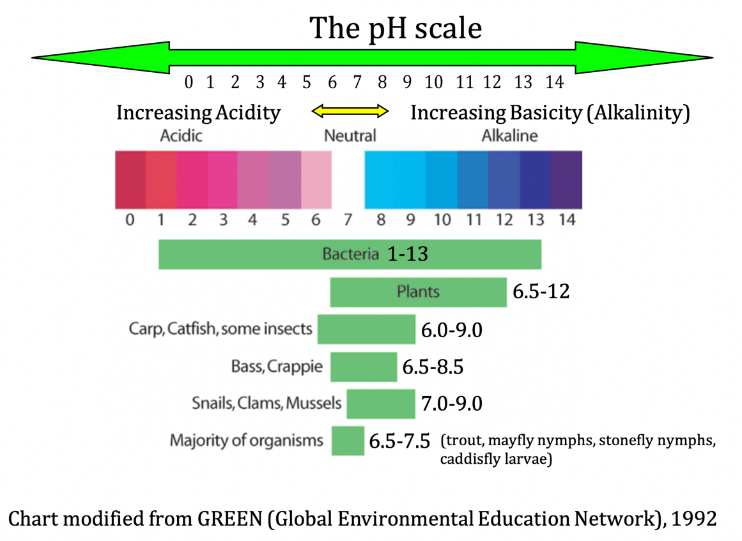
Next, review water quality standards with your students…

Water Quality Standards: Water quality experts developed water quality standards using the terms excellent, good, fair, and poor. These are qualitative measures of water quality across all tests; whether you are measuring for pH or other water quality tests, the four qualitative terms are used. Excellent and good indicate that the stream is in the neutral range and healthy, with excellent being better than good. Fair and poor indicate that pH is too acidic or basic meaning the results are problematic for aquatic organisms, with poor being worse than fair. Excellent and good standards mean that for that water quality test the results are positive. Fair and poor results indicate that problems.

Here are the pH standards:
pH Water Quality Standards | pH Range
Excellent - neutral | 6.5-7.5
Good - neutral zone | 6.0-6.4 or 7.6-8.0
Fair - too acidic/basic | 5.5-5.9 or 8.1-8.5
Poor - too acidic/basic | Below 5.5 or Above 8.5

Various tools are available for collecting pH data. Show students the tools they will be using to collect pH data.
pH tools and other water quality testing options:
Scientific probes, pH paper, or pH kits can be used to measure pH. Two companies, Pasco Scientific, https://www.pasco.com, and Vernier www.vernier.com/ sell a variety of probes that may be used throughout this curriculum. Probes are now wireless and data can be sent to cell phones, tablets, or computers. pH paper may also be used and may be obtained from various companies that supply science equipment and chemicals. pH kits, along with a variety of kits for other water quality testing, may be obtained from companies such as Hach, https://www.hach.com or LaMotte, http://www.lamotte.com/en/education/water-monitoring/5870-01.html

2. Plan in-class investigation (~25 min)
Purpose: Assist students to conceptualize and plan an in-class investigation to test the pH of everyday substances used outside.
Ask students - If they were to go outside today and test the pH of the water, would they be able to know what the results mean for the water quality and organisms? Students should be able to connect the pH number they would obtain to both the pH chart and to the pH water quality standards. For example, if the pH was 7.3 that would mean that the largest variety of organisms would be able to live in the stream because based on pH, the stream would be excellent according to water quality standards. For example, trout and mayfly nymphs need a pH between 6.5-7.5 so they could live in a stream with a pH of 7.3. On the other hand, if the stream’s pH was 8.7 only plants and bacteria could live in the water with a poor water quality standard. This is because plants can live in a pH range of 6.5-12 and bacteria can live in a pH range from 1-13.
Students should know WHAT the pH results mean for organisms, but ask them if they would know WHY they got those results? What might be the reason for the results? Ask what could be done in class that would provide students with some insights that would allow them to infer why the stream’s pH might be acidic or basic?
The goal is to assist students to figure out that they can test everyday products that people use outside that could get into the stream in large amounts. Students are not used to conceptualizing and designing their own investigations so this is not an easy task for them. They will need guidance and support. Nudge students to think about the reading. Hopefully, a student will suggest testing products. If not, you can suggest, “What do you think about testing the pH of everyday substances used outdoors?”
Brainstorm a list of possible products. Let students know that in order to test for pH, products must be in solution (in water). Some products are already in solution like Windex. Other products, like fertilizer, will need to be put in water. Students may suggest dirt. Although found in nature, dirt can enter streams because of human activity such as during construction when dirt can runoff into waterways. Or if people cut down trees, roots no longer hold the soil so loose dirt could enter a waterway.
Substances used for the pH investigation will be used again, in Lesson 6, for an investigation involving dissolved solids (the conductivity water quality test). To test pH, products must be in solution. Students may suggest products that do not dissolve. For now, that’s fine. These products will be discussed during the lesson on turbidity (suspended particles).

Here are common products:
Fertilizer (test more than one as different fertilizers can have different pH’s), Windex, windshield wiper fluid, antifreeze, dish soap (people often use to wash trash cans), car wash soap, vinegar (people clean windows), road salt, dirt, tap water, murphy oil soap (used to clean people’s decks). Collect rainwater if you can (acid rain?). Also test tap water (people hose off driveways, have sprinkler systems, and mix products with tap water). Think about testing products that are advertised as earth friendly. Avoid dangerous chemicals like insecticides. Avoid car oil - it does not have a pH and it ruins the pH probe.

Once you have generated a list of products ask students about their ideas of how to set up the investigation. Students can generate ideas of how to set up an investigation as well as the procedure for conducting the experiment. One potential guide sheet is included. Discussion should include keeping everything the same (controlling variables) except for the product that will be tested.
Options: pH Lab setup and experimental procedure

Students can work in small groups to generate ideas. You can discuss ideas as a whole class. Small groups will extend the lesson. Regardless of your approach, everything needs to be controlled except for the product. In the end you should settle on one lab set-up and procedure.

Date Recording Options
Option 1. You may want students to create a “sloppy copy” data table with partners. You can ask students what should go into the data table or simply let partners draw their ideas and then have a few students draw their tables on the board. The class can critique the tables and then pull the best ideas together to create a final version. Not only do students want columns for the substances and the results, they should also include a column for predictions. Additionally, both prediction and result columns should be subdivided into a space for a number and for the matching text. For example, if a student predicts a product has a pH of 12, that would be strongly basic. This will provide students with experience in using the pH scale to better understand how it works. If completed in class, it will extend the lesson.
Option 2: You may ask students to generate ideas of what should go into a data table during class and then have students complete a data table for homework. Option 3: You can supply students with a data table - included below and with the unit, Lesson #3.

You will need to conduct the investigation:
Labeled containers: If you have beakers great, but clean tennis cans work well. If putting in water, use distilled water. Same amount of water (500 mL). Same amount of product. Ask students how much product to mix with the water. Students may suggest a couple of tablespoons, a cup, ½ cup etc. Try to come to consensus. If you teach several classes you can make a couple of batches where 2 or 3 classes share. A picture of a set up may be found in Day 2 of the lesson.

Concluding the lesson (~5 min)
This concludes day one of the three- or four-day lesson. Ask students to summarize today’s lesson. We explored pH and its importance to water quality. We’ve now designed an investigation to test the pH of everyday products that people use on the land. Once we test the pH of our stream, knowing the pH of everyday products can help us to figure out why our stream has a certain pH. Let students know that you will be setting up the materials for the investigation that will take place during the next class.

Homework: The homework depends on your approach to the data table. You may want students to create a nice data table for homework. A data table for the investigation is provided.

Day 2: Test pH of everyday substances
1. Investigating the pH of everyday substances (~30 min)
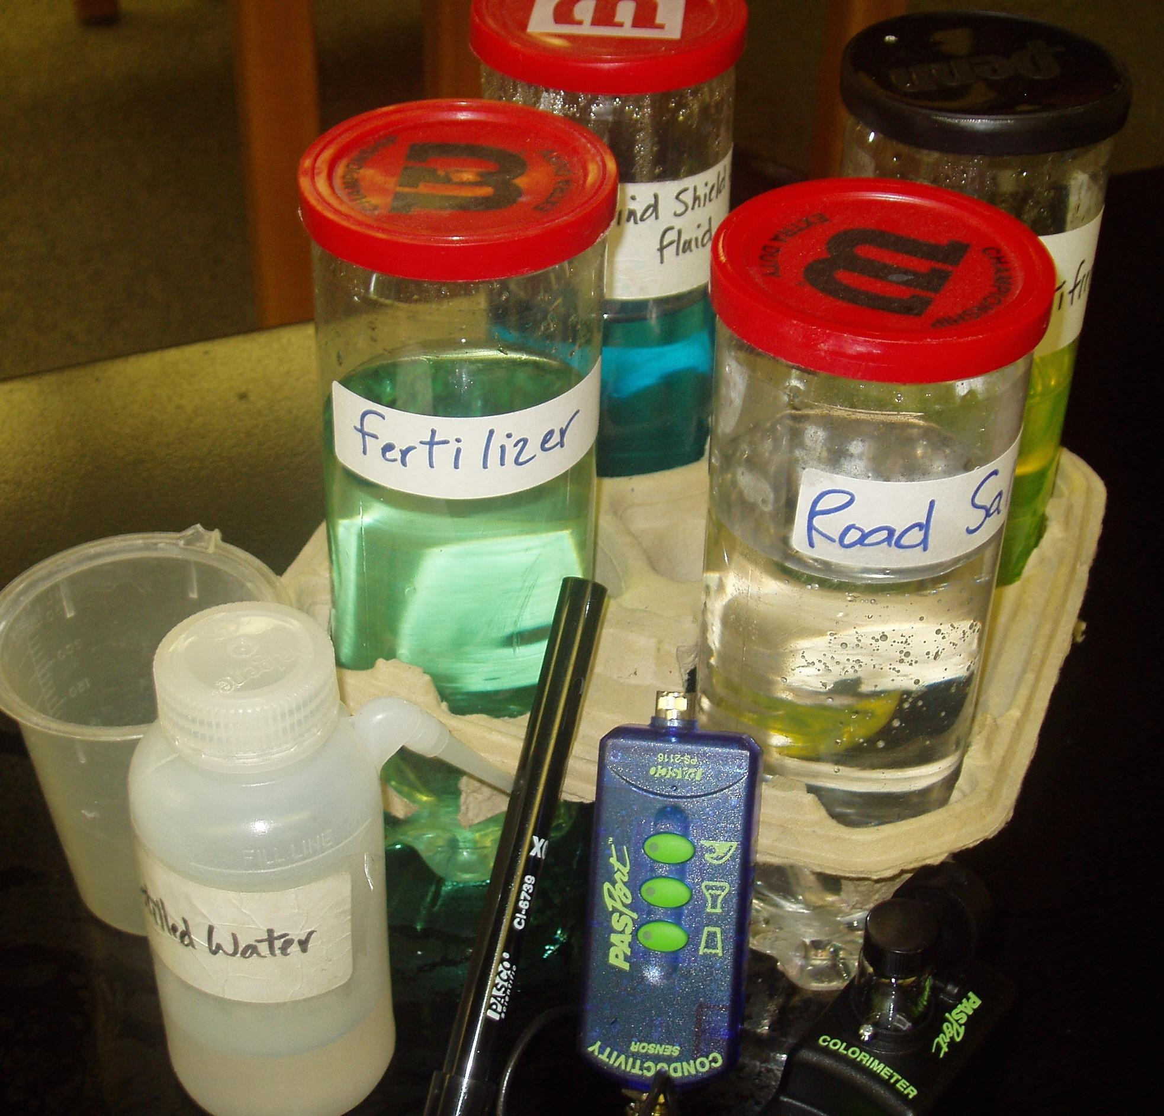
Purpose: Gain insight into the pH of everyday products that could impact water quality
Begin by reviewing yesterday’s class: You can begin by asking students to summarize what was done in class yesterday - we started to investigate pH and designed an investigation to test the pH of many products. We know that products people use on lands can runoff into waterways.
Let students know that, based on yesterday’s planning, you have put various products in tennis cans for testing (see picture). Discuss the testing procedure with students. Have a list of all of the products on the board.
Tips:
1. 500 mL of the various products are placed in labeled tennis cans. The tennis cans are then placed in cup holders from fast food restaurants. This helps to avoid spillage.
2. A container of three or four products may be placed at each table, along with a spray bottle of distilled water for cleaning off the probes for use between each substance. This is to avoid contamination.
3. If students are using pH paper, they may simply dispose of each slip after one use in a container placed on the table.
4. You can decide if students will test only the products at their table and then share results or if student groups will move from table to table to test all of the products.
Credit: Ann M. Novak

Pass out data tables for each student. A data table is included below. If students created their own data tables for homework, ask students to take out their tables. Ask students to write the names of the products in the far-left column. Discuss the table with students pointing out that there are columns for both predictions and results. These are subdivided into boxes for numbers and text. Explain to students that they should use the pH scale that is at the top of the data table to help them as they predict the pH of the substances. They should record their predictions, both the number (i.e. 8.5) and the text (i.e. weak base) in the appropriate boxes. Students should both predict and record their numbers to the nearest tenth.
This is an opportunity to further discuss quantitative and qualitative measurements that were introduced in Lesson 2.

Datasheet for pH of substances lab (available as a separate document)
Are everyday products people use outside acidic, basic, or neutral?

We know that products we use on land can run downhill into storm drains or down a hill and end up in streams. If we test the pH of everyday products it can help us to understand why we might get the pH results when we go out to the stream to test for pH. Fill in each box. Use the pH scale provided to help you with your predictions and results. An example is provided.

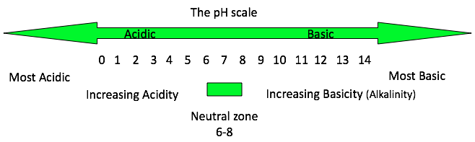
pH Data
Substance | Prediction  # acid, base,  neutral | Results  Trial 1 | Results  Trial 2 | Results  Trial 3 | Result  Ave | Result: Acid, base, neutral
Antifreeze | 2 strongly acidic | 8.9 | 9.1 | 9.1 | 9.0 | Weakly basic

Datasheet rows continue…

Student groups will now test the products. Ensure that each student wears goggles. Group sizes will depend on your equipment. Smaller groups will allow all students to test. They should take turns. Be sure to stress to students that they need to rinse the probe between products. They should test each three times to ensure the results are consistent. They may record the average or the most consistent number.

2. Engaging in Sense-making: sharing and discussing pH results (~15 min)

Purpose: Students gain insight into the relationships between what products people use on land and their potential impact on water quality. Students share data to look for discrepancies and patterns in the data. Students will then build from this sense-making activity to continue to make sense of the pH of a fresh waterway and its relationship to its suitability for freshwater organisms as they construct a scientific explanation.
It is important to share the data. First, it allows the class to see if the data is consistent. If one group’s numbers are continually different from others than you may need to check that probe. Next, it allows students to identify patterns. One important pattern for students to identify is that most cleaning products are basic. Some fertilizers are acidic, while others are more neutral or basic.
Encourage students to discuss the various products that they tested. Ask students if there are products that could negatively impact a stream’s pH if they were to get into the waterway in large quantities? Students should use the chart from the pH Student Reader. Pick one example of a product to discuss as a class. For example, Murphy Oil soap has a pH that is around 10. Ask students, if a stream has a pH of 10, what are some examples of organisms that would die and other organisms that could live? What pH range do these organisms need?
Because of the dilution process it is important to avoid suggesting that if Murphy Oil flows into a stream that it will cause the stream’s pH to become 10.

Snails, clams, and mussels need a pH between 7-9 so they could not live in a stream if the pH was 10. Bacteria and many plants could live. Bacteria can live in a pH between 1-13 and plants live in pH ranges from 6-12.
Ask students if there are choices of products that could be used that would not have a negative impact on a stream’s pH?
Teaching extension: This is an opportunity for you to ask students to generate ideas of action steps that they and others can take to decrease the possibility of unintentionally contributing acidic or basic pollutants. Ideas include taking your car to a professional car wash. Here, soapy water goes down drains to the local water treatment plant instead of running downhill into storm drains that connect to waterways. If washing your own car, wash it on grass so it slowly seeps through the ground where the ground can naturally absorb the chemicals. Plant can live in basic environments so grass can act as a Riparian buffer. When washing trash cans or a deck, choose earth friendly products. Decreasing the use of fossil fuels would also help prevent the formation of acid rain.

Concluding this part of the lesson: Let students know that in learning about pH and freshwater bodies of water they have engaged in many of the same activities as professional scientists: they have asked a question (Are everyday products people use outside acidic, basic, or neutral?), designed and carried out an experiment to investigate the question, and engaged in sense-making to analyze their results. Inform students that tomorrow they will use their knowledge by engaging in a scientific practice – constructing explanations – an important practice utilized by professional scientists to understand and explain phenomenon.

Day 3: Introduce scientific explanations
1. Assessing students learning so far: Introducing Scientific Explanations (~30 min)
Purpose: Introduce scientific explanations to students by relating the pH of everyday substances to freshwater organisms. For this explanation, students will choose one product and use the pH of that product to construct an explanation about organisms living in a stream with a similar pH.
Later in the unit, students will develop explanations to determine water quality of a stream or other waterway based on results from water quality tests. Begin by telling students that, in addition to designing and carrying out experiments, scientists carefully and thoughtfully look at evidence and develop explanations where they make claims based on evidence that use science ideas to explain phenomena. Students too, will use science ideas to answer a question using appropriate evidence. Next, introduce the Explanation framework (McNeill & Krajcik, 2012): claim, evidence, reasoning, and rebuttal to students and define each term. This framework is often referred to as the CER framework (claim, evidence, reasoning).
Explanations in English Language Arts

Common Core State Standards (2010) states that students should be able to “write arguments to support claims in an analysis of substantive topics or texts, using valid reasoning and relevant and sufficient evidence.” Such standards make clear that the abilities to develop and support claims are key competencies in ELA. For more information about connections to ELA, see Connections to Common Core State Standards (NGAC and CCSSO 2010) in the overview.

Students may be familiar with scientific explanations from earlier experiences or they may be new to students. Here are the components of explanations:
    - Claim: A claim is a statement that answers a question or is a conclusion to a problem. A claim reflects accurate relationships between variables. In this explanation, students will make a claim that relates the pH of water, based on the pH of a product people use on land, with organisms’ ability to live in that water.
    - Evidence: The data, both quantitative and/or qualitative, that backs up the claim provides the evidence for the explanation. This evidence needs to be scrutinized in two ways. We must ask ourselves:
      - Is the evidence sufficient? Is there enough to back up the claim?
      - Is the evidence appropriate? Is it valid? In other words, does it relate to the claim?
    - Reasoning: For reasoning, science ideas must be used to discuss why the evidence counts to support the claim. Reasoning ties together science ideas with evidence to explain what it means and how it backs up the claim.
    - Rebuttal: A rebuttal considers and then rules out an alternative explanation. It can also consider and rule out a science idea that might be used in reasoning why something occurred.
For the explanations students construct in this lesson, they will focus on claim, evidence, and reasoning. Later in the unit, after water quality data, students will include a rebuttal. For this explanation students will choose one product that was tested during the pH lab. They will make a claim that answers the question, If a stream has the same pH as the pH of their product could organisms live in the stream? They will need to support this claim with evidence. This is a fairly simple explanation that introduces students to the framework so there will be only one piece of evidence, quantitative evidence will include the name of the product and its pH. They will use the pH lab results for their evidence. Reasoning includes science ideas that will discuss why the evidence supports the claim. Science ideas include 1. whether the pH number is acidic, basic, or neutral, 2. how the product might enter the waterway, and 3. if the stream’s pH was this number what organisms could and could not live in the waterway including the pH range these organisms need. They will use the chart, the Range of pH that different organisms can tolerate, from earlier in the lesson. Because of dilution, be careful to explain to students that they should avoid saying that the product will cause the stream’s pH to become the pH of the product. Emphasize the language: IF the stream has the same pH as _____ . Below is an example of a possible explanation.
Teaching strategies: 1. You could share this explanation prior to students writing their own explanation to support them in understanding the components of the explanation. 2. You may want to have students first write their own explanation and then show them this explanation. They could then critique their own explanations and rewrite them. 3. Students could write explanations and share them with partners. After critiquing each other’s explanations, you could share the example and then have students rewrite their explanations. 4. Students could write explanations with partners.

pH Explanation related to streams and products (example)
Few organisms could live in a stream if it has a pH that is the same as car wash soap. (claim) Car wash soap has a pH of 9.0 (evidence). Car wash soap is weakly basic and can enter streams through run-off where the soapy water runs downhill and into storm drains. Storm drains are connected to various waterways, including streams. If a stream had a pH of 9.0 then many organisms would die. For example, Bass, Bluegill, and Crappie would die because they live in a pH range between 6.5-8.5. Most organisms (trout, mayfly nymphs, stonefly nymphs, etc) would also die because their pH range is 6.5-7.5. Bacteria, however, could live in this range because they can live in a pH range from 1-13. Plants can live in a pH range between 6.5-12 so they would also be able to live in a pH of 9. (reasoning)
Once students have completed their explanations you have several options. You can ask a few students to share their explanations and have the class critique each explanation. You can collect and assess student work on your own, providing students with feedback related to both the framework (Did they include a claim, evidence, and reasoning?) and with accuracy of all three components. In either approach (and you may wish to do both), stress to students that they are novices in constructing explanations and that this explanation introduced them to how explanations help to further develop understanding and to explain phenomenon, in this case, organisms in fresh waterways and their relationship to what people do on land that can impact the water’s pH.
Concluding the entire lesson: This concludes the three- or four-day lesson. Let students know that they should now be able to test their stream water and understand what the pH numbers that they obtain mean: whether the stream is acidic, basic, or neutral and what types of organisms can live there and what types cannot according to water quality standards - understanding the relationship between the pH of the stream and the quality of the water for various populations of organisms. They now also have some insight into possible products that people use on land that might account for the readings that they obtain. For example, if their stream’s pH is 9, they can rule out the substances that they tested that were acidic. This will continue to assist students to see the relationship between products people use on land and the impact on a waterway’s pH.
Understanding the idea of relationships, how one variable affects another variable (how the two variables are related) is an important crosscutting concept and is key in constructing explanations and developing models of phenomena. Introducing the idea of relationships here will begin to lay the foundation for student work in lessons where they write explanations and/or create models of their stream.

Let students know that tomorrow we will test the pH of the stream (or whatever phenomenon you are using). If going outside, remind students to dress appropriately for the weather.

Homework: Students will write a prediction about the pH of the stream. (~5 min)
Predictions will include four parts:
- A pH number along with the corresponding text (ie. I predict the stream will have a pH of 8.5 which is basic).
- The standard for their prediction (Excellent, good, fair, or poor)
- A statement about the types of organisms that can live (all, many, some, very few) that matches the standard
- At least one reason for their prediction.

Here’s an example:
I predict the stream will have a pH of 5.3 which is acidic. This is poor according to water quality standards so very few organisms can live in it. I’m predicting this because we tested fertilizer in class and it had a pH of 4.2 and I think lots of people are using fertilizer around here because I see nice lawns.
You will decide if students will write their prediction in a notebook, on paper, or in the online lesson.

Day 4: Collecting pH of your water body
1. Investigating the pH of the stream (~30-45 min)
Purpose: Collect the first piece of water quality data – pH.
Begin by asking students to share their predictions. Another option is to collect data first and then share predictions. Provide students with instructions for data collection. Below is one possible data table for students to use.
pH of fresh water body datasheet (available as a separate document)
pH of the stream | Observations of substances or conditions that could impact the stream’s pH
Trial 1 _____  Trial 2 _____  Trial 3 _____ Average __________ | In the water:  Near the water:  Recent Weather:

Recording the weather is important because rainwater can pick up pollutants and carry them to waterways either through storm drains or simply by running downhill.
Groups:
Based on your phenomenon, equipment, and student population, you will need to decide how to group students. Ideally, student groups are 3-4 students and each group has its own stream section where it will collect data for each water quality test.

Data collection options: If your stream is nearby and you can collect data in one class period that is ideal. Students should test three times to ensure accuracy. They could also test in different locations within their stream section. If needed, water samples from a stream could be brought into class.

2. Engaging in Sense-making: Sharing and discussing pH results (~5-15 min)
Purpose: Students share data to look for discrepancies and patterns in the data.
You may want student groups to write their results on the board. If there is an outlier, this group may want to re-test. There could be other plausible factors that influence student results based on the location of where they tested in relation to the land. Students may work in groups to focus on these questions:
- According to your results is the stream acidic, basic, or neutral?
- How healthy is the water’s pH for organisms?
- What water quality standard do your results convey (excellent, good, fair, or poor) for pH?
- What types of organisms could and could not live in the stream based on your results? Use the pH chart to assist you.

This may be followed up with a class discussion.
A comprehensive data table is provided for students to record data from the water quality tests that they conduct during the project. Students may now fill in the information about pH in that table.
Water Quality Test Results
How Healthy is our stream for freshwater organisms?
How do our actions on land potentially impact the water?

Organize your results from all of the water quality tests into one data table below. Notice the far-right column labeled Observations. Record any information that you may have observed in or near the water that might help you determine what caused the results you obtained for that test.

Results of all WQ tests datasheet (available as a separate document)
Name of Water Quality Test | Results | Water Quality Standard | Observations
pH

Concluding the lesson: (3-5 min) This concludes the three or four-day lesson on pH. Let students know that pH is the first water quality measure. Connect pH to the Driving Question Board. This may include the overall results (acidic, basic, or neutral as well as an overall number). Check to see if any of the student questions were addressed with this lesson. You may add other ideas to the DQB.

Connect to the driving question, “How healthy is our stream for freshwater organisms and how do our actions on land potentially impact the stream and the organisms that live in it?” Ask students if they feel confident to answer the driving question and make overall conclusions about the stream’s health for supporting organisms. Relate this back to the basketball analogy. Was seeing that the person was a good free-throw shooter enough evidence to make a claim that she could succeed as a college basketball player?

The stream phenomenon is a complex system. pH is only one measure of the quality of the water. We want to gather more evidence. We will now look at a second measure of water quality related to temperature to see if the water’s temperature is suitable for organisms.

Homework: Students will complete the student reader, “Is the stream too warm for freshwater organisms?” Students apply their understanding at the end of the reader by completing questions related to thermal pollution. You may decide to have students wait to complete these questions until after you have discussed thermal pollution in class. The reading follows. The reading is also found as a separate document in Lesson #4.

pH PowerPoint

Lab setup, pH of substances
Data sheet, pH of substances
Data sheet, pH of freshwater body
Data sheet, results of all water quality tests
student reader - pH
student reader - pH - key

Student Reader: Temperature
Student Reader Key: Temperature

LESSON #4: Temperature - Is our stream too warm for freshwater organisms?
Lesson question: Is our stream too warm for freshwater organisms?
Overview: In the previous lesson, students explored pH, the first water quality measure. In this two-day lesson, students explore thermal pollution, a second water quality measure of a stream’s health. Through a student reader and class discussion, they are introduced to thermal pollution, what the temperature test measures, and the causes and consequences of thermal pollution. Students then test the water quality of their stream and have insight into whether or not the stream has thermal pollution and is healthy for freshwater organisms based on the temperature water quality measure. They end the lesson having two pieces of evidence, pH and temperature differences to begin to decide the overall health of the stream to support aquatic organisms.
NGSS Performance Expectations for Unit: PE: MS-LS2-4, PE: MS-LS2-1, PE: MS-ESS3-3
Learning Performances:
LP6: Students collect and analyze data to explore the relationship between people’s actions on land, the temperature of the stream, and the quality of the water for various populations of organisms.

Safety Guidelines: Students should be careful to avoid falling into the water.
Preparation:
Time: 2-3 days
Materials:
temperature probes or thermometers
data sheet - temperature of freshwater body
data sheet - results of all water quality tests
Student Reader: Temperature
Student Reader Key: Temperature
Assessment: Temperature
Assessment Key: Temperature

Day 1: Thermal pollution and thermal pollution standards
1. After Reading: Probing for understanding. (~30 min)
Purpose: To assist students to explore the relationship between the temperature of the stream and the quality of the water for various populations of organisms. Discuss main ideas about thermal pollution and its importance for water quality and how people’s actions on land can cause thermal pollution of waterways.
Background

Prior Knowledge: By middle school students should understand that temperature is a measure of how hot or cold something is. They should be familiar with a thermometer.
Here are elements of the DCI that are introduced in this lesson.

- Human activities have caused thermal pollution of waterways, can significantly alter the biosphere, sometimes damaging or destroying stream habitats.
- Organisms, and populations of organisms, are dependent on their environmental interactions both with other living things and with nonliving factors.

Thermal pollution is an abnormal temperature increase. It is a very different type of pollutant in that it is not “stuff” that gets into waterways but rather a transfer of energy that results in a temperature increase.

There are four Causes of Thermal Pollution that are related to people. Each is discussed in the Student Reader. They include, 1. hot surfaces, 2, macro particles, like soil, that absorb heat if in water, 3. factories that dump hot water into waterways, and 4, cutting down trees that provide shade to waterways.

In addition to the four causes of thermal pollution discussed in the student reader it is important to discuss the weather and season with your students. In cold climates, it can be very sunny with no chance of thermal pollution because it is too cold for surfaces to heat up or particles in water to heat up. So while the conditions of surfaces and particles are potential causes for students to note, students also need to be aware of weather as a crucial condition as well.

There are four Consequences of Thermal Pollution, also articulated in the student reader. They include 1. Fish dying, 2. Algal blooms, 3. Potential for less oxygen, and 4. Weaken organisms that are more vulnerable.

The reading introduces students to what temperature, as a water quality test, measures and the causes of thermal pollution and consequences to organisms and the ecosystem. Through discourse, ask students what the temperature test measures (thermal pollution) and what is meant by thermal pollution. It is important for students to understand that we are not interested in the specific temperature of a waterway, but rather the temperature difference between two locations. Reinforce what is in the reading. Stress that thermal pollution is an abnormal temperature increase (not decrease), that of course water temperature increases during the summer and decreases during the winter - this is normal. That of course waterways in Florida will be warmer than waterways in Michigan or Alaska - this is normal. Thermal pollution means that the stream suddenly becomes abnormally hot. It is a very different type of pollution because it isn’t “stuff” like students are used to thinking about when it comes to pollution.
Use the reading to ask students to discuss the four causes of thermal pollution. Follow this with the four consequences of thermal pollution. You may want students to be in small groups or conduct this as a class discussion.
Optional activity: Heating various surfaces to measuring temperature. You may set up several heat lamps. Put one over a roof shingle, another over a chunk of asphalt, a patch of grass, etc. Put the heat source the same distance from each surface. Heat for several minutes. Turn off the lamp and measure the temperature of each surface. The human-made surfaces will be much hotter than the grass. This will lead to a discussion of one of the causes of thermal pollution – heating of surfaces.

2. Measuring thermal pollution and thermal pollution standards (~10 min)
Purpose: Show students how to measure temperature and calculate for thermal pollution. Introduce students to water quality standards for thermal pollution.
Water Quality Standards: Just as with pH, water quality experts developed water quality standards using the terms excellent, good, fair, and poor to identify if fresh waterways have thermal pollution. The standards reflect recording temperature at two different locations that are not close to each other and subtracting to get a temperature difference. Excellent and good indicate that the stream has no thermal pollution, with excellent being better than good. These temperature differences are the result of natural occurrences such as differences in stream depth or shade versus sun. Fair and poor indicate thermal pollution meaning the results are problematic for aquatic organisms, with poor being worse than fair.
Here are the standards for Thermal Pollution:
Temperature Water Quality Standards | Temperature difference  (in °Celsius change)
Excellent - no thermal pollution | 0-2⁰
Good - no thermal pollution | 2.1-5⁰
Fair - thermal pollution | 5.1-9.9⁰
Poor - thermal pollution | Above 10⁰

Provide students with practice calculating temperature differences. For example, tell students that temperature data is collected at Point A with a reading of 13.8^{0.} Point B has a temperature of 12.2⁰. Ask students what the results mean in terms of the temperature water quality test? How do they know? What do the results mean for freshwater organisms?
Students should subtract 12.2⁰ from 13.8⁰ to get a 1.6⁰ temperature difference. Since this falls in the 0-2⁰ temperature change category it means that there is no thermal pollution, with an excellent water quality standard, and that according to the temperature test, the water quality is excellent for freshwater organisms.
The student reader includes two examples at the end for students to complete. If they haven’t completed them yet, have students complete these. Students could complete them with partners. Discuss responses.
Teaching tip: It is easy for students to confuse the actual temperature, 12.2⁰ in this case, with a temperature difference. Providing students with multiple examples will help them to understand.

Let students know that experts measure the temperature at two different locations, separated by one mile, and subtract to get the temperature difference. They then use the standards to determine whether or not there is thermal pollution.
Chances are good that you will not be able to measure one mile apart. You will need to determine what students will use as their comparison. For example, inform students that they will measure the temperature in the stream at the same location that they measured pH. They will then go to a spot further away and measure again for their comparison. This can be completed at another group’s section that is farthest away or another point that you predetermine.

Data may be collected using a temperature probe or a thermometer.
Concluding the lesson: This concludes day one of the two-day lesson. Let students know that they should now be able to test their stream water and understand what the temperature differences that they calculate mean - whether the stream has thermal pollution or not - and its implications for stream life. They also have some insight into the four causes of thermal pollution and should think about whether or not any of these potential causes could impact our stream. This will assist students to see the relationship between people’s land use practices, thermal pollution, and the impact on a waterway’s temperature. They should assist students to understanding the relationship between the temperature differences of the stream and the quality of the water for various populations of organisms.

Emphasizing relationships is key in developing models and constructing explanations. Continuing to build on it here will assist students in the next lesson and future lessons where they create models and explanations of the stream.

Let students know that tomorrow we will test for thermal pollution of the stream (or whatever phenomenon you are using). If going outside, remind students to dress appropriately for the weather.

Homework: Students will write a prediction about thermal pollution of the stream. (~5 min)
Predictions will include four parts:
- A temperature difference number along with the corresponding text (ie. I predict the stream will have thermal pollution with temperature differences of 7⁰ Celsius).
- The standard for their prediction (Excellent, good, fair, or poor)
- A statement about the types of organisms that can live (all, many, some, very few) that matches the standard
- At least one reason for their prediction.

Here’s an example:
I predict the stream will have thermal pollution with temperature differences of 7⁰ Celsius. This is fair according to water quality standards so very few organisms can live in it. I’m predicting this because I see lots of sidewalks and roofs and I know these heat up when it’s warm outside.
You will decide if students will write their prediction in a notebook, on paper, or in the online lesson.

Day 2: Investigating temperature differences in your water body
1. Investigating temperature differences of the stream - measuring for thermal pollution (~30-45 min)
Purpose: Collect the second piece of water quality data - temperature differences.
Begin by asking students to share their predictions. Another option is to collect data first and then share predictions. Provide students with instructions for data collection. Below is one possible data table for students to use. The same student groups should collect data at the same locations

Data sheet, temperature of freshwater body (available as a separate document)
Temperature difference of the water body | Observations that could impact the water body’s temperature
Stream Temp farther downstream Difference between  (subtract the two)  Trial 1 _____ Trial 1 _____ __________  Trial 2 _____ Trial 2 _____ __________  Trial 3 _____ Trial 3 _____ __________  Average __________ | In the water:  Near the water:

Groups:
Based on your phenomenon, equipment, and student population, you will need to decide how to group students. Ideally, student groups are 3-4 students and each group has its own stream section where it will collect data for each water quality test.

Data collection options: If your stream is nearby and you can collect data in one class period that is ideal. This water quality test isn’t conducive to bringing in samples from a stream because the water samples will end up at room temperature. Students should test three times to ensure accuracy. They could also test in different locations within their stream section.

Day 3: Sharing and discussing temperature difference results
1. Engaging in Sense-making: sharing and discussing temperature difference results (~5-15 min)
Purpose: Students share data to look for discrepancies and patterns in the data.
You may want student groups to write their results on the board. You have two options.
- Option one: Students could report actual temperatures across the entire stream, writing them in order on the board. The class can then look at all of the actual data and see the highest and lowest numbers, subtract, to obtain the largest temperature difference of the entire tested area.
- Option two: Students write their temperature differences on the board and these can be compared.

If there is an outlier, this group may want to re-test. There could be other plausible factors that influence student results based on the location of where they tested in relation to the land.
Discuss the results, in small groups first if you like, and then as a class.
Students may work in groups to focus on these questions:
- According to your results is the stream thermally polluted?
  - If yes, what might be the cause?
  - If no, are there potential causes, but at this time they are not impacting the stream?
- Based on the stream’s temperature test, is it healthy for organisms?
- What water quality standard do your results convey (excellent, good, fair, or poor) for the temperature test?

This may be followed up with a class discussion.
Potential causes of thermal pollution may exist even though students’ results show no thermal pollution. For example, there are many surfaces in watersheds: roads, parking lots, sidewalks, roofs, etc. These surfaces can heat up. The weather will be an important factor in contributing to thermal pollution. If it is hot weather, surfaces heat up. If it’s not hot though, these many surfaces will not be hot. Particles in water also heat up, but if it’s been cool weather, these particles will not heat up. Another factor is rain. Even if it’s been hot, if there hasn’t been any rain hitting those hot surfaces and then running into storm drains then the water will not be affected. Sometimes a potential cause can be ruled out because it doesn’t exist. For example, if you do not have a factory located on your stream or creek, then you can always rule out factories dumping hot water as one of the causes, should your waterway have thermal pollution.

Students may now fill in the temperature results into the comprehensive data table.
Teaching extension: This is an opportunity for you to ask students to generate ideas of action steps that they and others can take to decrease the possibility of thermal pollution.

Assessing student learning: This is an opportunity to provide students with assessment tasks to see where they are in their learning about thermal pollution. An assessment and assessment key are provided:
Assessment: Temperature
Assessment Key: Temperature

Results of all WQ tests datasheet (available as a separate document)
Name of Water Quality Test | Results | Water Quality Standard | Observations
pH
Temperature Difference

Concluding the lesson: (3-5 min).

Connect the temperature test to the Driving Question Board. This may include the question for the lesson: Is our stream too warm for freshwater organisms? and the overall results (thermal pollution or no thermal pollution). Check to see if any of the student questions were addressed with this lesson. You may add other ideas to the DQB.

Connect to the driving question, “How healthy is our stream for freshwater organisms and how do our actions on land potentially impact the stream and the organisms that live in it?” Ask students if they feel confident to answer the driving question and make overall conclusions about the stream’s health for supporting organisms. Relate this back to the basketball analogy. Was seeing that the person was a good free-throw shooter enough evidence to make a claim that she could succeed as a college basketball player?

Remind students that the stream is a complex system. We now have two pieces of water quality data to use as evidence about the stream’s overall health. Let students know that tomorrow we will begin to develop models of the stream to help us figure out how healthy the stream is overall, based on what we know so far.

If you are going to wait until Lesson #10 to construct models then after discussing the basketball analogy let students know that we will continue to investigate the stream with another water quality measure and move to Lesson #6. For homework students could complete the Student Reader, “Does our stream have too many nitrates, phosphates or salt?” that can be found at the end of Lesson #5 as well as in Lesson #6.

Homework: None
data sheet - temperature of freshwater body
data sheet - results of all water quality tests
Student Reader: Temperature
Student Reader Key: Temperature
Assessment: Temperature
Assessment Key: Temperature

LESSON #5: How healthy is our stream based on pH and temperature evidence?
Overview: In the previous two lessons, students investigated two water quality measures, pH and temperature (thermal pollution). In this 2-day lesson, student groups develop a model of the stream system based on what they know now to assist them to figure out the overall quality of water for organisms. Modeling complex phenomena, like the water quality of streams, can support students in developing usable understanding of science ideas as well as in building understanding of the practice (Mayer & Krajcik, 2015). Understanding water quality involves using many causal relationships, so it is an ideal phenomenon for students to model. Students can also use their models to predict water quality if changes happen within the system. The lesson begins with a discussion of models: What are scientific models? Why do we want to create models? SageModeler, a modeling tool designed for student use, is introduced as an online computer modeling program. A simple, non-science model that connects to students’ everyday lives is built by the teacher to introduce students to the tool. Student groups are then asked to construct a model of the stream. This is a formative assessment that serves to provide both students and the teacher with information of where students are with their learning right now. This activity should also foster students’ continued development of their understanding of the DCI’s as well as modeling as an important scientific practice. CCC’s of cause and effect, systems, patterns, and change and stability are all integrated in the modeling process. In future lessons, as additional water quality tests are conducted, students will revise their models in order to have a more comprehensive model of the stream as a system.
Flexibility in the unit: If you are going to have students develop one model as a culminating activity of the unit you will combine Lessons #5, #7, and Lesson #10 at the end of the unit. You will skip Lesson #5 and move to Lesson #6.

Learning Performance:
LP7: Students develop models to explore how pH and temperature changes resulting from human activity affect water quality and the organisms that live in the stream.
Safety Guidelines: None
Preparation: Practice using SageModeler. Set up various classes on the Learning Portal
Go to the Concord Consortium Website to access the Learning Portal Users Guide for Teachers (https://learn-resources.concord.org/docs/teacher-user-guide-v1.1.pdf). This guide will assist you in setting up online accounts and classes.
Time: 2-3 days
Materials: A main computer and projection device. Computers for each group. Two students per group is ideal. If you have a computer for each student you may have students working in pairs with each partner on a different computer. Access to https://sagemodeler.concord.org.
student reader, dissolved solids
student reader, dissolved solids - key

INSTRUCTIONAL SEQUENCE

Day 1: Models and modeling with SageModeler
1. Assessing student prior knowledge. What do they know about models? (~ 5 min)
Purpose: Identify students’ prior knowledge of scientific models. Discuss the purpose of developing models.
Ask students what they think of when they hear the word models. Students often think of miniature representations of very large things (cars, digestive system, solar systems etc.) or large representations of very small things (atoms, cells, etc). Stress to students that scientific models are tools that help us explain or predict various phenomena. In order to be a scientific model it has to illustrate relationships between variables. Stress to students that in order for something to be a variable it has to have quantities that can change.
Background information: Scientific Models are tools that help us explain or predict phenomena. Models illustrate relationships between variables. Variables have quantities that can change.

2. Developing models of our stream - introduction (~5 min)
Let students know that we can create models of our stream. We can identify variables and set up relationships between the variables to explain the phenomenon of the stream. Our goal is to develop models of the stream system by representing various factors (variables) that influence water quality - we will begin by focusing on the first part of our driving question: How healthy is our stream for freshwater organisms?
Ask students, “What would the variables be in our stream models? What are components of a stream that can change? (pH level, amount of thermal pollution, amount of fish/water quality).
Let students know that we are going to use a modeling tool called SageModeler that allows us to plan a model, build the model, use the model by running a simulation, and then revise the model if it doesn’t “work” the way we think it should work. Why might this happen? Stress to students that SageModeler doesn’t have ANY content! The model builders (the students, in this case) develop the model. They can make a working model that is COMPLETELY wrong! It will still “work” though. WE are responsible to create a model that accurately includes science ideas, that accurately shows the relationships between variables, and that predicts and explains the phenomenon of water quality for organisms. That is why we will critique our own models and revise them as we develop them. We will also share our models to provide each other with feedback so that we can then revise our models. We have to view our model as a “work in progress” where we are open to suggestions to improve the model.
Emphasize that we will build our first version of the model based on what we know right now - our knowledge of pH and thermal pollution and their effects on water quality for fish and other aquatic organisms (in other words, their relationship to water quality which can be expressed as fish populations or the amount of fish). Once we learn about other water quality tests (measures) we will then add them to our current models. So we will expand and revise our models over the next couple of weeks.
3. Teacher demonstration of SageModeler (~15-20 min)
Purpose: Illustrate to students how to use SageModeler using a non-science example.
To open a new SageModeler document, log into https://sagemodeler.concord.org. You may also want to run the “Getting Started” tutorial by first clicking on “Open Document or Browse Examples.”

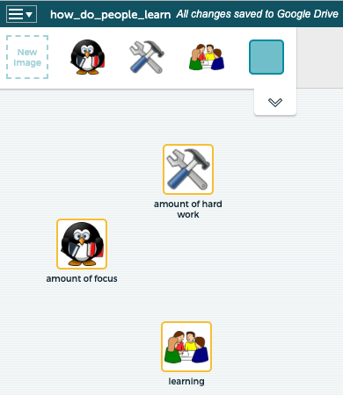
Say to students, “Let’s create a model to answer the question, “How do people learn?” We need to ask, “What does learning depend on - what variables contribute to learning?” Brainstorm with students to probe their ideas. Students may say how hard someone works and if they pay attention in class. Build from student ideas. “One variable is “learning” (the amount of learning) and learning depends on the following two variables: Hard work (the amount of hard work) and in-class engagement (how focused students are). These variables - learning, hard work, and in-class engagement - can change. Some days, for example, you may find that you are very engaged. Sometimes you may not work as hard as other times.”
First, we need to choose images to represent each of the variables: Learning, hard work, and amount of in-class focus. Remind students again, that in order for something to be a variable, it has to have quantities that can change. To add a variable to the canvas, drag a “New Image” to the screen. Here are possible images that are then labeled:
Next, set up the relationships by connecting variables together - hard work is related to learning, and in-class engagement is related to learning. To connect variables, drag the arrow icon from one variable to another. Both variables imply (and you should stress this to students) the amount of work and the amount of focus.
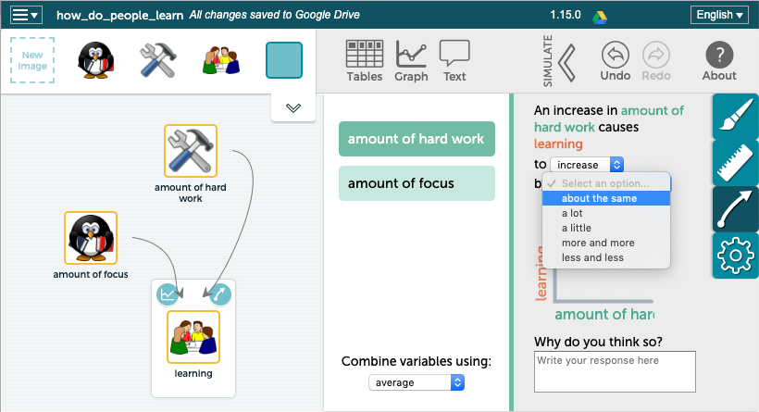
Follow this by defining the relationships between variables. Double click on a variable or its connection to bring up the relationship inspector. You can also click on the arrow icon. Have students use the text in the pop-up window as a guide to see if their relationship makes sense: “An increase in amount of focus causes learning to (increase/decrease/vary) by (about the same, a little, a lot, more and more, less and less).
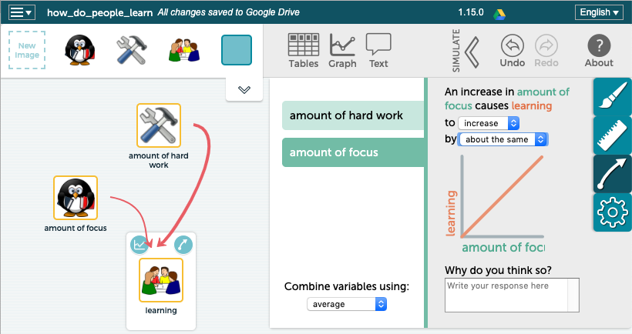
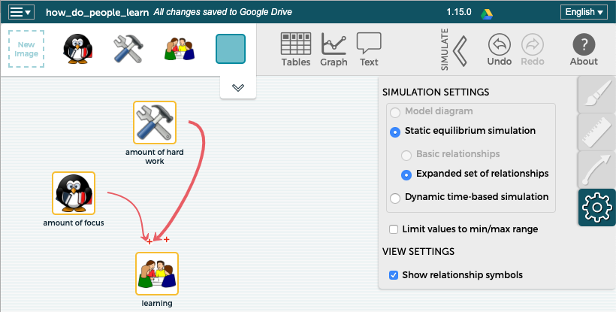
As you set up the relationships you will see red or blue lines that coincide with increase or decrease, respectively. Students can also fill in the “Why do you think so?” box. When they are developing their water quality model, this text box will prompt them to think about science ideas, particularly causes and consequences related to each water quality measure.
Go to the vertical toolbar at the far right and select the lowest icon to access the settings inspector. Select the “show relationship” symbols. This will add the “+” or “-” symbol (positive or negative) to the relationship arrow.

You are now ready to run your model. Click the SIMULATE arrow to view your model with sliders and bar graphs. Notice a sliding bar that now appears next to each variable, “focus” and “hard work.” These are independent variables. The bars may be manually slid up and down and will be reflected in the simulation where you can see the effect on learning, which is the dependent variable. The amount of learning depends on the amount of focus and the amount of work (hard work).
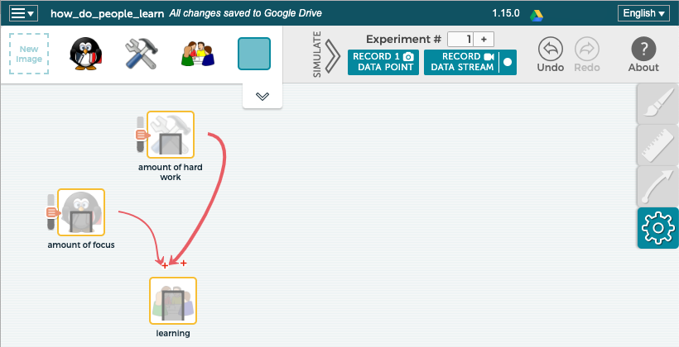

Now look at the top right and see two boxes: one is called Record Data Point and the other, Record Data Stream. These are under Experiment #1. You have the option of recording one data point at a time or to make a recording of several data points all at once. Choose Record Data Stream and move the sliding bars for focus and hard work up and down. A data table will appear that records the data. Look at the orange bars to see how changes in focus and hard work affected learning. What patterns to you notice?
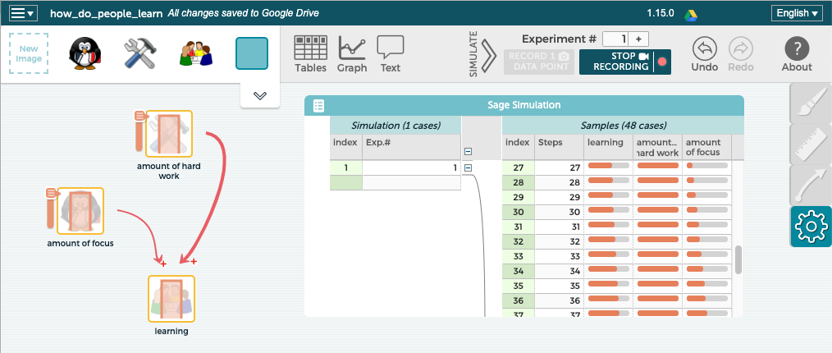
Another option is to display the data in a graph. Select the graph option from the top palette or a graph icon above any variable. You can click on any table header (variable) and drag it to a graph axis. For example, drag and drop the word, “learning” to the y-axis (it is the dependent variable) and “amount of hard work” into the x-axis (the independent variable).
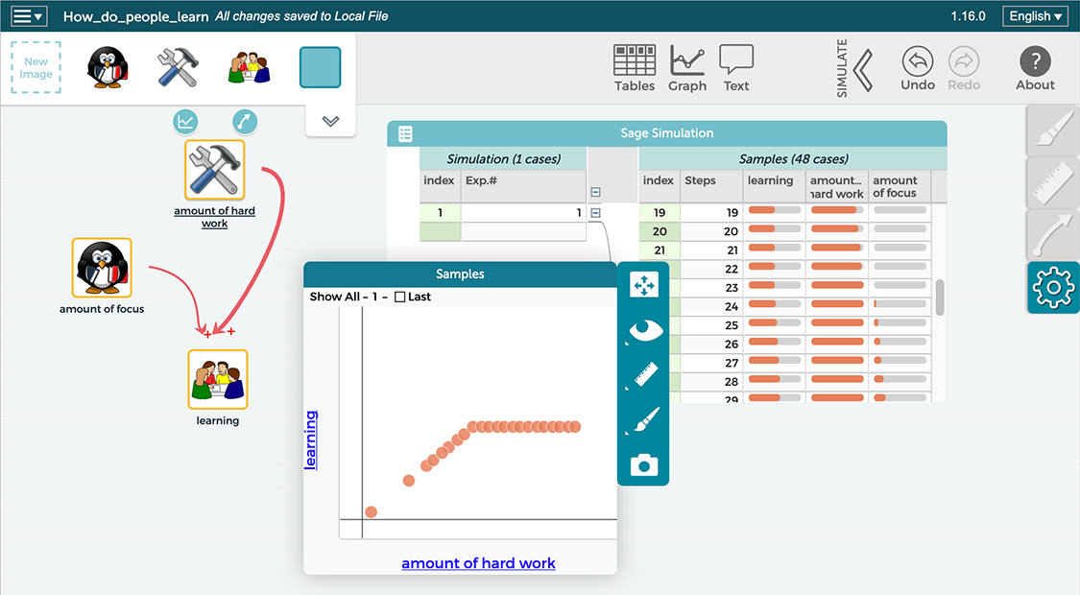

Notice that the graph shows changes to your sliders only, NOT change over time. This is an important distinction. When building a static model, you will always see results for ALL variables immediately. In this example above, “learning” rises for the first nine steps because it is correlated with the independent variable of hard work which we moved up during this part.
Link to this learning model:
https://sagemodeler.concord.org/#shared=97257
HINT: You can save or share a copy of any SageModeler file by clicking on the “hamburger” menu (3 lines) on the top left of the SageModeler canvas. If your students are working independent of Concord’s online activities, you will want students to share their files by sending you a shared link to their SageModeler files.

4. Student groups develop water quality models: Use the remainder of the class to have students start their water quality models. Students will continue to work on the models the following day.
Purpose: Students groups develop models of the stream system to show relationships between the pH and temperature measures of water quality and their impact on the health of the stream for freshwater organisms.
Developing water quality models will assist students to develop understanding of core ideas and crosscutting concepts as they are engaged in the scientific practice of modeling. The models also serve as formative assessment - feedback to both students and the teacher of where students are with their learning now.

This activity is ideal with groups of two students for each computer.
Launch SageModeler to create an initial model of the water quality of the stream based on what we know now using two measures of water quality: pH and temperature differences (thermal pollution).

Option 1: Using the learn.concord.org portal: Have students begin Activity 5, page 1 and follow directions. They will click on the interactive labelled, “How healthy is our stream based on pH and temperature differences?”

Option 2: Have students open SageModeler directly at https://sagemodeler.concord.org. Note that students will have save their work to Google drive or locally on a computer as well as send you a share link to their work.

Once in SageModeler

- Find pictures to represent the variables (pH, Temp differences, and health of the stream)
- Draw links between variables you think affect each other.
- Set the relationships between those variables.

Allow students to begin to work on their models. Encourage students to use the data from the two water quality measures. Students can refer back to the student readers and/or notes taken during class. Move from group to group. Some groups will need more support than others.
Making science learning accessible to all learners: Encouraging students to use their notes or to refer back to the student readers will assist to support all learners in their understanding of and use of the science ideas in their models.

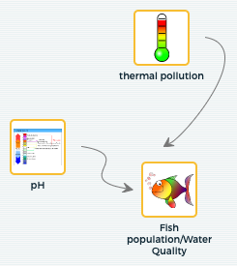
Encourage students to help each other. Some groups will work faster than other groups. Once they get their models working in the way in which they think accurately portrays the stream phenomenon, they can expand their models to include the causes of changes in pH and temperature; these are the variables that influence the water quality measures (which in turn affect the water quality of the stream). This connects to the second part of the driving question: How do our actions on land potentially impact the stream and the organisms that live in it?
Here is a possible progression of a basic model that students might develop. They may choose different icons than the ones here and that is fine.
This example is not meant for the teacher to create. Students should spend time in the planning and building phase and then run their models.

During the “Plan” stage, students choose variables and identify pictures to represent those variables. Even though it is labeled “thermal pollution” you should stress to students that this means the amount of thermal pollution; the range would be from none to high levels of thermal pollution. This idea of amount applies to all of the variables because there are ranges for each. Remember, variables have quantities that can change; otherwise they are not variables.
Students then make connections between the variables and define relationships between those variables during the “building” stage. Below is an example of the pH relationship tool. You can ask students about the relationship between pH and water quality. Students should choose the “vary” relationship and then draw a bell-shaped curve since the best pH would be 7, in the middle, and the water quality decreases as pH becomes acidic or basic (goes up or down).
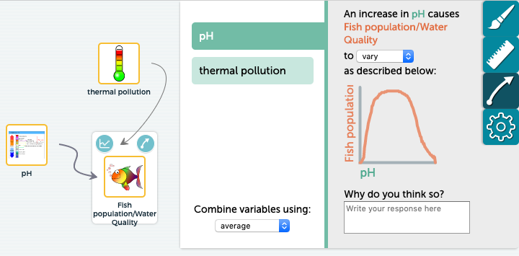

Students next identify the relationship between thermal pollution and fish population/water quality. A text box is available for students to explain why they have created that relationship. Having students use this feature will assist them to think more deeply about the ideas that will foster understanding. As well, it will provide you with more insight into their thinking as you assess their models.

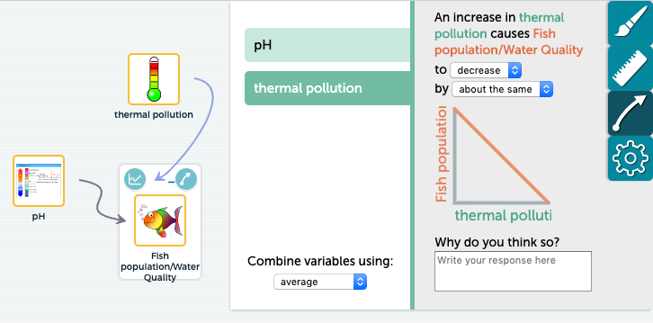

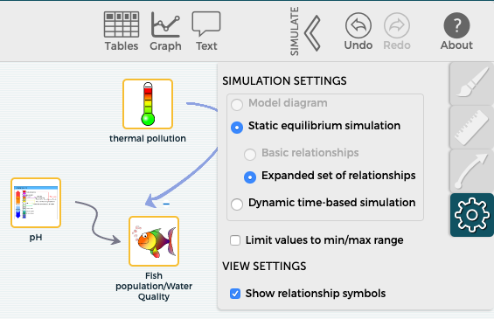
Students can click on the settings inspector (gear icon) to check off the “show relationship symbol” (see picture below) to get a visual indication that the relationship they created is accurate. Notice the blue line between thermal pollution and fish population has a (-) sign indicating that thermal pollution negatively impacts fish.

Here is a link to this model to this point: https://sagemodeler.concord.org/#shared=97507

Students can now “use” their models to run a simulation. Click the SIMULATE arrow. Notice that the independent variables (pH and thermal pollution) now have sliding bars that can be moved up and down. As the sliders are moved, the bar charts on the simulation icons also move. HOW they move depends on the relationship that was set up. Also notice at the top right, it says “Experiment #” and below are two buttons, RECORD 1 DATA POINT, and RECORD DATA STREAM. A data table automatically appears after pressing RECORD DATA STREAM and moving a slider. Again, these results are “static” – they show values for all variables as you change the independent variables, one step at a time. They DO NOT show change over time.

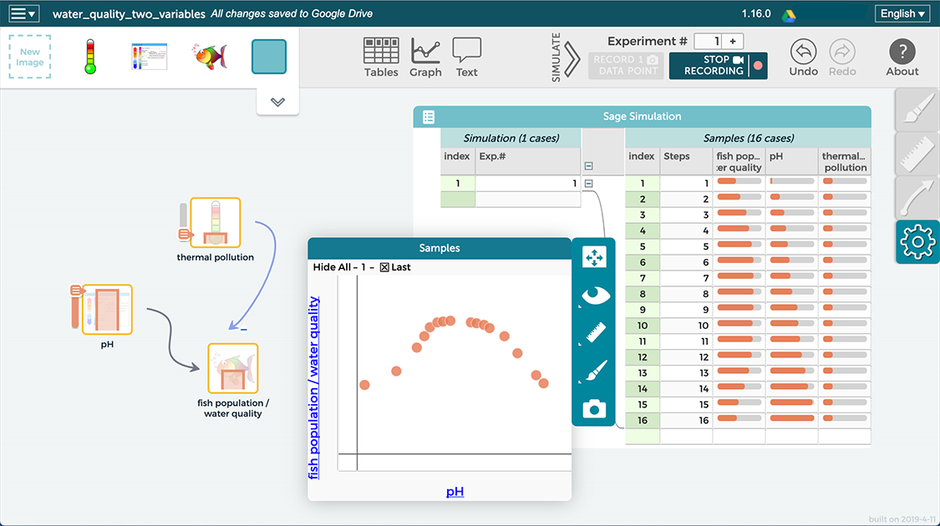

Students may also choose to “graph” their data by pressing the graph button at the top of the canvas or the graph icon near the top left corner of a variable. Since water quality (fish population) depends on the other variables, it is the dependent variable and should be dragged to the y-axis of the graph window. One variable (pH or thermal pollution) is dragged to the x-axis as an independent variable. Since the purpose of building the model is to model the combined results of all of the water quality tests, the table option may be more useful at viewing the entire water system.

In the simulation above only the pH slider was moved. You can see this in the table and the graph. As pH increased, you will see that the fish population increased to a point then dropped off. Is our model working as expected? As I increase thermal pollution, what do think should happen to my pH vs. water quality graph? These are the types of discussions you can have with your students. Students should test their models to see if their models “work” the way they think they should work. If not, students then revise their models, adding or removing variables or changing relationships (more and more, a lot, etc).

Discussion and Sense-making opportunities:

Purpose: To have students evaluate their models to see if they “work” the way that they think they should work.

Remind students that SageModeler has no content and they can develop models that “work” but do not accurately reflect the phenomenon. It is the responsibility of the students to evaluate their models. This process should further foster students learning about important science ideas, crosscutting concepts, and the practice of modeling. Students can use their notes when developing their models. There are several possibilities including the following suggestions:

- Using their models to predict water quality: Encourage students to use the sliders to put them to the position where the water quality should be the best. Ask them where they should put the sliders? (for pH the slider should be in the middle – 7, and for thermal pollution the slider should be the lowest; the lowest temperature differences are the best). In this way, students are predicting that the water quality will be high. Students can now run their models to see if their predictions match.

  - If they match, then students might conclude that their models work.

  - If they don’t match, students should think about why there is a mismatch. Do they need to adjust their models? Do they need to rethink their understanding of the science concepts?

- Observe what happens as they change one variable to see if it matches their thinking. Does the change in that variable affect the water quality the way that they think it should?

- Check all parts of the model. Test, evaluate, revise if needed, and retest.

It is often the case that students move at different paces. If a group or two completes their model, including running it and making sure it works the way that they think is accurate, you can have them expand their models to include the various causes for each of the water quality tests. These will be the variables that affect pH, and the variables that affect temperature differences. Encourage students to use the student readers to assist them. Students can choose images and define relationships between these. Here is a screenshot of what an expanded model could look like.
It is not expected that all (or any) students develop models at this level of sophistication. This is enrichment for groups who need it.

Below is an example of a model that includes some causes for changes in pH of waterways and several causes of thermal pollution. The sliders on variables affecting thermal pollution have all been placed at the position for the best water quality except for hot water from factories. This slider is up and the result is that thermal pollution, the dependent variable is also up, though not by as much. Students can move these sliders to test their models. They can also do simulations to obtain a data table as well as graphs.

Link to one possible model of water quality linked to pH and thermal pollution: https://sagemodeler.concord.org/#shared=97260

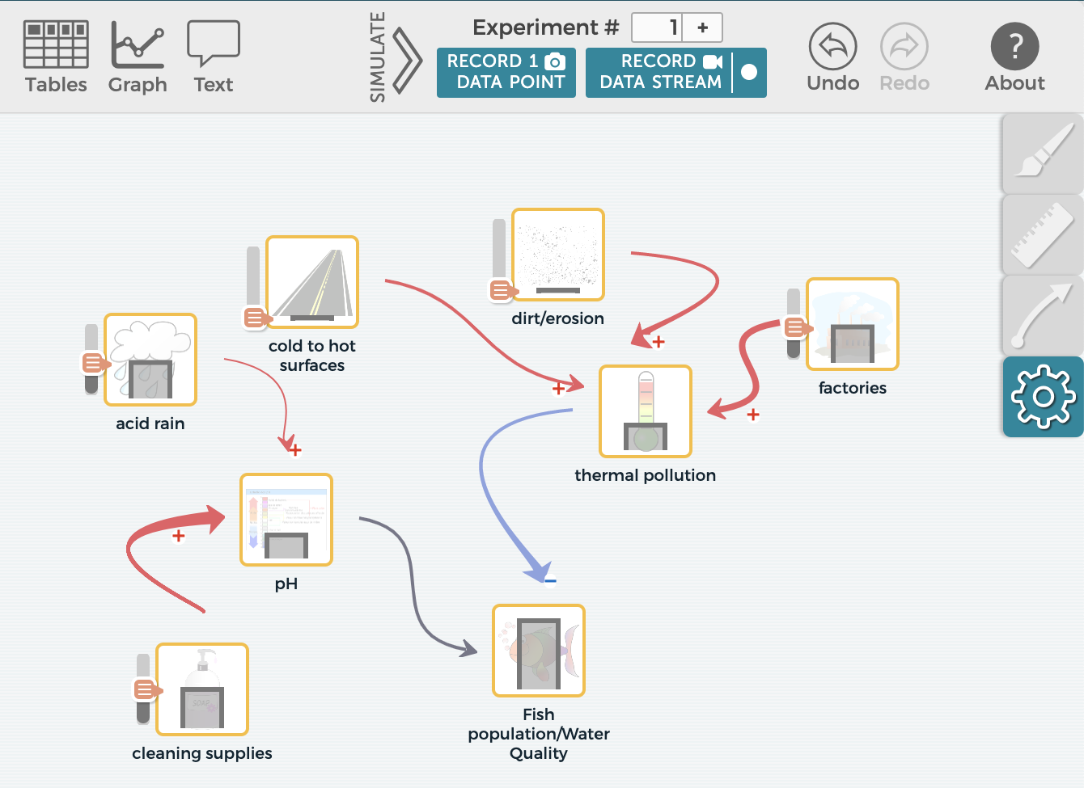

Concluding the lesson (2 min)
This concludes day one of the two-day lesson. Students will continue to work on their models during class tomorrow. Some groups will also share their models.

Homework or reading: None

Day 2: Continue building models and share/critique
1. Continue building models (~30 min)
Purpose: Students will use time to work in their groups to complete their water quality models based on pH and thermal pollution.

2. Sharing/Critiquing models (~10-20 min)
Purpose: Sharing and critiquing student models is extremely valuable. It fosters a community of learners and assists students to see connections between ideas. It also allows students to see how different groups have modeled the stream phenomenon.
Option: some groups will complete their models before other groups. Groups can share their models with each other. Ask one group to explain their models to another group. Next, the other group can do the same. They should talk through their models and explain the variables and their relationships to water quality (fish population). They should run their models, using either the graph tool or the simulation tool. They can move the toolbars for the variables to show how the water quality is impacted. They may provide each other feedback. Groups may then go back and revise and improve their models based on feedback.

Either request volunteers to share their models with the class or ask a couple of groups. You can display models for everyone to see. Groups should talk through their models and explain the variables and their relationships to water quality (fish population). They should run their models, using either the graph tool or the simulation tool. They can move the toolbars for the variables to show how the water quality is impacted.
As a class, discuss if the model “works” and provide any feedback to the group, including any suggestions they might have to improve the model.
Summary: Models are meant to assist us in explaining phenomena. Ask students what conclusions they would make about the overall health of the stream based on pH and temperature. This can be done first in small groups and then in a class discussion. Ask students to include an overall statement (the stream is very healthy, somewhat healthy, not very healthy, very unhealthy etc), a water quality standard (excellent, good, fair, or poor), and reasons based on science ideas.
Have a discussion to see if the class can come to consensus. This assumes that students’ evidence from both water quality tests were similar. If they were not similar, then a discussion to support your statements should follow. Students could illustrate their ideas with their models by placing the bars at the places where the data falls.
Concluding the lesson (5 min)

This concludes day two of the two-day lesson. A third day may be needed. Remind students that the stream is a complex system. You may refer back to the analogy of the basketball player and collecting several pieces of evidence to determine her level of play. pH and thermal pollution are two measures of the quality of the water. We will collect more data that can be used as evidence to gain insight into the stream phenomenon. We will now look at a third measure of water quality related to the amount of dissolved solids to see its relationship to suitability for freshwater organisms.

Homework: Students will complete the student reader, “Does our stream have too many nitrates, phosphates or salt?”

student reader, dissolved solids
student reader, dissolved solids - key

LESSON #6: How many dissolved solids are in our stream
Overview: In previous lessons students explored two water quality measures, pH and temperature, and developed a model of the stream’s health based on those two measures. In this lesson, students learn about and obtain a third piece of evidence, the amount of dissolved solids with particular focus on nitrates, phosphates, and road salt. Getting additional insights using a new water quality measure provides a broader, more comprehensive picture of the stream’s health to support freshwater organisms.
In this 3-day lesson, students explore various dissolved substances and their impact on water quality. Through a student reader and class discussion they are introduced to dissolved solids, focusing on road salt, nitrates and phosphates - and the causes and consequences of too many of these dissolved solids. Using the materials tested in the pH lab from Lesson 3, students now test for dissolved solids of various everyday substances that people use on land in large quantities (causes). Students then test the water quality of their stream and have insight into whether or not the stream has too many dissolved solids, what products might be contributing to those levels, and if the stream is healthy for freshwater organisms based on this water quality measure.
Assessing student learning: An assessment task for the lesson is provided as part of a larger assessment in Lesson #9: https://docs.google.com/document/d/1Q1a9grXQUrfhmIXLvhB1HwU2W2GBA6PZftmlQkU-wtY/edit

In the next lesson, students will expand their models to include their newly obtained evidence.
NGSS Performance Expectation: PE: MS-LS2-4, PE: MS-LS2-1, PE: MS-ESS3-3

Learning Performances:
LP8: Students plan and carry out an investigation to test the level of dissolved solids of everyday substances that people use on land that can get into waterways in large quantities.

LP9: Students collect and analyze data to explore the relationship between the level of dissolved solids of the stream and the quality of the water for various populations of organisms.

LP10: Students construct an argument to infer which specific substances account for the levels of dissolved solids in the water and how human activity impacts those levels.

LP11: Students construct an argument that levels and sources of dissolved solids may or may not lead to a disruption of the life cycle.

Safety Guidelines: Students will be testing everyday substances, but some may be adverse to people if they get into their eyes. They should wear goggles. Students should be careful to avoid falling into the water when testing the conductivity of their waterway.
Preparation: The everyday products that were used for the pH lab (see Lesson #3) will now be utilized in this lesson. Conductivity probes, probes that measure the amount of dissolved solids, are utilized in this lesson.
Time: 3 days
Materials:
For the teacher | groups | individuals
 | - One conductivity probe or kits (could use nitrates and phosphate kits)  - Products from Lesson 3  - Squirt bottles of distilled water for cleaning the probes | - student reader, dissolved solids  - student reader, dissolved solids - key  - Data table for investigation  - Goggles  - Data table for all water quality tests

INSTRUCTIONAL SEQUENCE

Day 1: Understanding Conductivity
Background
Here are elements of the DCI that are introduced in this lesson. Other water quality tests also address some of these DCI’s.
- People unknowingly use products outside that can impact the amount of dissolved solids of streams.
- Human activities alter the biosphere and may negatively impact populations of organisms.
- Organisms, and populations of organisms, are dependent on their environmental interactions both with other living things and with nonliving factors
Other background
- Nitrogen and phosphorus are essential nutrients for growth and repair and are often found in compounds as nitrates and phosphates. All organisms need them in small amounts. Plants are able to access nitrates and phosphates from their roots. Animals access nitrates and phosphates through ingestion. Fertilizers contain nitrates and phosphates and are used in agriculture. Individuals put fertilizer on gardens and lawns.
- Some soaps contain phosphates. Some states have banned the use of phosphates in laundry soap. Other products like dishwashing soap may contain phosphates.
- Fertilizer and soap can get washed into waterways during rain events through runoff. If a waterway has too many nitrates and phosphates it can result in excess algae or algal blooms.
- Algae have a relatively short lifespan. When excess algae dies it becomes organic waste. Bacteria decompose organic waste. Because there is an abundance of organic waste, the bacteria population dramatically increases. Bacteria also use oxygen. If there are excess bacteria they will use up all of the oxygen. Fish and other aquatic organisms die from lack of oxygen. This results in more organic waste. The cycle starts again. The result is an oxygen-depleted environment that can lead to a dead zone: a place that lacks the conditions necessary for life. Here is a link for more information about dead zones: https://www.scientificamerican.com/article/ocean-dead-zones/
- Road salt is used in northern climates during the winter in huge quantities. When the snow melts in the spring, the salt is washed into the water. Freshwater organisms are not meant to live in salty water.
- Low amounts of conductivity are best for waterways.

Optional: You may wish to discuss with students that dissolved solids usually enter water as non-point source pollutants. See the optional box in Lesson 3 for further discussion.
Optional: Students could read labels from cleaning supplies to see if they identify phosphates.

1. After Reading: Probing for understanding (5 min)
Purpose: To briefly probe students’ understanding by asking students to share what they learned from the reading. For homework, students completed a reading that introduced them to the three main dissolved solids: nitrates, phosphates, and salt and their potential problems for freshwater organisms. Ask students to share what they learned. You may connect back to the introduction video about algal blooms in Florida (Toxic Algae Blooms Keep Florida Beachgoers Away Video - ABC News (1:49 minutes)
http://abcnews.go.com/US/video/manatee-emerges-algae-covered-water-40283466

2. Assist students to develop understanding of Conductivity (45 minutes)
Assist students to begin to describe the relationship between amount of dissolved solids (measured by a conductivity probe) of the stream and the quality of the water for various populations of organisms by discussing the main ideas about conductivity: the causes and consequences of too many dissolved solids, including how people’s actions on land can impact waterways.
Optional: You may want to define dissolving, solvent, and solute and that some things do not dissolve. This will add time to the curriculum.

Include the following:
- We test conductivity to determine if the water has too many dissolved solids, particularly nitrates phosphates, and road salt.
- Nitrogen and Phosphorus are found in nature and are essential nutrients for growth and repair. They are often found in compounds as nitrates and phosphates. They are essential; ALL organisms need them, BUT in only very small amounts.
- Nature has a balanced life cycle where plants, both on land and in water, pick up nitrates and phosphates through their roots, in order to grow. When these plants die (whether in the water or on land) they become dead matter, also called organic waste. Bacteria and other organisms decompose the plants. Nitrates and phosphates are released back into soil or water and become available for other plants. This is an “in-balance” cycle referred to as a life cycle.
- People put nitrate and phosphate compounds in fertilizer to help plants grow. Farmers use it on crops and individuals use it on home gardens or on lawns.
- Other sources of nitrates and phosphates are any type of organic waste: dog, duck, or geese manure or cow manure from dairy farms.
Teaching extension: This is an opportunity for you to ask students to generate ideas of actions steps that they and others can take to decrease the possibility of unintentionally contributing these pollutants. Ideas include picking up after dogs or avoiding the practice of cutting vegetation near waterways. Vegetation acts as a buffer. Not only does vegetation “catch” pollutants to prevent them from running into a stream, it also inhibits wildlife such as ducks and geese from being on the water’s edge.

- Phosphates can be found in some cleaners such as laundry and dishwashing soap. Some states have banned phosphorus from laundry soap because of the effects on waterways.
- When it rains, fertilizer and other products that contain nitrates and phosphates can get picked up and carried downhill to various waterways. Fertilizer can get carried to waterways through storm drains as well. This provides a waterway with excess nitrates and phosphates.

- Excess nitrates and phosphates can result in an algal bloom – excess algae growth.

- Algae have a relatively short life span. When all of the algae die they become excess organic waste.

- Bacteria decompose organic waste. Because there is an abundance of organic waste, the bacteria population dramatically increases. Bacteria also use oxygen. If there are excess bacteria they will use up all of the oxygen.

- Fish and other aquatic organisms die from lack of oxygen. This results in more organic waste. The cycle starts again. The result is an oxygen depletion cycle that can lead to a dead zone: a freshwater area that lacks the conditions necessary for life – not enough oxygen.
Optional: While dead zones are more common in oceans they can occur in lakes and even rivers.

Search for YouTube videos related to algal blooms and fertilizer run-off. In the upper Midwest, for example, there are many videos related to algal blooms in Lake Erie. Florida is plagued with Red Tide and other algal blooms. See if you can find an algal bloom issue in a lake in your area. If not, show one from Lake Erie and/or Florida.

- Road salt is used in northern climates during the winter in huge quantities. When the snow melts in the spring, the salt is washed into the water. Freshwater organisms are not meant to live in salty water.

Next, introduce water quality standards to students:
2. Water Quality Standards: Just as with pH and thermal pollution, water quality experts developed water quality standards for the amount of dissolved solids using the terms excellent, good, fair, and poor to identify if fresh waterways have too much or acceptable levels. Excellent and good indicate that there are not too many dissolved solids in the stream with excellent being better than good. Fair and poor indicate too many dissolved solids*, meaning the results are problematic for streams, with poor being worse than fair.
*It should be noted that when it comes to salt in fresh waterways there is a “tipping point” of 1400-1500 mg/L that will begin to impact freshwater organisms.
Here are the Conductivity Standards as wall as total nitrate and phosphate standards:
Dissolved Solids Water Quality Standards | Conductivity probe | Total Phosphate | Nitrates
Excellent – not too many dissolved solids | 0-100 mg/L | 0-1 mg/L | 0-1 mg/L
Good - not too many dissolved solids | 100-250 | 1.1-4 | 1.1-3
Fair - too many dissolved solids | 250-400 | 4.1-9.9 | 3.1-5
Poor - too many dissolved solids | > 400 | > 10 | > 5

Conductivity tools
Scientific probes can be used to ascertain conductivity. Several companies, including Pasco Scientific, https://www.pasco.com, and Vernier www.vernier.com/ sell a variety of probes, including Probes that are now wireless where data can be sent to cell phones, tablets, or computers. In addition to conductivity probes, nitrate and phosphate kits may be purchased from companies such as HACH and LaMotte.

3. Concluding the lesson (2-3 min)
Ask students whether we are hoping for high, medium, or low conductivity readings (If you are using kits, adjust your questions accordingly). Low reading would be the best for the stream. Let them know that before we measure the conductivity level of the stream we want to conduct an experiment, in class, that will provide us with insight into conductivity.

4. Homework: Ask students to think about how we can investigate conductivity in class. Have them bring their ideas to the next class.

Day 2: Conductivity of everyday substances
1. Plan in-class investigation (~5 min)
Purpose: Assist students to figure out that they can test the same substances from the pH lab, but now with conductivity probes.
For homework, students were asked to think about how to investigate conductivity in class. Ask students to share their ideas.
Options: You could ask students to share and generate ideas in small groups and then share as a class. You could conduct this as a class discussion only.
Students may say that they want to test lemons and coke, etc. The goal is to steer students to test the products that are already set up from the pH lab (see Lesson 3). These are substances that can get into the stream in large quantities. Many of these substances dissolve in water.
2. Planning an Investigating – What is the conductivity of everyday substances? (~10 min)
If someone has not come up with the idea of testing the products that can get into the stream in large quantities, present the students with the idea and ask them what they think: What do you think about asking the question, “What is the conductivity of everyday products people use on the land?”
Some of the products do not dissolve. No need to let students know this now. Students will later test for turbidity. Turbidity tests for solids that do not dissolve. For now, students can test all of the products.

Options: You could ask students to develop a data table or you could provide students with a data table. If students develop a table they can work with partners to create a “sloppy copy” (rough draft) into notebooks. A few students can put their data table on the board to share. Taking the best from all groups, you can build consensus on the format. Students may then make “nice” tables.
An example of a data table is included below. One is also included separately.

Datasheet for conductivity of substances lab (available as a separate document)
Substance | Prediction | Results  Trial 1 | Results  Trial 2 | Results  Trial 3 | Result  Average | Standard
Antifreeze
Datasheet rows continue…

3. Investigating the conductivity of everyday substances (~20-30 min)
Pull out the various products that are in tennis cans for testing (see Lesson 3 and the picture below). Discuss the testing procedure with students. Have a list of all of the products on the board.
Be sure to stress to students that they need to rinse the probe between products (not between trials). They should test each three times to ensure the results are consistent. They may record the average or the most consistent number.
Due to the concentration of the mixture (how much of each product per water) conductivity of substances may be exceedingly high. Remind students of how much of each product was added to how much water. Let students know that the results from today’s in-class lab should help them with their prediction for the conductivity level of the stream.
4. Engaging in sense making: sharing and discussing dissolved solids through conductivity results (~10 min*)
It is important to share the data. First, it allows the class to see if the data is consistent. If one group’s numbers are continually different from others than you may need to check that probe. Next, it allows students to identify patterns. Make sure that all students have opportunities to discuss the patterns they see. Students may find that fertilizers have very high readings, as does road salt. Students may be surprised to see that conductivity reading of dirt is much lower (although nitrates and phosphates can bind with dirt). You may ask student if dirt dissolves or wait to discuss this during the turbidity lesson. You can talk with students about the results and discuss concentration of the tested substances compared to concentration of these substances in a waterway.
Optional. More time may be spent with sense making if you have time. Encourage students to discuss the various products that they tested. Ask students if there are products that could negatively impact a stream if they were to get into the waterway in large quantities? Are there choices of products that could be used that would not have a negative impact on a stream’s conductivity readings? For example, are there alternatives to using fertilizer? If you live in a northern climate are there alternatives to using road salt? What about simply using less?

5. Concluding the lesson: This concludes day two of a three-day lesson. Let students know that they should now be able to first make predictions and then test their stream water and understand what the conductivity numbers that they obtain mean: whether there are too many dissolved solids or not. They can also have some insight into possible products that people use on land that might account for the readings that they obtain. For example, if the waterway that is being tested is near neighborhoods with nice lawns and conductivity readings are high, students may deduce that people could be using fertilizer. Or if testing the spring after road salt has been applied on roads throughout the winter, students might deduce that the high numbers are related to road salt. This will assist students to see the relationship between products people use on land and the impact on a waterway’s conductivity levels.

Understanding the idea of causal relationships is key in developing models and writing explanations. Continue to emphasize cause and effect relationships related to the science ideas.

Let students know that tomorrow we will test the conductivity of the stream (or whatever phenomenon you are using). If going outside, remind students to dress appropriately for the weather.

Homework: Students will write a prediction about the conductivity of the stream. (~5 min)
Predictions will include four parts:
- A conductivity number and text about dissolved solids (e.g., I predict the stream will have a conductivity of 150 mg/L, which means not too many dissolved solids).
- The standard for their prediction (Excellent, good, fair, or poor)
- A statement about the consequence (in-balance or could lead to out-of-balance cycle) that matches the standard.
- At least one reason for their prediction (based on science ideas from the Student Reader).

Here’s an example:
I predict the stream will have a conductivity reading of 150 mg/L. This is good according to water quality standards so there are not too many dissolved solids. I’m predicting this because there are not many lawns near our stream and the homes with lawns don’t look very lush; I don’t think they use fertilizer.
You will decide if students will write their prediction in a notebook, on paper, or using a computer.

Day 3: Investigating conductivity of your water body
1. Investigating the conductivity of the stream (~30-45 min)
Purpose: Collect the third piece of water quality data: conductivity.
Begin by asking students to share their predictions. Make sure all students are able to share and explain why they made the prediction. Another option is to collect data first and then share predictions. Provide students with instructions for data collection. Below is one possible data table for students to use.
You should follow the same procedure that was done for pH and temperature.
Conductivity of fresh water body datasheet (available as a separate document)
Conductivity of the stream | Observations that could impact the stream’s conductivity
Trial 1 _____  Trial 2 _____  Trial 3 _____ Average __________  Average divided by 2: __________ mg/L | In the water:  Near the water:  Recent Weather:
2. Engaging in sense making: Sharing and discussing conductivity results (~5-15 min)
Purpose: Students share data to look for discrepancies and patterns in the data.
You may want student groups to write their results on the board. Results will most likely be similar. There may be plausible factors, however, that influence student results based the location of where they tested in relation to the land, for example, a pipe that is discharging substances into the water. If a plausible factor is not identified, and a group has significantly different results from the other groups, It could be an outlier, in which case the group may want to re-test.
Students may work in groups to focus on these questions:
- According to your results is the stream’s conductivity healthy for organisms? Are there too many dissolved solids?
- What water quality standard do your results convey (excellent, good, fair, or poor) for conductivity?
- If there are too many dissolved solids, what do you think could be the cause(s) – where might they be coming from?
- Based on your results what are the possible consequences? Use your science notes to help.

This may be followed up with a class discussion. Major ideas can also be added to the driving question board.
Students should now fill in the comprehensive data table that is provided for them to record data from all of the water quality tests that they conduct during the project.
Results of all WQ tests datasheet (available as a separate document)
Name of Water Quality Test | Results | Water Quality Standard | Observations
pH
Temperature Difference
Conductivity

Concluding the lesson: (2 min) This concludes the three-day lesson on conductivity. Remind students that conductivity is the third water quality measure. Ask if they can feel confident to make an overall conclusion about the stream’s health for supporting organisms. Relate this back to the basketball analogy that was introduced in Lesson 2 (Instructional sequence #4). Would seeing that the person was a good free-throw shooter, dribbler, and passer provide enough evidence that she could succeed as a college basketball player? Certainly, having three pieces of evidence is better than having only one piece of evidence; three pieces provide a stronger “picture” of the stream system.

Relate back to the driving question. We are investigating. “How healthy is our stream for freshwater organisms and how do our actions on land potentially impact the stream and the organisms that live in it?” Gathering more evidence from water quality measures will provide an even more comprehensive, evidence-based picture of the stream’s overall health for organisms. Make sure all students are able to take part in the discussion.

Assessing student learning: An assessment task for the lesson is provided as part of a larger assessment in Lesson #9. Conductivity, dissolved oxygen, and turbidity assessment: https://docs.google.com/document/d/1Q1a9grXQUrfhmIXLvhB1HwU2W2GBA6PZftmlQkU-wtY/edit
Conductivity, dissolved oxygen, and turbidity assessment Key:
https://docs.google.com/document/d/1W5eg7aOhkoIgJ4ihnFTe0IsHAr_lBPcNldXECvHT82s/edit

Homework: None
In the next lesson, students will expand their original models to include their newly obtained evidence.

- If you are going to wait until Lesson #10 to construct models then after discussing the basketball analogy let students know that we will continue to investigate the stream with another water quality measure and move to Lesson #8. For homework students could complete the Student Reader, “Is there enough oxygen for fish and other aquatic animals in the stream?”
- DO student reader: https://docs.google.com/document/d/12-yO9z4POQ6He6TLx5Y0g1AUP_Ge0qeFIvhAPyJAVSI/edit
- DO student reader key: https://docs.google.com/document/d/1XVVku-TRlscJfCwF8nQr89Wq0R7ZYjlpB_5q5fgwWys/edit

LESSON #7: How healthy is our stream based on pH, temperature, and dissolved solids?
Overview: In the previous lesson, students investigated a third water quality measure, the amount of dissolved solids measured as conductivity. In this lesson, students revise their model of the stream system that currently includes pH and thermal pollution variables and add conductivity as a third variable. To be accurate, the models must show the relationships between the variables (the various water quality measures and human activity on land) and the water quality illustrated through impact on population of organisms. Students’ models must also show that the set of relationships work together to explain the stream phenomenon.

As with the first version of the model, this is a formative assessment that serves to provide both students and the teacher with information of where students are with their learning. This activity should also foster students’ continued development of their understanding of the DCI’s as well as modeling as an important scientific practice. Crosscutting concepts of cause and effect, systems, patterns, and change and stability are also integral in explaining the phenomenon of water quality.

In lesson #8, students investigate a fourth water quality measure, amount of dissolved oxygen, followed by a fifth water quality measure in Lesson #9, turbidity, that measures the amount of suspended solids. After these additional water quality tests are conducted, students will again revise their models in order to have the most comprehensive model of the stream as a system, based on all of the evidence they have gathered. This will allow students to fully respond to the driving question, “How healthy is our stream for freshwater organisms and how do our actions on land potentially impact the stream and the organisms that live in it?”

Unit’s NGSS Performance Expectation: PE: MS-LS2-4, PE: MS-LS2-1, PE: MS-ESS3-3

Learning Performance:

LP12: Students develop models to explore patterns of shifts in populations of water organisms that are negatively impacted as the result of human activities that result in disruptions to physical or biological components of an ecosystem.
Safety Guidelines: None
Preparation: Students initial models.
Time: 2 days (possibly 1 day)
Materials: A main computer and projection device. Computers for each group.

INSTRUCTIONAL SEQUENCE
1. Revising models - intro (~ 5 min)
Purpose: Review SageModeler with particular focus on variables. Set a context for model revision.
Ask students what types of things are modeled - scientific models are tools that explain various phenomena or are used to make predictions. In order to be a scientific model it has to illustrate relationships between variables and take account of all available evidence.
Depending on your data you may want to have a discussion about the water quality of the stream. Some of your data may indicate positive results for your waterway. Other data may indicate negative results. For example, in northern climates a waterway may have a neutral pH and no thermal pollution. However, because of road salt that may be used in winter, dissolved solids measured with conductivity probes may be extremely high. Other very common sources of dissolved solids in many areas of the country are nitrates and phosphates from fertilizer used on lawns, gardens, and in agriculture.

Ensuring all voices are heard: Facilitate a conversation asking students if they need to re-think the overall quality of the water under study based on three pieces of evidence. Make sure to seek the views of all students. One strategy is to have students share their ideas in small groups before sharing as a class. This discussion could be at the beginning of the lesson or after students revise and test their models.

2. Revising models of our stream – adding new evidence (~20 minutes)
Purpose: Students revise their initial water quality models by adding dissolved solids (conductivity) data.
Click the button to launch SageModeler to revise your model of the water quality of the stream based on THREE pieces of evidence: pH, temperature differences (thermal pollution), and conductivity (dissolved solids).

SageModeler Button text: How healthy is our stream based on pH, temperature differences, and conductivity?

- Find pictures to represent the variable of conductivity and label it.
- Draw links between variables you think affect each other.
- Set the relationships between those variables.

Allow students to begin to work to incorporate the variable of conductivity (dissolved solids) into their models. Encourage students to use the data from the water quality test. As well, students can refer back to the student readers and/or notes taken during class. Move from group to group. Some groups will need more support than others. Encourage students to help each other. Some groups will work faster than other groups. Once they get their models working in the way in which they think accurately portrays the phenomenon, they can share their models with other groups that are also finished. Groups should explain their models to each other, request feedback, and revise models, as needed.
Making science learning accessible to all learners: Encouraging students to use their notes or to refer back to the student readers will assist to support all learners in their understanding of and use of the science ideas in their models.

Here is a possible basic model that students might develop. They may choose a different icon than the ones here and that is fine. You can open a copy of this model at: https://sagemodeler.concord.org/#shared=97954.
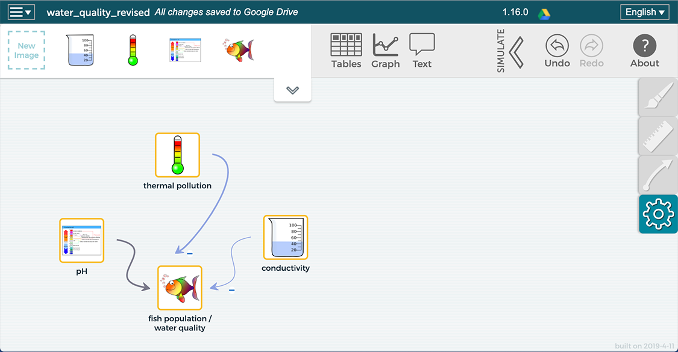
Students can now “Use” their models to run a simulation. They can use the table or graphs or a combination of the two to test, evaluate, revise if needed, and re-test their models.

Below are possible questions that students can respond to that may assist them to think more deeply about their models:

- How did adding conductivity impact how your model worked?

- What variables did you add to show what causes conductivity?

- How does your model account for all the evidence you have regarding water quality?

It is often the case that students move at different paces. If a group or two completes their model, including running it and making sure it works the way that they think is accurate, you can have them expand their models to include the various causes for each of the water quality tests. These will be the variables that affect conductivity. Encourage students to use the student readers to assist them. Students can choose images and define relationships between these. It is not expected that all (or any) students develop models at this level of sophistication. This is enrichment for groups who need it.

Students will continue to work on their models during class tomorrow. Some groups will also share their models.

3. Sense-making opportunities: Critiquing models:

Purpose: To have students evaluate their models to see if they “work” the way that they think they should work.

Remind students that SageModeler has no content and they can develop models that “work” but do not accurately reflect the phenomenon. It is the responsibility of the students to evaluate their models. This process should further foster students learning about important science ideas, crosscutting concepts, and the practice of modeling. Students should use their notes, their patterns they noticed in their data, and the reading when developing their models. There are several possibilities including the following suggestions:

- Using their models to predict water quality: Encourage students to use the sliders to put them to the position where the water quality should be the best. Ask them where they should put the sliders? (for pH the slider should be in the middle – 7, for thermal pollution and conductivity the slider should be the lowest - the lowest temperature differences are the best as are a low amount of dissolved solids). In this way, students are predicting that the water quality will be high. Students can now run their models to see if their predictions match.

  - If they match, then students might conclude that their models work.

  - If they don’t match, students should think about why there is a mismatch. Do they need to adjust their models? Do they need to rethink their understanding of the science concepts?

- Now have them see if they can get the water quality to be poor.
- Observe what happens as they change one variable to see if it matches their thinking. Does the change in that variable affect the water quality the way that they think it should?
- Check all parts of the model. Test, evaluate, revise if needed, and retest.

4. Sharing/Discussion (~10-20 min)
Purpose: Sharing and critiquing student models is extremely valuable. It fosters a community of learners and assists students to see connections between ideas. It also allows students to see how different groups have modeled the stream phenomenon.
Either request volunteers to share their models with the class or ask a couple of groups. You can display models for everyone to see. Groups should talk through their models and explain the variables and their relationships to water quality (fish population). They should run their models, using either the graph tool or the simulation tool. They can move the toolbars for the variables to show how the water quality is impacted.
As a class, discuss if the model “works” and provide any feedback to the group, including any suggestions they might have to improve the model. Encourage all students to take part in the discussion.
Summary: Models are meant to explain and predict phenomenon. Ask students what conclusions they would make about the overall health of the stream based on pH, temperature, and conductivity. This can be done first in small groups and then in a class discussion. Ask students to include an overall statement (the stream is very healthy, somewhat healthy, not very healthy, very unhealthy etc), a water quality standard (excellent, good, fair, or poor), and reasons using science ideas related to causes and consequences.
Have a discussion to see if the class can come to consensus. This assumes that students’ evidence from all three water quality tests were similar. If they were not similar, then a discussion to support your statements should follow. Students could illustrate their ideas with their models by placing the bars at the places where they data falls.
Concluding the lesson (2 min)

This concludes day two of the two-day lesson. Remind students that the stream is a complex system. You may refer back to the analogy of the basketball player and collecting several pieces of evidence to determine her level of play. pH, thermal pollution, and conductivity are three measures of the quality of the water. We will collect more data that can be used as evidence to gain insight into the stream phenomenon that will allow us to answer the driving question. We will now look at a fourth measure of water quality related to the amount of dissolved oxygen to see its relationship to suitability for freshwater organisms.

Ask students what questions they would need to have answered that would help them know why dissolved oxygen is important to water quality. For each water quality measure students have explored what the test measures and why it is important for water quality, the causes related to each test, and the consequences. Students will do the same for this next test.

Homework: Students will complete the student reader, “Is there enough oxygen to support life in the stream?

LESSON #8: How much oxygen is in our stream? Is there enough oxygen to support life?

Overview: In the previous lesson, students expanded their models to include the amount of dissolved solids (conductivity). In this lesson, students explore and collect a fourth piece of evidence - dissolved oxygen (DO) to determine if the stream has enough oxygen to support aquatic organisms. Students investigate the sources of DO and consequences for low DO. They also gain insight into what causes DO levels to drop.

In the next lesson, students will collect a final piece of evidence, turbidity, to measure the amount of suspended particles in the water.
Assessing student learning: An assessment task for the lesson is provided as part of a larger assessment in Lesson #9.

NGSS Performance Expectation: PE: MS-LS2-4, PE: MS-LS2-1, PE: MS-ESS3-3

Learning Performances:
LP13: Students collect and analyze data to explore the relationship (cause and effect) between the amount of dissolved oxygen in the stream and the quality of the water for various populations of organisms.

LP14: Students construct an argument that levels of dissolved oxygen may or may not be a result of a disruption of the life cycle.

Safety Guidelines: Students will be using chemicals. They should wear goggles. Students should be careful to avoid falling into the water when collecting water samples from their waterway.
Preparation: Dissolved oxygen kits are used in this lesson. Because of the expense, the teacher demonstrates how to conduct the tests in class. Students follow along with the same equipment but do not actually conduct the test. Depending on your resources, however, you may want students to practice using the kits in class. Dissolved oxygen probes may be used instead of the kits.
Scientific probes or dissolved oxygen kits can be used to ascertain dissolved oxygen. Dissolved Oxygen kits may be obtained at HACH (hach.com) or LaMotte (http://www.lamotte.com/en/). Probes: Two companies, Pasco Scientific, https://www.pasco.com, and Vernier www.vernier.com/ sell a variety of probes. Probes are now wireless and data can be sent to cell phones, tablets, or computers.

Time: 3 days
Materials:
For the teacher | groups | individuals
DO kit or probe for demonstration  DO conversion chart  Ruler or straight-edge | - One dissolved oxygen kit or DO probe  - Thermometers or temperature probes  - Directions for use of the DO kit | - DO student reader: https://docs.google.com/document/d/12-yO9z4POQ6He6TLx5Y0g1AUP_Ge0qeFIvhAPyJAVSI/edit  - DO student reader key: https://docs.google.com/document/d/1XVVku-TRlscJfCwF8nQr89Wq0R7ZYjlpB_5q5fgwWys/edit  - Data table for investigation  - Goggles  - Data table for all water quality tests  - DO conversion chart  - Ruler or straight-edge
INSTRUCTIONAL SEQUENCE

Day 1: Understanding Dissolved Oxygen
Background
Human activities alter the biosphere and may negatively impact populations of organisms.
Other background
- Just like humans, aquatic animals, fish and other organisms, need oxygen to survive. Trout, for example, need high amounts of oxygen and are considered an indicator fish; if trout are present, that indicates that there is plenty of oxygen. Carp, on the other hand, can survive in low oxygen levels (although they can certainly survive with great amounts of oxygenated water). High levels of oxygen are the best for waterways. (Trout also need a very neutral pH – 6.5-7.5 - and cannot live in waters that have thermal pollution)
- Oxygen gas is dissolved in the water (Optional: you may want to include a discussion of oxygen as the solute and water as the solvent).
- There are two sources of oxygen in the water:
  - The atmosphere: fast moving water captures oxygen from the air by trapping it and pulling it into waterways. Fast moving water can come from waterfalls, water crashing into rocks, rainwater hitting water, etc.
  - Water plants produce oxygen as a product of photosynthesis.
- This water quality test connects to two other water quality tests: dissolved solids (conductivity) and temperature (thermal pollution).
- Connection to dissolved solids (nitrates/phosphates). Remember: When excess algae (due to excess nitrogen and phosphorus) die they become organic waste. Bacteria decompose organic waste. Because there is an abundance of organic waste, the bacteria population dramatically increases. Bacteria also use oxygen. If there are excess bacteria they will use up all of the oxygen. Fish and other aquatic organisms die from lack of oxygen. This results in more organic waste. The cycle starts again. The result is an oxygen-depleted environment that can lead to a dead zone: a place that lacks the conditions necessary for life.
- Connection to temperature. Remember: Warm water cannot hold as much oxygen as cold water.

1. After Reading (Homework from Lesson 7): Probing for understanding. Assisting students to develop understanding of Dissolved Oxygen (~20-25 minutes)
Assist students to begin to understand the importance of oxygen in waterways and the relationship between amount of oxygen and the quality of the water for various populations of organisms by discussing the main ideas about oxygen: the sources and consequences of too little oxygen, and what causes DO levels to drop. For homework, students completed a reading that introduced them to dissolved oxygen. Ask students to share what they learned.
Because students have completed the reading for dissolved oxygen, you should be able to facilitate an interactive discussion with students, which allows them to generate the main ideas. Guide students using the following questions:
- Why do we test for dissolved oxygen (DO)? What does it measure and why is it important?
- What are the sources of DO?
- What is the consequence of low DO?
- What causes DO levels to drop?
These ideas include the following:
- We test dissolved oxygen to determine if the water has enough oxygen to support aquatic animals who need oxygen just like we do. Emphasize to students that oxygen is not a pollutant but rather something that is good for the stream. Students may assume that everything is bad for waterways.
- There are two sources of oxygen in the stream: the atmosphere and water plants. Discuss each source.
- Without enough oxygen, fish and other organisms that need oxygen die. This is the major consequence of too little oxygen.

- Excess organic waste (dead matter) and thermal pollution cause DO levels to drop. Warm water cannot hold as much oxygen as cold water. Organic waste is decomposed by bacteria. If there is excess organic waste, bacteria and other organisms decompose this waste. Because there is an abundance of organic waste, the bacteria population dramatically increases. Bacteria also use oxygen. If there are excess bacteria they will use up all of the oxygen.

- Connect oxygen with dissolved solids, the conductivity measure, and with temperature. You may ask students if they can make connections between the several water quality measures.

Teaching extension: This is an opportunity for you to ask students to generate ideas of action steps that they and others can take to decrease the possibility of unintentionally contributing pollutants that cause oxygen levels to decrease. Ideas include raking dead leaves away from storm drains to prevent them from getting into waterways and providing excess organic waste. Picking up after dogs, or avoiding the practice of cutting vegetation near waterways also decreases organic waste. Action steps that decrease the potential for thermal pollution (See Lesson 4) also will assist to avoid the decrease of oxygen levels.

Next, introduce water quality standards to students:
2. Water Quality Standards: Just as with the other water quality measures, water quality experts developed water quality standards for the amount of oxygen using the terms excellent, good, fair, and poor to identify if fresh waterways have too little or acceptable levels. Excellent and good indicate that there is enough oxygen in the stream with excellent being better than good. Fair and poor indicate too little oxygen meaning the results are problematic for streams, with poor being worse than fair.
Dissolved Oxygen kits provide oxygen reading in mg/L. The standards are in % so a conversion chart is used. Since oxygen levels are impacted by temperature, the temperature of the water also needs to be measured.
Here are the Dissolved Oxygen Standards:
Dissolved Oxygen Water Quality Standards | Dissolved Oxygen: %
Excellent – plenty of oxygen | 91%-110%
Good – enough oxygen | 71%-90% and above 110%
Fair - too little oxygen | 51-70%
Poor - too little oxygen | Below 50%

3. Converting Dissolved Oxygen from mg/L to percent.
Students will need directions and practice to convert DO from mg/L to percents. Below is a conversion chart. Notice across the top is a bar for water temperature. Dissolved oxygen is impacted by temperature; warm water can hold less DO so temperature of the water needs to be collected. Across the bottom of the chart is oxygen in mg/L. The DO kit provides this data. To convert to DO % a dot is marked on the temperature line followed by a dot on the oxygen in mg/L line. Next, connect the dots using a ruler. Read the diagonal line, which is the % saturation, or DO %.

Practice using the DO conversion chart (a document in Lesson #8 materials)
Provide students with a couple of opportunities to convert their DO readings into DO percents. Here are a couple of possible examples:

- Your water has a dissolved oxygen reading of 10 mg/L and a temperature of 12⁰ Celsius. What is the DO percent of your water? What water quality standard (excellent, good, fair, or poor) does this represent? Based on your results is there enough oxygen in the water to support aquatic animals? (DO ~ 90%, excellent water quality for oxygen which means there is enough oxygen to support aquatic animals).

- Your water has a dissolved oxygen reading of 6m g/L and a temperature of 10⁰ Celsius. What is the DO percent of your water? What water quality standard (excellent, good, fair, or poor) does this represent? Based on your results is there enough oxygen in the water to support aquatic animals? (DO ~ 55%, fair water quality for oxygen which means there is not enough oxygen to support aquatic animals).

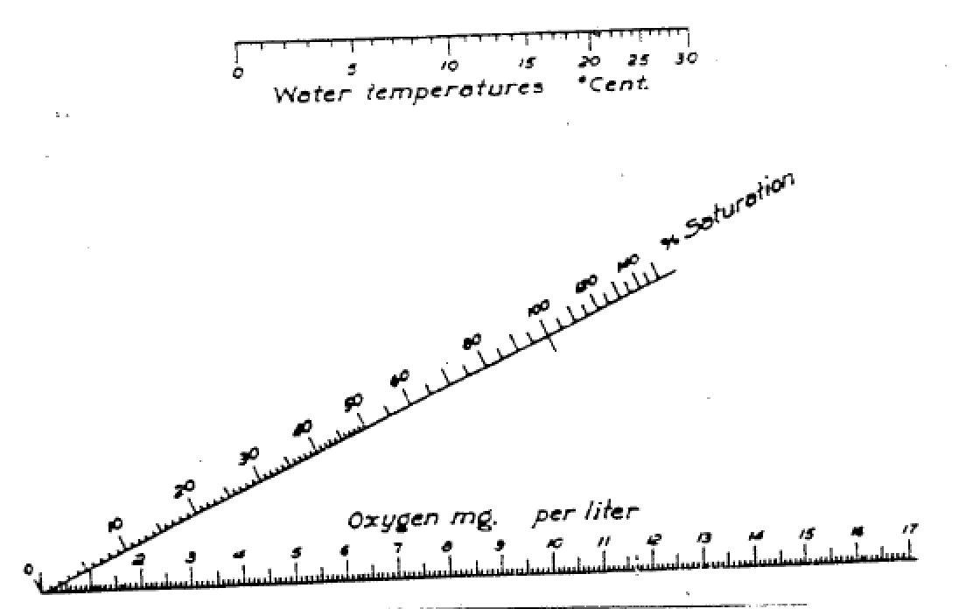

4. Concluding the lesson (2-3 min)
Ask students whether we are hoping for high, medium, or low oxygen readings. High readings would be the best for the stream. If you are using kits, let students know that before we measure the oxygen levels of the stream we need to learn how to use the kits. That leads to tomorrow’s lesson.

4. Homework: None

Day 2: Taking measurements with dissolved oxygen kits
1. Demonstrate and practice using dissolved oxygen kits (~5 min)
Purpose: Demonstrate and carefully read through the directions for conducting the dissolved oxygen test using a DO kit.
Students should wear goggles if using DO kits. Students need to carefully follow the directions. It is easy for students to mix up packets #1 and #2 so they need to read carefully. Students also need to measure the temperature. Depending on your science budget you may demonstrate how to use the kits or have students also practice.

Options: You may demonstrate how to use the kit. Student groups could also have kits and follow along but not actually open the packets of chemicals. Another option is for students to test a sample of water with you. Either way, going through together, step-by-step, will help to ensure that students follow the procedure accurately.
It is helpful to have the directions projected on a screen in addition to a hard-copy for students.
Here is one suggestion for demonstrating the procedure for testing the oxygen level in a sample of water:
Slowly and gently fill up a tennis can (or other container) with water from the tap. Fill up a second container, but this time run the water at full force so water quickly pushes into the container. Make sure that the water is at the same temperature (cold water, for example). Ask students which container they predict will contain more oxygen (fast water captures oxygen from the air so the second container will have more oxygen).
Step-by-step conduct the DO test, showing students as you read through the directions.
Following the procedure for the DO test you will have results in mg/L. You will then use the DO conversion chart to obtain a percent by using DO measurement (mg/L) and the temperature of the water (degree C). Discuss the results with students.
2. Concluding the lesson: This concludes day two of a three-day lesson. Let students know that they should now be able to first make predictions and then test their stream water and understand what the dissolved oxygen numbers that they obtain mean: whether there is enough or too little oxygen to support aquatic animals. When making predictions encourage students to think about how fast their water flows and if there has been recent heavy rain etc. These are things that can contribute to DO. They can also think about various aspects related to temperature. And finally, they should consider if there is organic waste and how much.

Let students know that tomorrow we will test the oxygen levels of the stream (or whatever phenomenon you are using). If going outside, remind students to dress appropriately for the weather.

Homework: Students will write a prediction about the dissolved oxygen of the stream. Prompt students to think back to their observations of the stream. Ask students to think about the two sources of DO and what causes DO levels to drop. (~5 min)
Predictions will include four parts:
- A dissolved oxygen percent
- The standard for their prediction (Excellent, good, fair, or poor)
- A statement about the consequence (enough or not enough oxygen to support life) that matches the standard.
- At least one reason for their prediction (based on science ideas from the Student Reader).

Here is an example:
I predict the stream will have 95% oxygen. This is excellent according to water quality standards so there will be enough oxygen for fish. I’m predicting this because there is very fast water that hits large rocks and captures oxygen from the air.
You will decide if students will write their prediction in a notebook, on paper, or using a computer.

Day 3: Investigating the dissolved oxygen of your water body
1. Investigating the oxygen of the stream (~30-45 min)
Purpose: Collect the fourth piece of water quality data: dissolved oxygen.
Begin by asking students to share their predictions. Another option is to collect data first and then share predictions. Provide students with instructions for data collection. Below is one possible data table for students to use. Students will also need the DO conversion chart (link D.O. chart)
Because the Dissolved Oxygen test is labor intensive and costly (if kits are used) students will not do three trials and take an average.
Dissolved oxygen (DO) of freshwater body datasheet (available as a separate document)
D.O. mg/l | Temperature °C  ^{(degrees Celsius)} | D.O. % | Standard | Observations that could impact the stream’s DO
In the water:

Near the water:

Recent weather:

2. Engaging in sense making: Sharing and discussing oxygen results (~5-15 min)
Purpose: Students share data to look for discrepancies and patterns in the data.
You may want student groups to write their results on the board. Since oxygen levels are influenced by rapids, waterfalls, etc. they may be different. However, if there is an outlier, this group may want to re-test. Students may work in groups to focus on these questions:
- What is the DO of the stream? How does that DO impact the water quality?
- According to your results is the stream’s oxygen level healthy for organisms?
- Is there enough oxygen? Too little?
- What water quality standard do your results convey (excellent, good, fair, or poor) for the amount of oxygen?
- If there is not enough oxygen, what do you think could be the causes (have students look at what causes DO levels to drop)
- Based on your results what are the possible consequences? Use your science notes to help.

This may be followed up with a class discussion. Looking for causes and consequences and patterns are important crosscutting concepts that will also assist students in learning important science ideas as they analyze their data. Stability and change is another important crosscutting concept, particularly related to excess organic waste that was the result of human activity of using fertilizer in agriculture and home gardening and lawns.
Students should now fill in the comprehensive data table that is provided for them (See Lesson #3) to record data from all of the of the water quality tests that they conduct during the project.
Water Quality Test Results
How Healthy is our stream for freshwater organisms?
How do our actions on land potentially impact the water?

Organize your results from all of the water quality tests into one data table below. Notice the far right column labeled Observations. Record any information that you may have observed in or near the water that might help you determine what caused the results you obtained for that test.

Results of all WQ tests datasheet (available as a separate document)
Name of Water Quality Test | Results | Water Quality Standard | Observations
pH
Temperature Difference
Conductivity
Dissolved Oxygen

Concluding the lesson: (2 min) This concludes the three-day lesson on dissolved oxygen. Remind students that oxygen is the fourth water quality measure. Ask if they can feel confident to make an overall conclusion about the stream’s health for supporting organisms. You may relate this back to the basketball analogy that was introduced in Lesson 2 (Instructional sequence #4). Would seeing that the person was a good free-throw shooter, dribbler, passer, and defender provide enough evidence that she could succeed as a college basketball player? Certainly, having four pieces of evidence provides a stronger “picture” of the stream system. Relate back to the driving question. We’re investigating "How healthy is our stream for freshwater organisms and how do our actions on land potentially impact the stream and the organisms that live in it?” Gathering more evidence from water quality measures will provide an even more comprehensive, evidence-based picture of the streams overall health for organisms. Let students know that we will collect and analyze one more piece of evidence, called turbidity, then evaluate all of the evidence to answer our driving question. We will expand our models and construct a scientific explanation to assist us in the process.

Assessing student learning: An assessment task for the lesson is provided as part of a larger assessment in Lesson #9. Conductivity, dissolved oxygen, and turbidity assessment: https://docs.google.com/document/d/1Q1a9grXQUrfhmIXLvhB1HwU2W2GBA6PZftmlQkU-wtY/edit
Conductivity, dissolved oxygen, and turbidity assessment Key:
https://docs.google.com/document/d/1W5eg7aOhkoIgJ4ihnFTe0IsHAr_lBPcNldXECvHT82s/edit

Introduce the Student Reader. Turbidity, floating or suspended particles, may be part of the list that students generated back in Lesson 2 when they conducted a brief internet search asking, “How do experts determine water quality?” You may want to remind students of this. In addition, student generated questions from Lessons 1 and 2 related to turbidity may already be on the driving question board.

Ask students if any of the water quality measures that have been investigated so far are related to solids? Students have measured dissolved solids (road salt, nitrates, and phosphates) so far. Ask students if they think that all solids dissolve. You can refer students to the various substances that were tested for pH levels in Lesson #3 and conductivity levels in Lesson #6 and show students containers like dirt or sand. This sets a nice context for studying turbidity. Let students know that this last test will measure particles in water that do not dissolve.

Homework: Student Reader: Turbidity.

LESSON #9: How many floating particles are in the stream? Is this a problem for freshwater organisms?

Overview: Turbidity, the final water quality measure, rounds out the evidence-based exploration of how healthy a waterway is for freshwater organisms and how peoples’ actions on land may impact water quality. This measure connects to other water quality measures: thermal pollution and dissolved oxygen. While conductivity measures the amount of dissolved solids, turbidity measures the amount of suspended, or floating, solids. Knowing the turbidity of the water, along with the other water quality measures, will allow students to make claims about the overall health of the water supported using a wide range of evidence, and use a modeling tool to model the entire water system and/or to construct a scientific explanation of this complex phenomenon. A final model may be developed in the concluding lesson of the unit, Lesson #10. A final explanation may be constructed in Lesson #11.
Assessing student learning: This lesson includes an assessment task for turbidity as part of a larger assessment that includes assessment tasks for conductivity (dissolved solids) and dissolved oxygen.
Conductivity, dissolved oxygen, and turbidity assessment: https://docs.google.com/document/d/1Q1a9grXQUrfhmIXLvhB1HwU2W2GBA6PZftmlQkU-wtY/edit
Conductivity, dissolved oxygen, and turbidity assessment Key:
https://docs.google.com/document/d/1W5eg7aOhkoIgJ4ihnFTe0IsHAr_lBPcNldXECvHT82s/edit

There are several different ways to collect turbidity data including an optional design opportunity.
In the previous lesson, students explored and collected a fourth piece of evidence - dissolved oxygen (DO) to determine if the stream (or other waterway) has sufficient oxygen to support aquatic organisms. In this lesson, students will collect a final piece of evidence, turbidity, to measure the amount of suspended particles in the water.
Prior to data collection, students learn what turbidity measures and they investigate the sources of turbidity and consequences for organisms if turbidity levels are high.
This lesson leads to the final lessons of the unit where students add dissolved oxygen and turbidity to their existing models or write a scientific explanation of the stream system. They use their final models and/or explanations to respond to the driving question for the unit, “How healthy is our stream for freshwater organisms and how do our actions on land potentially impact the stream and the organisms that live in it?

NGSS Performance Expectation: PE: MS-LS2-4, PE: MS-LS2-1, PE: MS-ESS3-3, MS-ETS1-1 (a design opportunity is an optional activity)

Learning Performances:
LP15: Students collect and analyze data to explore the relationship (cause and effect) between the turbidity levels of the stream and the quality of the water for various populations of organisms.

LP16: Students construct an argument to infer which specific substances might account for the turbidity levels of the water and how human activity impacts those levels.
LP17: Students design and build a device to capture pollutants that allow them to collect, analyze and interpret turbidity data from a waterway

Safety Guidelines: No matter which method is used to test turbidity, students should wear goggles. Students should be careful to avoid falling into the water when collecting water samples from their waterway. Students should wash their hands when returning to the classroom.
Preparation: There are several options for turbidity data collection.
- A Secchi disc is a round disc that is lowered into the water. The depth at which the markings are no longer visible is a measurement of the clarity of the water. This method is typically used for a lake or pond and is not feasible if measuring in shallow water.
- Turbidity sensors may be obtained from Pasco Scientific https://www.pasco.com, and Vernier www.vernier.com/
- Turbidity Tube: This long tube has a mini-secchi disc at the bottom. Students completely fill the tube with a sample of water and look through the top of the tube. Water is siphoned from the bottom of the tube. When the secchi disc is clear the water flow is stopped and a reading is taken to see the depth at which the markings are clearly visible. Turbidity tubes may be purchased through various scientific companies.
- Students can design and build their own system for measuring turbidity (discussed in the lesson).
Time: 2 days (3 days if students engage in the optional design challenge)
Materials:
For the teacher | groups | individuals
 | - Data collection device: One of the four options described in the preparation section  - Materials to design and build a turbidity collection device | - Turbidity student reader  - Data table for investigation  - Goggles  - Data table for all water quality tests

INSTRUCTIONAL SEQUENCE

Day 1: Understanding Turbidity
Background
Here are elements of the DCI that are introduced in this lesson. Other water quality tests also address some of these DCI’s:
- Human activities alter the biosphere and may negatively impact populations of organisms.
Other background
- Turbidity is the murkiness of water caused by suspended (floating) solid particles that can enter the water through run-off. High turbidity means poor water quality.
- There are several causes of floating particles in water that include dirt, organic waste, human and animal waste, algae or other floating tiny plants, and urban and industrial waste. These are discussed in the Student Reader for Turbidity.
- Some floating particles occur in nature. The focus of this lesson, just as with the earlier lessons, will be human activities that occur on land that can contribute to the number of floating particles.
- One consequence of high turbidity is that particles in the water absorb heat which can result in thermal pollution and therefore, turbidity is related to thermal pollution. As well, warm water cannot hold as much oxygen. Therefore, turbidity is also related to DO. Help students to make these connections.
- There are other consequences of high turbidity, which are discussed in the student reader.

1. After Reading: Probing for understanding. Assisting students to develop understanding of Turbidity (~25-30 minutes)
Remind students that in the last lesson they learned about dissolved oxygen. In this lesson we will begin to learn about our last water quality measure, turbidity. That will provide us with five pieces of evidence to answer the units driving question. Begin this lesson by discussing the reading and why turbidity is an important water quality measure. Assist students to begin to understand the importance of having low turbidity in waterways and the relationship between amount of turbidity and the quality of the water for various populations of organisms by discussing the main ideas about turbidity: what it measures, and the sources and consequences of too many floating particles. For homework, students completed a reading that introduced them to turbidity. Ask students to share what they learned.
Because students have completed the reading for turbidity, you should be able to facilitate an interactive discussion with students, which allows them to generate the main ideas. Guide students using the following questions:
- Why do we test for turbidity? What does turbidity measure and why is it important?
- What are sources of turbidity?
- What are the consequences of high turbidity?
These ideas include the following:
- We test turbidity to measure the amount of suspended/floating particles in water. These particles cause the water to be murky so turbidity provides information of how clear or the clarity of the water. Low turbidity is best for waterways.
- There are many causes of turbidity. Any particles that do not dissolve contribute to turbidity. Nature provides some suspended particles. However, some particles enter water because of human activity on the land.
  - Dirt, that runs off from construction sites or from erosion caused when people cut down trees etc. is a major cause of turbidity. The water looks dark.
  - Organic waste: dead leaves, plants etc. floating in the water
  - Human waste from leaking septic tanks and animal waste from not picking up after your dog or from ducks/geese that congregate near water because people feed them.
  - Algae/other tiny plants in water (if fertilizer runs into water causing an algal bloom). The water looks a pea-green color.
  - Urban waste from cities: litter, car oil, etc. Anything that does not dissolve.
  - Industrial waste: waste from factories that do not dissolve.
Teaching extension: What are microbeads and why are they illegal? Microbeads are tiny plastic particles that have been put in various products such as facial scrubs and toothpaste. Environmental groups worked to ban them. Visit this Popular Science site to learn more: https://www.popsci.com/what-are-microbeads-and-why-are-they-illegal

- There are several consequences of turbidity:

  - Floating particles in the water absorb heat and can result in thermal pollution:

    - Connect thermal pollution with the turbidity measure. You may want to ask students if they can make a connection between the two water quality measures.

    - Connect dissolved oxygen with turbidity and thermal pollution. Again, ask students if they can make connections between the water quality measures. Warm water can hold less oxygen.

  - Floating particles block sunlight. Water plants cannot photosynthesize without the sun. This also impact dissolved oxygen level.

  - Floating particles can sink and smother fish and insect eggs.
Note: Floating particles are not only on top of the water. Turbidity pertains to all loose particles that do not dissolve. Therefore, these particles could float on top of the water, be suspended in the water, or sink to the bottom of the water. Particles on the bottom can easily be disturbed during rain events or anytime runoff occurs.

  - Floating particles can clog fish gills. Fish use their gills to obtain oxygen from water and to allow carbon dioxide to pass out.

  - Turbidity is indirectly related to conductivity. When dead matter is in the water (dead leaves, animal waste, etc.) it initially is solid and thus contributes to turbidity. Through decomposition the dead matter breaks down and nitrates and phosphates are released; these nutrients are dissolved.

Teaching extension: This is an opportunity for you to ask students to generate ideas for action steps that they and others can take to decrease the possibility of unintentionally contributing to increased turbidity. Ideas include putting up retention fences around construction sites so that when it rains, loose dirt is trapped. Raking dead leaves away from storm drains will prevent them from getting into waterways where they could increase the amount of floating particles. Picking up pet waste or avoiding the practice of cutting vegetation near waterways also decreases organic waste.

Next, introduce water quality standards to students:
2. Water Quality Standards: Just as with the other water quality measures, water quality experts developed water quality standards for turbidity using the terms excellent, good, fair, and poor to identify if fresh waterways have too much or acceptable levels. Excellent and good indicate that there are low levels of turbidity in the stream with excellent being better than good. Fair and poor indicate too many suspended particles meaning the results are problematic for streams, with poor being worse than fair.
Since there are several different ways to measure turbidity there are also different units. Use the table below to identify the units and standards based on the way you measure turbidity.
Turbidity Standards:
Turbidity Water Quality Standards | Turbidity probes  NTU’s: | Secchi disk or Turbidity Tube | Engineered filtration system
Excellent – no (or very little) turbidity, not too many floating particles | 0-10 | > 3 feet  > 91.5 cm | 1 = none or very little turbidity
Good – low turbidity | 10.1-40 | 1 foot to 3 feet  30.5 cm to 91.5 cm | 2 = low turbidity
Fair – Medium turbidity, too many floating particles | 40.1-150 | 2 in to 1 foot  5 cm to 30.5 cm | 3 = medium turbidity
Poor – high turbidity, too many floating particles | > 150 | < 2 in  < 5 cm | 4 = high turbidity

2. Data collection procedure for turbidity probes, turbidity tubes, or Secchi Disk (if you are going to design your own data collection equipment skip to #3). (~10 min)
Purpose: Demonstrate how to use the various instruments to collect turbidity data.

Show students, step-by-step, the procedure that they will use to collect turbidity data. Next, match up your data collection with the correct units from the turbidity standards. Skip to Number 4.

3. Design Challenge: How can we collect turbidity data? (This optional activity may add one additional day to the curriculum)

Purpose: Students design and build a device to capture floating pollutants that allow them to collect, analyze and interpret turbidity data.

Stress to students that all of the water quality equipment and procedures were invented by someone at some point in time; that’s what scientists do! What that means is that we can also invent a design and build our own turbidity measuring device.

You may have students work with a partner or small group to brainstorm ideas of how to capture suspended particles. This could include having students draw and label a picture as well as writing a procedure. You may want to provide students with some constraints prior to their discussion. These include having students think about 1. How to obtain water samples, 2. What procedures they will follow to ensure that they control variables (do everything the same), 3. What materials they will need. 4. Students need to generate ideas that are safe and feasible. Great ideas that are impractical or unsafe are not useful. 5. Another consideration is to determine if all groups should follow the same procedure.

Once student groups generate ideas, guide a class discussion where groups share their ideas. Ask students to look for common ideas across the groups. Build on students’ ideas. Help students to think about possible advantages and disadvantages or possible challenges in the designs.

One possible design: Students could use coffee filters and place them into tennis cans to create a well. Wrap the edges of the coffee filter around the outside of the tennis can and secure with a rubber band. Students could obtain a sample of water from their water source and pour the water through the coffee filter. All students should get the same amount of water (perhaps a cup filled ¾ full) that they scoop from the stream. Students should avoid scooping the bottom of the stream. Once the water has completely filtered through the coffee filter students remove the coffee filter to observe the amount of floating particles. They decide if there are none/very few (excellent), low (good), medium (fair), or high (poor) number of particles. They can compare their results. This design/procedure is a little subjective, but it is a measure of turbidity. Students can also mass the coffee filters before filtering stream water and after filtering. Students would need to let the coffee filters completely dry prior to massing the filtered water.

You and your students may come up with additional designs.

4. Concluding the lesson (2-3 min)
Ask students whether we are hoping for high, medium, or low turbidity readings. Low readings would be the best for the stream.

Let students know that tomorrow we will test the turbidity levels of the stream (or whatever phenomenon you are using). If going outside, remind students to dress appropriately for the weather.

Homework: Students will write a turbidity prediction. (~5 min)
Predictions will include four parts:
- A turbidity amount (high, medium, low, none or a number) based on how the test is conducted
- The standard for their prediction (Excellent, good, fair, or poor)
- A statement about the consequence (not too many or too many floating particles) that matches the standard.
- At least one reason for their prediction (based on science ideas from the Student Reader).

Here is an example:
I predict the stream will have high turbidity. This is poor according to water quality standards so there will be too many floating particles. I’m predicting this because there is lots of erosion near the stream so loose dirt will be floating in the water.
You will decide if students will write their prediction in a notebook, on paper, or using a computer.

Day 2: Investigating the turbidity of your water body
1. Investigating the turbidity of the stream (~30-45 min)
Purpose: Collect the fifth piece of water quality data: turbidity.
Begin by asking students to share their predictions. Another option is to collect data first and then share predictions. Review instructions for data collection (These will depend on which type of instrumentation you will use). If students designed filtration devices they will need to prepare them. Below is one possible data table for students to use. The first column will depend on which data collection device students use. Units may need to be added. You can decide if students will do three trials and get an average or if they will complete one.
Turbidity of fresh water body datasheet (available as a separate document)
Amount of turbidity | Standard | Observations that could impact the stream’s turbidity
In the water:

Near the water:

Recent weather:

2. Engaging in sense making: Sharing and discussing turbidity results (~5-15 min)
Purpose: Students share data to look for discrepancies and patterns in the data.
You may want student groups to write their results on the board. Students may work in groups to focus on these questions:
- According to your results is the stream’s turbidity level healthy for organisms? Are there too many floating particles?
- What water quality standard do your results convey (excellent, good, fair, or poor) for turbidity?
- If there are too many floating particles, what do you think could be the causes (have students look at what causes turbidity)
- Based on your results what are the possible consequences? Use your science notes to help.
This may be followed up with a class discussion. Looking for causes and consequences and patterns are important crosscutting concepts that will also assist students in learning important science ideas as they analyze their data.
Students should now fill in the comprehensive data table that is provided for them to record data from all of the of the water quality tests that they conduct during the project.
Water Quality Test Results
How Healthy is our stream for freshwater organisms?
How do our actions on land potentially impact the water?

Organize your results from all of the water quality tests into one data table below. Notice the far right column labeled Observations. Record any information that you may have observed in or near the water that might help you determine what caused the results you obtained for that test.

Results of all WQ tests datasheet (available as a separate document)
Name of Water Quality Test | Results | Water Quality Standard | Observations
pH
Temperature Difference
Conductivity
Dissolved Oxygen
Turbidity

Concluding the lesson: (2 min) This concludes the two-day (or three, if the optional activity was completed) lesson on turbidity. Remind students that turbidity is the fifth water quality measure they will be investigating. Ask if they can feel confident to make an overall conclusion about the stream’s health for supporting organisms: Are they able to answer the driving questions? You may again relate this back to the basketball analogy that was introduced in Lesson 2 (Instructional sequence #4). Would seeing that the person was a good free-throw shooter, dribbler, passer, defender and if she’s a team player, be enough evidence that she could succeed as a college basketball player? Certainly, having five pieces of evidence provides a strong “picture” of the stream system. Relate back to the driving question. We are investigating, “How healthy is our stream for freshwater organisms and how do our actions on land potentially impact the stream and the organisms that live in it?” We now have a variety of evidence from water quality measures that provide us with a comprehensive picture of the streams overall health for organisms. Let students know that we will now evaluate all of the evidence to answer our driving question. We can expand our models to assist us in the process. We can construct a scientific explanation to explain the stream system phenomenon.

Assessing student learning: This lesson includes an assessment task for turbidity as part of a larger assessment that includes assessment tasks for conductivity (dissolved solids) and dissolved oxygen. You may wish to give this assessment to students the following day.
Conductivity, dissolved oxygen, and turbidity assessment: https://docs.google.com/document/d/1Q1a9grXQUrfhmIXLvhB1HwU2W2GBA6PZftmlQkU-wtY/edit
Conductivity, dissolved oxygen, and turbidity assessment Key:
https://docs.google.com/document/d/1W5eg7aOhkoIgJ4ihnFTe0IsHAr_lBPcNldXECvHT82s/edit

Homework: Students should review the Student Readers from conductivity, dissolved oxygen, and turbidity (Lessons #6, #8, and #9) in preparation for an assessment. Direct students in particular to focus on causes and consequences of each water quality measure.

LESSON #10: How healthy is our stream and how do our actions on land impact it? Final Model

Overview: This lesson is one possible concluding lesson of the unit where students add dissolved oxygen and turbidity to their existing models. They use their final models to respond to the driving question for the unit, “How healthy is our stream for freshwater organisms and how do our actions on land potentially impact the stream and the organisms that live in it?”
Remember - this unit is flexible. You may choose to do Lesson #10 (Final models), Lesson #11 (Scientific explanations), or both. In addition, Lesson #12 provides an assessment challenge, where students are presented with a new scenario and new data that allows them to use their understanding in a new situation. This is one of the goals of the NGSS.

The model should illustrate relationships between all of the water quality measures and the water quality for organisms. Some of the water quality measures are related to other water quality measures. This final model will now include pH, temperature differences, conductivity (dissolved solids), dissolved oxygen, and turbidity as five variables that impact water quality.

Students are now answering the driving question - Students are figuring out that all 5 variables, measured by various water quality tests, impact the stream water quality and that these will impact organisms.

Additionally, they should see that some of the water quality measures impact each other. Turbidity impacts temperature. Temperature impacts dissolved oxygen. Dissolved solids are indirectly related to dissolved oxygen; both measures are related to the amount of organic waste.

Unit’s NGSS Performance Expectation: PE: MS-LS2-4, PE: MS-LS2-1, PE: MS-ESS3-3

Learning Performances:
LP18: Students construct a model of how various water quality measures resulting from human activities in agriculture, industry and everyday life can have major impacts on rivers, lakes, and streams, to illustrate cause and effect relationships, that small changes in one part of the system (the stream phenomenon under study) might cause large changes in another part of the system, and that stability might be disturbed either by sudden events or gradual changes that accumulate over time.

Safety Guidelines: None
Preparation: Students need access to their models.
Time: 2 days
Materials: A main computer and projection device. Computers for each group.
INSTRUCTIONAL SEQUENCE
1. Revising models of our stream – adding new evidence (one day)
Purpose: Students revise their water quality models by adding dissolved oxygen and turbidity.
Click the button to launch SageModeler to revise your model of the water quality of the stream based on FIVE pieces of evidence: pH, temperature differences (thermal pollution), conductivity (dissolved solids), dissolved oxygen, and turbidity.

SageModeler Button text: How healthy is our stream based on five pieces of evidence: pH, temperature differences, conductivity, dissolved oxygen, and turbidity?

- Find pictures to represent the variables of dissolved oxygen and turbidity and label them.
- Draw links between variables you think affect each other for each measure.
- Set the relationships between those variables.

Allow students to begin to work to incorporate dissolved oxygen and turbidity into their models. Encourage students to use the data from the water quality test. As well, students can refer back to the student readers and/or notes taken during class. Move from group to group. Some groups will need more support than others. Encourage students to help each other. Some groups will work faster than other groups. Once they get their models working in the way in which they think accurately portrays the phenomenon, they can expand their models to include the causes for change in oxygen and turbidity levels; these are the variables that influence the water quality test (which in turn affect the water quality of the stream). They should use any observations they recorded in or near the water or in the area that might be related to a cause or consequence of the test.
Encourage students to look for relationships between water quality measures that were tested and modeled earlier in the unit. Suggest that they look for common causes for different water quality measures. This may assist students to see water quality of a stream as a complex system, rather than separate pieces.

Here is a possible final basic model that students might develop. They may choose different icons than the ones here and that is fine: https://sagemodeler.concord.org/#shared=97968.
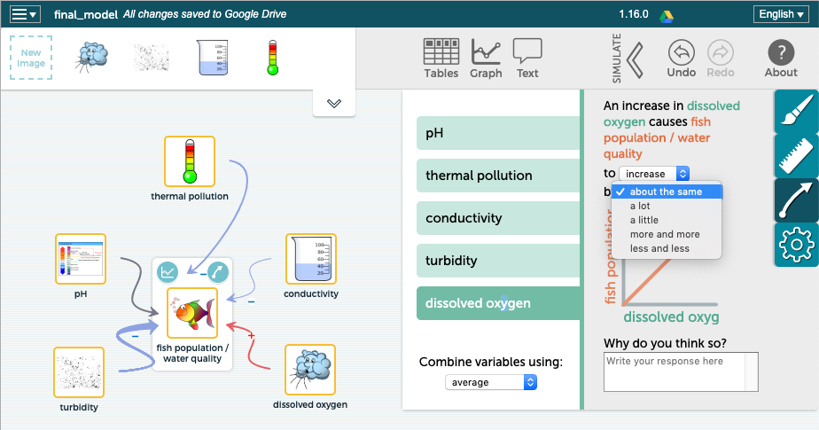

Students can now “test” their models by running a simulation. They can use the table or graphs or a combination of the two to test, evaluate, revise if needed, and re-test their models.

Below are possible questions that students can respond to that may assist them to think more deeply about their models:

- What did you change in your most recent model?

- What were your reasons for making these changes?

- How does you model account for the water quality of the stream?

- Do the changes you made in your model help respond to the driving question better? Why or why not?

- What are you still uncertain about in your model?

- Have you looked at your entire model to see if there are connections or relationships between the various water quality measures including any of the same causes. Does your model reflect these connections?

Students will continue to work on their models during class tomorrow. Some groups will also share their models.

3. Sense-making opportunities: Critiquing models:

Purpose: To have students evaluate their models to see if they “work” the way that they think they should work.

Remind students that SageModeler has no content or model built into it and they develop models that “work” to explain the phenomenon. If the model doesn’t accurately reflect the phenomenon, then they need to change their model. It is the responsibility of the students to evaluate their models. This process should further foster students learning about important science ideas, crosscutting concepts, and the practice of modeling. Students can use their notes when developing their models. There are several possibilities including the following suggestions:

- Using their models to predict water quality: Encourage students to use the sliders to put them to the position where the water quality should be the best. Ask them where they should put the sliders? (For pH the slider should be in the middle – 7, for thermal pollution, conductivity, and turbidity the sliders should be the lowest, and for dissolved oxygen the slider should be the highest. In this way, students are predicting that the water quality will be high. Students can now run their models to see if their predictions match.

  - If they match, then students might conclude that their models work.

  - If they don’t match, students should think about why there is a mismatch. Do they need to adjust their models? Do they need to rethink their understanding of the science concepts?

- Observe what happens as they change one variable to see if it matches their thinking. Does the change in that variable affect the water quality they way that they think it should?

- Check all parts of the model. Test, evaluate, revise if needed, and retest.

Just as in the prior modeling classes, if a group or two completes their model, including running it and making sure it works the way that they think is accurate, you can have them expand their models to include the various causes for each of the water quality tests. These will be the variables that affect dissolved oxygen and turbidity. Encourage students to use the student readers to assist them. Students can choose images and define relationships between these. It is not expected that all (or any) students develop models at this level of sophistication. This is enrichment for groups who need it.

4. Sharing/Discussion (~20 min)
Purpose: Sharing and critiquing student models is extremely valuable. It fosters a community of learners and assists students to see connections between ideas. It also allows students to see how different groups have modeled the stream phenomenon.
Either request volunteers to share their models with the class or ask a couple of groups. You can display models for everyone to see. Groups should talk through their models and explain the variables and their relationships to water quality (fish population). They should run their models, using either the data table or graph tool accessible through the simulation tool. They can move the toolbars for the variables to show how the water quality is impacted.
As a class, they can discuss if the model “works” and provide any feedback to the group, including any suggestions they might have to improve the model.
Check to see if groups have made connections between the various measures. Students should connect temperature with dissolved oxygen (warm water can hold less oxygen), turbidity with temperature (floating particles can absorb heat), conductivity and oxygen (indirectly – excess nitrates and phosphates can cause algal blooms and when the excess dead algae are decomposed by bacteria, the now excess bacteria can use up all the oxygen).

Summary: Models explain and predict phenomenon. Ask students what conclusions they would make about the overall health of the stream based on all of the evidence and their models. Link this back to the driving question, “How healthy is our stream for freshwater organisms and how do our actions on land potentially impact the stream and the organisms that live in it?” Again, this can be done first in small groups and then in a class discussion. Ask students to include an overall statement (the stream is very healthy, somewhat healthy, not very healthy, very unhealthy etc.), a water quality standard (excellent, good, fair, or poor), and reasons.
Have a discussion to see if the class can come to consensus. This assumes that students’ evidence from all five water quality tests were similar. If they were not similar, then a discussion to support student statements should follow. Students could illustrate their ideas with their models by placing the bars at the places where their data falls.
Concluding the lesson (2 min)

This concludes day two of the two-day lesson as well as the entire unit. Remind students that the stream is a complex system. You may refer back to the analogy of the basketball player and collecting several pieces of evidence to make a more confident determination of her level of play.

Probe student understanding, not only of the science ideas and their answer to the driving question, but also of the nature of science. These ideas include that scientists work to explain phenomena in the natural world and how they go about explaining phenomena is to begin by gathering evidence. Any explanation of phenomena and conclusions made about phenomena should be based on evidence. Developing models is one way to systematically analyze these data, to look for cause and effect relationships and patterns to explain phenomena, in this case a complex system - the quality of a stream (or whatever waterway you investigated) for supporting life. Model-building also enables students to use their understandings, an important goal of science education.

LESSON #11: How healthy is our stream and how do our actions on land impact it? Final Explanation

Overview: In this lesson students construct a scientific explanation to respond to the driving question for the unit, “How healthy is our stream for freshwater organisms and how do our actions on land potentially impact the stream and the organisms that live in it?” Three options are provided that will allow you to choose what is best for your classroom. This lesson, however, is written for option two. The lesson is easily modified for the other options.
In previous lessons students have developed understanding of various water quality measures and collected water quality data from a stream, river, or lake. Now that they have collected all of their water quality data they will use their understandings to explain the phenomenon of the stream system by constructing a scientific explanation. There are several options:
- Option one: Students construct an explanation to address the driving question by looking at the overall health based on evidence from all water quality measures.
- Option two: Students construct an explanation to address the driving question based on one specific water quality measure, with different individuals or groups focusing on different water quality measures. Using this approach, the unit then ends with a culminating activity – A Water Quality Symposium – where students share their explanations from individual water quality tests and then work towards building consensus to make one claim of the overall quality of the stream for freshwater organisms based on all of the evidence gathered from all of the tests.
Option three: If students have collected their data in separate data collection episodes, over a period of time, they may construct an “evolving explanation,” where they write their initial explanation after collecting two pieces of evidence (two water quality tests). They then later revise their explanation as they add a third piece of evidence. They may need to adjust their claim to make sure it takes all evidence into account. They can continue to add to and revise their explanation after subsequent data collection episodes. Refer to the unit flowchart, end of Lesson #4 and Lesson #6 and the final explanation here in Lesson #11. (To read further about evolving explanations see Novak, A. M. & Treagust, D. F. Adjusting claims as new evidence emerges: Do students incorporate new evidence into their scientific explanations? J. Res. Sci. Teach. 2018, 55, 526-549, DOI 10.1002/tea.21429)

NGSS Performance Expectation: PE: MS-LS2-4, MS-LS2-2: PE: MS-LS2-1, PE: MS-ESS3-3

Learning Performances:
LP19: Students construct a scientific explanation of how various water quality measures resulting from human activities in agriculture, industry and everyday life can have major impacts on rivers, lakes, and streams, to illustrate cause and effect relationships, that small changes in one part of the system (the stream phenomenon under study) might cause large changes in another part of the system, and that stability might be disturbed either by sudden events or gradual changes that accumulate over time.

Safety Guidelines: None
Preparation: Students need to have the data from the water quality measures. Decide if students will work individually on an explanation or in groups and who will construct explanations for which water quality measure.
Time: 2-3 days
Materials: Several guide sheets, with varying levels of scaffolds, are included in the lesson. These guide sheets provide students with prompts for various portions of the explanation with room for notes that can be used to write the explanation. If computers are available for students they may construct explanations electronically, either individually or as groups. A main computer and projection device will allow explanations to be shared, critiqued, and discussed more easily. Students may also write explanations by hand.
INSTRUCTIONAL SEQUENCE

Day 1: Introducing students to explaining the stream phenomenon
1. Introducing students to explaining the stream phenomenon: Constructing explanations of our stream - intro (15-20 min)
Purpose: Students construct explanations to address the driving question based on one specific water quality measure. This process provides students with a sense-making opportunity to figure out the health of the stream based on that one water quality test.
Remind students that for weeks they have been exploring the unit’s driving question for the unit: How healthy is our stream for freshwater organisms and how do our actions on land potentially impact the stream and the organisms that live in it?
Focus students’ attention on the water system: water quality is not only about the water and the organisms that live in the water, but also what people do on the land, thus the second part of the driving question. Remind students that to investigate the complex water system they have investigated various parts of the system by exploring several sub-questions. Students have explored these sub-questions by conducting water quality measures that include collecting qualitative and quantitative data. With students, generate the list of sub-questions that have been investigated:
- Is the stream acidic, basic, or neutral? (pH)
- Is our stream too warm for freshwater organisms? (thermal pollution)
- Are there too many dissolved solids in the stream? (nitrates, phosphates, salt)
- Is there enough oxygen to support life in the stream? (dissolved oxygen)
- How many floating particles are in the stream? Is this a problem for freshwater organisms? (turbidity)

Remind students that for each of these sub-questions an important component to consider is another important question:

- How could my actions (or people’s actions) outside impact the quality of the water?

Let students know that different students or groups of students will construct an explanation that addresses one of the sub-questions. These explanations will be shared and discussed.

Review scientific explanations with students by connecting back to Lesson 3 where students were introduced to explanations. Review claim, evidence, and reasoning. Students will also add a rebuttal for these explanations.

Asking students to include an action step that people could take on land to improve the water quality or to maintain the water quality if it is already positive is a way to empower students to take positive action to ensure healthy fresh waterways. This is an option that can be added to the explanations.

- Claim: A claim is a statement that answers a question or is a conclusion to a problem. A claim reflects accurate relationships between variables. In this explanation, students will make a claim specific to one, water quality test and relate it to organisms. It will then reflect the water quality.
- Evidence: The data, both quantitative and/or qualitative, backs up the claim by providing the evidence for the explanation. This evidence needs to be scrutinized in two ways. Students must ask:
  - Is the evidence sufficient - Is there enough evidence to back up the claim?
  - Is the evidence appropriate? Is it valid? In other words, does it relate to the claim?
- Reasoning: using science ideas to discuss why the evidence counts to support the claim. Reasoning ties together science ideas with evidence to explain what it means and how it backs up the claim.
- Rebuttal: A rebuttal considers and then rules out an alternative explanation. It can also consider and rule out a science idea that might be used in reasoning why something occurred. For these explanations, students will consider all causes and determine if they can rule out any of them.
Making science learning accessible to all learners: Several options for student supports are provided. These guideline/outline documents include varying levels of scaffolds for students. The guides provide students with prompts for various portions of the explanation with room for notes that will be used to write the explanation. You may choose one, or modify one, that best serves your students. Possible examples of explanations are included below.

2. Constructing Explanations (20-30 min)
Purpose: Students work individually or collaborate in groups to take notes. They use these notes to construct explanations of one specific water quality measure. The explanations can serve as artifacts for either formative or summative assessment.
Working individually or with partners, students take notes, using guide sheets that provide them with prompts for various portions of the explanation as well as space for notes. Students then use their notes to construct an explanation in order to figure out and explain the stream’s health based on the water quality test they have chosen or been assigned.

Emphasize to students that their explanation should illustrate relationships between what people do on the land, the water quality measure, and the water quality for organisms.

Allow students to work on their explanations. Encourage students to use the data, both quantitative and qualitative, from the water quality test. As well, students should refer back to the student readers and/or notes taken during class that assist them to determine causes and consequences of their water quality test; these will help students connect their evidence to their claims using science ideas that are the variables that influence the water quality test (which in turn affect the water quality of the stream). They should use any observations they recorded in or near the water or in the area that might be related to a cause or consequence of the test. Move from group to group. Some groups will need more support than others. Encourage students to help each other. Some groups will work faster than other groups.
Here is a possible explanation that students might develop for pH. This example is very comprehensive. Students can use the explanation framework and complete meaningful, yet less comprehensive, explanations. Student explanations, though, will depend on the actual evidence they collect.
Possible pH explanation:
Is the stream acidic, basic, or neutral? According to pH, the stream is neutral and healthy for supporting most organisms. (claim) Testing at various locations we got a pH of 7.1, 7.8, and 7.7. We did not observe any soap suds in the water and the water looked clear. We have houses, roads, and storm drains in the area. The houses have nice lawns. There are lots of shrubs around. It had rained the day before we collected our data, but was not raining the day of data collection (evidence – both quantitative and qualitative). Our pH results are positive and fall in the good and excellent ranges for water quality. This means the stream is in the neutral zone, between 6-8, and that many, but not all, organisms can live in the water. For example, bass and crappie could live in the water because they need a pH between 6.5-8.5. However, trout and mayfly nymphs could not live in the water because they need a pH between 6.5-7.5. We know it rained right before data collect and that there were nice lawns at houses in the area so people could use fertilizer or other products like car wash soap or other soaps to clean their decks or garbage cans and that these products could get picked up by rain run-off and get carried to storm drains or run downhill and then flow into the stream. We tested fertilizer in our pH lab and it had a pH of ____. We think the shrubs around the stream may have acted like buffers to absorb some of the pollution to prevent them from washing into the stream. (reasoning) One thing that could have changed the pH of the water was acid rain. We can rule this out because, even though it rained, our numbers were not acidic. They were in the neutral zone for water quality and were in the direction towards bases. (rebuttal). In order to keep our stream neutral, people can plant Riparian buffers – shrubs etc. – around their yards to help absorb pollutants. Plants can live in more basic conditions (6.5-12) so can absorb pollutants. People can also use fewer products outside on the land that might be acidic or basic. (Action step).
Possible oxygen explanation:
We are asking, Is there enough oxygen in the stream for aquatic organisms? There is plenty of oxygen for organisms in the stream. (claim). When we measured oxygen we got 95%, 90% and 98%. All of these numbers fall into the excellent range for water quality standards. We had a mini-waterfall and small rapids near our testing site. The water had a couple of dead leaves, but was mostly clear. There were a few dead plants in the water. The weather was cool the day we collected data and the days before with no rain. (evidence) Our results are positive because aquatic animals need oxygen to live. Fast moving water can capture oxygen from the air and because we have the mini-waterfall and rapids we think they help capture oxygen from the air and that is why we have such high numbers. There is some organic waste, a few dead leaves and plants, and bacteria decompose these and also use oxygen, but there isn’t very much so there aren’t excess bacteria that would use up the oxygen. (reasoning) There are two things that we can rule out related to oxygen. First, we know that warm water can hold less oxygen. It’s cool right now and the water is cold, so we can rule out thermal pollution. We also know that water plants produce oxygen and could add to oxygen numbers. Since it’s fall and the water plants are dead we know that they did not help make our numbers so high. (rebuttal). One thing people can do to help oxygen is to avoid raking their leaves close to storm drains. The leaves could end up in water and create excess organic waste for bacteria. (Action step).

Concluding the lesson (~2 min)
If students have completed their explanations, let them know that they will be sharing explanations in class the following lesson. If more time is needed for students to complete their explanations, students can either have time the next day or you may have them complete them for homework.

Day 2: Sharing and Critiquing of Explanations
Purpose: Students share their explanations with each other. Students engage in peer critique by providing feedback. Students work to build consensus around claims for each water quality test.
1. Sharing and Critiquing of Explanations (30-45 min)

If students have written their explanation in groups, one member of each group can read the group’s explanation and the whole class can provide feedback. This encourages a community of learners where the classroom culture is one of collaboration to work together to figure out and explain phenomenon.

You may want to collaborate with an English teacher or with a public speaking teacher and have students prepare more formal presentations. Group members could each take part in the presentation. This will add time to the unit.

It is very important to stress that students share positive comments and if they disagree with a portion of a group’s (or individual’s) explanation that they provide suggestions in a positive and helpful manner. Provide language for students so that they have an example. You may focus language on strengths and weaknesses: You may want to first ask students to provide positive feedback about an explanation: What are strengths of the explanation and why? Are there any weaknesses – parts of the explanation with which you disagree? What suggestions do you have to improve it?

Another option is to begin by asking students to determine if the explanation includes a Claim? Evidence - Valid and sufficient? Reasoning? Rebuttal?

In the end, you want students to work together to determine if a claim accurately answers a question about one of the water quality measures and if that claim is supported by the evidence and explained by connecting science ideas with that evidence (reasoning). In addition, you may ask if students have included a rebuttal that ruled out potential causes that do not impact the stream.

You may want students to revise their explanations based on the feedback they’ve received.

Concluding the lesson (3-5 min)
At this point the class may have consensus about the health of the stream based on the separate water quality measures. Ask students if this means we have answered the driving question? If your results have some water quality measures that are positive and other water quality measures that are negative, ask students if we can have separate claims about the health of the stream? For example, what if students claimed that according to pH the stream was neutral so very healthy and all organisms could live there, but that according to temperature results students claimed that the stream had thermal pollution so was unhealthy and not suitable for organisms. Probe student ideas. Ask students if we need to collectively examine all of the claims and evidence to develop an overall claim about the health of the stream that reflects all of the available evidence. Let students know that this is what we will be doing tomorrow.

Day 3: Water quality symposium
Purpose: To conduct a Water Quality Symposium in order to answer the driving question based on all five water quality measures.

Students will now work together to make conclusions about the overall health of the stream based on all water quality measures. This conclusion now includes pH, temperature differences (thermal pollution), conductivity (dissolved solids), dissolved oxygen, and turbidity as the five variables that impact water quality. They are now answering the driving question - Students are figuring out that all 5 variables, measured by various water quality tests, impact the stream water quality and that these will impact organisms.

Additionally, they should see that some of the water quality tests have relationships with others. Turbidity may impact temperature since floating particles in water can absorb heat. Temperature impacts dissolved oxygen since warm water cannot hold as much oxygen as cold water. Dissolved solids are indirectly related to dissolved oxygen; both measures are related to the amount of organic waste.

You may ask students if all water quality tests carry equal weight. For example, while extreme pH conditions, too acidic or basic, will kill fish, too many dissolved solids, particularly excess nitrates and phosphates from fertilizer runoff, can lead to a problematic cycle that could eventually lead to low oxygen levels that could result in fish dying. Or what if all the tests are positive but there is not enough oxygen in the water?

Summary: Ask students what conclusions they would make about the overall health of the stream based on all of the evidence (if students have constructed models they can use their models to help them). Link this back to the driving question, “How healthy is our stream for freshwater organisms and how do our actions on land potentially impact the stream and the organisms that live in it?” Again, this can be done first in small groups and then as a class discussion. Here is one suggestion for conclusions:
- Ask students to include an overall statement (the stream is very healthy, healthy, somewhat healthy, not very healthy, very unhealthy etc), an overall water quality standard (excellent, good, fair, or poor), and how many organisms could live (all, most, many, some, a few).
- Have students support this by writing how they came to this claim. They can create a one- sentence statement for each water quality test.
Here is an example of a conclusion:
Our stream is overall healthy with a water quality standard of good and can support many organisms. How did we arrive at this conclusion? Our stream’s pH is neutral with good standards. The stream does not have any thermal pollution with excellent standards. We have too many dissolved solids with fair standards. There is plenty of oxygen in the stream with good and excellent standards. There are only a few floating particles with good turbidity standards. Based on all of our evidence we conclude our stream’s quality is good and suitable for most organisms.

Have a discussion to see if the class can come to consensus. This assumes that students’ evidence from all five water quality tests were similar. If they were not similar, then a discussion to support student statements should follow.
Review claims: A claim is a statement that answers a question or is a conclusion to a problem. A claim reflects accurate relationships between variables. In this explanation, students will make a claim specific to the overall health of the stream (not just one measure).
Now ask students if we have answered the driving question. Help students see that their overall claim is a conclusion that reflects relationships between water quality measures and the health of the stream for freshwater organisms.
Concluding the lesson (2 min)

This concludes lesson 11 as well as the entire unit. Remind students that the stream is a complex system. You may refer back to the analogy of the basketball player and collecting several pieces of evidence to make a more confident determination of her level of play.

Remind students that they were engaged in the same activities of expert scientists. They investigated an authentic question and sub-questions about the natural world and collected real data in real time to analyze and answer those questions.

Probe student understanding, not only of the science ideas and their answer to the driving question, but also of the nature of science. These ideas include that scientists’ work to explain phenomena in the natural world and how they go about explaining phenomena is to begin by gathering evidence. Any explanation of phenomena and conclusions made about phenomena should be based on evidence. Developing explanations is one way to systematically analyze these data, to look for cause and effect relationships and patterns to explain phenomena, in this case a complex system - the quality of a stream (or whatever waterway you investigated) for supporting life.

If you wish to provide an opportunity for your students to use their knowledge in a new situation you may challenge them in Lesson #12.

LESSON #12: Assessment Challenge
Lesson question: Green City Residents: “Is what we are doing on the land hurting the quality of the water in Blue River?”

Overview: In this cumulative assessment students are challenged to make use of their knowledge of water quality systems by applying their understandings to a new situation.
Throughout the water unit students developed understanding of DCI’s, crosscutting concepts, and practices through exploring the phenomenon of a water system that included peoples impact on water quality. In this scenario students are provided with a context of a small community located in a watershed that drains into Blue River. Green City residents have a commitment to sustainability that includes a pledge to keeping their water healthy while still meeting their needs. Students are hired as water quality experts to analyze and interpret water quality data and explain it to the community. As well, they are asked to provide the community with insights on what they are doing that may be helping or hurting the water quality and action steps that they can do for improvement.
Students are provided with data that has already been collected and is represented in graphs. They will use this data as quantitative evidence. They are also provided with a picture that shows what is happening on land and in the water at three different locations, A, B, and C. They will use this as qualitative data. Water quality standards are also provided to students, although they do not include the qualitative equivalents of excellent, good, fair, and poor. Students are expected to know the patterns of these standards based on each test (for example high numbers for oxygen would be excellent and low numbers for thermal pollution would be excellent).
Students are asked to use all of the information provided: the picture, the graphs, and the standards and then to construct a scientific explanation. In effect, they will use the framework of claim, evidence, reasoning, and action steps for each location (A, B, and C). Rebuttals, ruling out causes that are not impacting the river, are not included as they would require too much time. Students are only focusing on what is in the picture and the graphs to tell a “Water quality story” to Green City residents through their explanation.
Two options are provided that will allow you to choose what is best for your classroom.
The assessment is written as a one-hour assessment. You may need to adjust this based on your situation. Remember, the unit is flexible and so is this assessment. You may modify it to suit the needs of your students.

Option one: Students work individually. You should encourage students to carefully “read” all of the handouts before they begin to write. You might encourage students to jot down some notes prior to writing the explanation. You can decide if students will use their science notes or students readers from the water unit or if they will complete this assessment without notes.
Option two: Students work in groups. Encourage students to carefully “read” all of the handouts before they begin to write. Members of the group can take notes and together write one explanation. You can decide if students will use their science notes or student readers from the water unit or if they will complete this assessment without notes.
NGSS Performance Expectations for the Unit:
MS-LS2-4. Construct an argument supported by empirical evidence that changes to physical or biological components of an ecosystem affect populations.
MS-LS1. Analyze and interpret data to provide evidence for the effects of resource availability on organisms and populations of organisms in an ecosystem.
MS-ESS3-3. Apply scientific principles to design a method for monitoring and minimizing a human impact on the environment.
Learning Performances:
LP19: Students construct a scientific explanation of how various water quality measures resulting from human activities in agriculture, industry and everyday life can have major impacts on rivers, lakes, and streams, to illustrate cause and effect relationships, that small changes in one part of the system (the stream phenomenon under study) might cause large changes in another part of the system, and that stability might be disturbed either by sudden events or gradual changes that accumulate over time.

Safety Guidelines: None
Preparation: Students need to have various handouts (see materials below).
Time: 2 days
Materials: Students will need the Blue River Scenario, Blue River Picture, Blue River Graphs, and the water quality standards. If computers are available for students they may construct explanations electronically, either individually or as groups. A main computer and projection device will allow explanations to be shared, critiqued, and discussed more easily. Students may also write explanations by hand.
Blue River Scenario: https://docs.google.com/document/d/1nOdr5Bhti_6r4X_61qAu-t_pUzV8mReUJVWkOiGZ0hY/edit
Blue River Picture: https://docs.google.com/presentation/d/1WPIQTSU1jvTtNnkB1tFocRiRzAZHiGNiD0ZJPXf-MEU/edit - slide=id.p1
Blue River Graphs: https://docs.google.com/document/d/14Q76XFJBovYIZi1n5BsfPKU_VcL_hTn6aTs1jxto6eY/edit
Water quality standards: https://docs.google.com/document/d/1Xljf55uq-7pwJTXXrEVjYMjHbOuo5rqK5YyS64Gz0xg/edit

INSTRUCTIONAL SEQUENCE:

Day 1: Overview of assessment task and review of scientific explanation
Purpose: Familiarize students with the scenario. Make sure students are clear about the directions and purpose of the assessment.
1. Introducing students to the culminating task (20min)
Remind students that for weeks they have been exploring the unit’s driving question for the unit: How healthy is our stream for freshwater organisms and how do our actions on land potentially impact the stream and the organisms that live in it? Now they are going to be challenged to use their understanding to figure out the health of a river and if a community that lives by the river is unintentionally hurting the quality of the water by what they are doing on the land.
First, prior to the assessment, students are provided with the scenario, but not the graphs or the picture. The goal is to have students become familiar with the challenge. Spend time reading through the scenario and explaining to students that they will write three paragraphs, one for each location that includes a discussion for that location. They will also conclude if overall what people are doing on the land is helping or hurting the water quality. This can be an introductory statement (claim) and/or a closing statement.
Ask students what they think should go into those paragraphs.

Review scientific explanations with students. Hopefully students will be able to generate the various components of explanations. Review claim, evidence, and reasoning. Students will also include action steps.

You can decide how much detail you want to review with students. For example, when you review evidence, you may want to ask students if they need to report qualitative and quantitative measures? Ask if they need to report numbers for each of the water quality measures? Do they need to report what is in the picture – in the water and on the land – as part of qualitative evidence? If students are going to explain what is happening, they need to include detail.

- Claim: A claim is a statement that answers a question or is a conclusion to a problem. A claim reflects accurate relationships between variables. In this explanation, students will make a claim specific to one, water quality test and relate it to organisms. It will then reflect the water quality.

- Evidence: The data, both quantitative and/or qualitative, backs up the claim by providing the evidence for the explanation. This evidence needs to be scrutinized in two ways. Students must ask:

  - Is the evidence sufficient - Is there enough evidence to back up the claim?
  - Is the evidence appropriate? Is it valid? In other words, does it relate to the claim?

- Reasoning: using science ideas to discuss why the evidence counts to support the claim. Reasoning ties together science ideas with evidence to explain what it means and how it backs up the claim.
Let students know that they will also include action steps for the community. These can include what members should stop doing and why and/or what members should do and why.

Day 2: Assessment - constructing explanations using the Blue River scenario
Purpose: Students take the culminating assessment
Constructing Explanations (60 min): Allow students to work on their explanations.

